CAFF Monitoring Series Report nr. xx
April 2013

Arctic Terrestrial Biodiversity Monitoring Plan

Terrestrial Expert Monitoring Group
Circumpolar Biodiversity Monitoring Program

DRAFT – FOR PEER REVIEW
Updated February 24th, 2012

Authors:
Christensen, T.; Payne, J.; Svoboda, M.; Gill, M. J.; Doyle, M.; Aronsson, M.; Behe, C.; Buddle, C.; Cuyler, C.; Heidmarsson, S.; Ibarguchi, G.; Kenning Krogh, P.; Madsen, J.; McLennan, D.; Nymand, J.; Pääkkö, E.; Rosa, C.; Salmela, J.; Schmidt, N. M.; Shuchman, R.; Soloviev, M.; Taylor, J.; and Wedege, M.

Layout and Editing:
Barry, T.; Fannar, K.; and Price, C. (CAFF International Secretariat, Akureyri, Iceland)
Ibarguchi, G. (Queen’s University, Canada)

Author Affiliations
Tom Christensen, Aarhus University, Denmark
John Payne, North Slope Science Initiative, Alaska, USA
Michael Svoboda, CBMP Office, Environment Canada
Mike Gill, CBMP Office, Environment Canada
Marlene Doyle, Science & Technology Branch, Environment Canada
Mora Aronsson, Swedish Species Information Centre
Carolina Behe, Inuit Circumpolar Council, Alaska, USA
Chris Buddle, McGill University, Canada
Christine Cuyler, Greenland Institute of Natural Resources
Starri Heidmarsson, Icelandic Institute of Natural History
Gabriela Ibarguchi, Queen’s University, Canada
Paul Henning Krogh, Aarhus University, Denmark
Jesper Madsen, Aarhus University, Denmark
Donald McLennan, Aboriginal Affairs & Northern Development Canada
Josephine Nymand, Greenland Institute of Natural Resources
Elisa Pääkkö, Metshallitus Natural Heritage Services, Finland
Cheryl Rosa, U.S. Arctic Research Commission, USA
Jukka Salmela, Natural Heritage Services, Finland
Niels Martin Schmidt, Aarhus University, Denmark
Robert Shuchman, Michigan Tech Research Institute, USA
Mikhail Soloviev, Lomonosov Moscow State University, Russia
Jason Taylor, U.S. Department of the Interior - Bureau of Land Management, USA
Morten Wedege, Norwegian Directorate for Nature Management

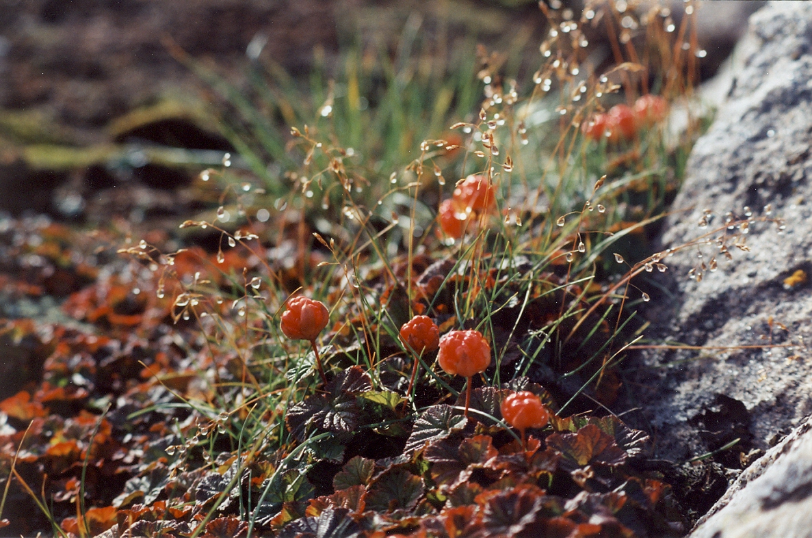
Photo: Cloudberry, Rubus chamaemorus (Gabriela Ibarguchi; Nunavut, Canada)

Table of Contents
Arctic Terrestrial Biodiversity Monitoring Plan 1
Authors: 1
Layout and Editing: 1
Author Affiliations 2
Table of Contents 3
Acknowledgements 6
Executive Summary 7
1 Introduction and Background 12
1.1 Benefits of Contributing to a Circumpolar, Coordinated Effort 13
1.2 Goals and Objectives of the Arctic Terrestrial Biodiversity Monitoring Plan 14
1.3 Scope of the CBMP-Terrestrial Plan 14
1.4 Integrated, Ecosystem-based Approach to Arctic Biodiversity Monitoring 15
1.5 Definitions of Biodiversity, Focal Ecosystem Components, Attributes and Parameters 16
1.6 Considerations for Monitoring Arctic Terrestrial Biodiversity 17
1.6.0 Species and Ecosystems included in the CBMP-Terrestrial Plan 17
1.6.1 Heterogeneity of Arctic terrestrial ecosystems 17
1.6.2 Drivers 18
1.6.3 Brief Overview of Monitoring and Limitations in the CBMP-Terrestrial Plan 20
1.7 Community Based Monitoring (CBM), Traditional Knowledge (TK), Citizen Science, and Historical Data 22
1.8 Links and Relevance to Other Programs and Activities 24
1.8.1 Arctic Council Working Groups and Activities: 25
1.8.2 Other Programs 27
2 TEMG Focal Areas: Geographic Boundaries and Definitions 30
2.1 Geographic Boundaries and Definitions 30
3 Monitoring Approach, Objectives and Methods 33
3.1 Overall Monitoring Approach 33
3.2 Central Questions to be addressed in the Monitoring 34
3.3 Scale of Monitoring and Reporting 35
3.4 Data and Modeling 36
3.4.1 Standardization and harmonization of protocols and data 36
3.4.2 Modeling 36
3.5 Key Concepts of the CBMP-Terrestrial Plan 36
3.5.1 Monitoring supported by conceptual models 36
3.5.2 Linkage to system drivers 37
3.5.3 The CBMP TEMG Conceptual Model 38
3.5.4 Identification of Focal Ecosystem Components, Attributes and Parameters 40
3.6 Establishing Reference (Baseline) Conditions 41
3.7 Establishing Thresholds of Concern 41
3.8 Linkages between the CBMP-Terrestrial Plan and the CBMP Indices and Indicators 43
4 Sampling Design 48
4.1 Sampling Design Overview 48
4.1.1 Introduction to CBMP-Terrestrial Plan sampling design 48
4.1.2 Interpreting the sampling design tables 49
4.1.3 Sampling Metadata 49
4.2 Vegetation 50
4.2.1 Vegetation sampling approach and design issues 50
4.2.2 Sampling protocols 55
4.2.3 Site establishment data 56
4.2.4 Vegetation sample processing, archiving and DNA analysis 56
4.2.5 DNA analysis of fungi from soil samples at the vegetation plots 57
4.3 Birds 68
4.3.1 Avian monitoring questions and design issues 70
4.3.2 Potential contributors to the avian monitoring scheme 72
4.3.3 Avian conceptual model in relation to monitoring 73
4.3.4 Terrestrial avian monitoring design principles and components 74
4.3.5 Monitoring on non-breeding grounds 79
4.3.6 Existing Capacity and future needs to deliver the CBMP-Terrestrial Plan 80
4.3.7 Sampling protocols 81
4.4 Mammals 102
4.4.1 Mammal monitoring questions 102
4.4.2 Potential contributors to the mammal monitoring scheme 103
4.4.3 Mammal conceptual model in relation to monitoring 103
4.4.4 Terrestrial mammal monitoring design principles and components 104
4.4.5 Existing monitoring capacity 106
4.4.6 Mammal sampling protocols 106
4.4.7 Sampling protocols 107
4.5 Arthropods and Invertebrates 115
4.5.0 Introduction and scope 115
4.5.1 Pan-Arctic sampling approach 115
4.5.2 Sampling protocols and design 117
4.5.3 Site establishment data 121
4.5.4 Sampling sorting, long-term storage, and DNA barcoding 121
5 Data Management Framework for the Arctic Terrestrial Monitoring Plan 131
5.1 Data Management Objectives for the CBMP 131
5.2 Purpose of Data Management 132
5.3 Coordinated Data Management and Access: the CBMP Web-based Data Portal 132
5.4 Data Storage, Policy and Standards 134
6 Data, Samples and Information Analysis 137
6.1 Basis for Analysis 137
6.1.1 Start-up phase 137
6.1.2 Implementation phase 138
6.2 Data Samples 139
6.2.1 Sample processing 139
6.2.2 Sample archiving 139
6.2.3 Tools, samples, and baselines to complement monitoring and future surveillance efforts 139
6.3 Data analysis strategy 142
7 Reporting 143
7.1 Audiences 143
7.2 Types and Timing of Reporting 143
7.3 Reporting Results 144
7.3.1 State of Arctic Terrestrial Biodiversity Report 144
7.3.2 Status of indicators 144
7.3.3 Program review 144
7.3.4 Scientific publications 145
7.3.5 Performance reports and work plans 145
7.3.6 Summaries and other communications material 145
8 Administration and Implementation of the Monitoring Program 148
8.1 Governing Structure 148
8.2 Program Review 150
8.3 Implementation Schedule and Budget 151
9 Literature Cited 157
10 GLOSSARY 174
11 Appendices 183
A Appendix: Metadata and Sampling Coverage Maps by Focal Ecosystem Elements - ONGOING 183
i. Introduction and Description 183
ii. MAPS 183
B Appendix: What Can We Monitor with Satellite Data in the Arctic? 183
i. Remote Sensing 183
ii. Satellite Imaging of Pan-Arctic Research Stations 188
C Appendix: Workshop Participants 190
i. Workshop 1 (October 11-13, 2011, Hvalsø, Denmark) - Designing an Arctic Terrestrial Biodiversity Monitoring Plan 190
ii. Workshop 2 (May 15-17, 2012, Anchorage, Alaska, USA) - Designing an Integrated Arctic Terrestrial Biodiversity Monitoring Plan 191

Acknowledgements
To be completed. The Terrestrial Expert Monitoring Group (TEGM) gratefully acknowledges the invaluable contributions of international collaborators, managers, experts, institutions, governments, and Aboriginal community members during the planning, development, and preparation of the final CBMP-Terrestrial Plan. In particular we wish to thank taxonomic and monitoring experts, field biologists, researchers, managers, professionals, and leaders who have contributed information for the Plan and who have provided invaluable comments on the proposed monitoring schemes, focal taxa, methods, existing data and monitoring capacity, concordance of selected indicators for monitoring with the needs of Arctic communities and for ecosystem management, and on the feasibility and level of impact of the approaches outlined in the CBMP-Terrestrial Plan. We also wish to thank Anna Maria Fosaa (Botanical Department at Natural History Museum Faroe Islands), Hallur Gunnarsson (CAFF - Data management) and county contributors who have been participating in the collation and preparation of a publically-available comprehensive inventory of monitoring capacity in the form of infrastructure and programs (and associated metadata on location, focal taxonomic groups, and on the characteristics and frequency of monitoring efforts; see Appendix A). The TEGM group gratefully acknowledges the members of the Conservation of Arctic Fauna and Flora Office for assistance during the planning, development, and review of the CBMP-Terrestrial Plan, and the organisers, hosting institutions, and session participants of two invaluable expert workshops (Workshop I and II see Appendix C) for advice, critical input, and for comments during the early preparation of the framework for the plan and during drafting and selection of key indicators and drivers for monitoring. We thank staff and members of our institutions and government agencies for their on-going support, in-kind contributions, and for access to resources and records during the completion of this Plan.
In addition, we are indebted to a great number of country experts for providing input and reviewing earlier drafts of Plan sections.
- Country experts (to be completed): SWEDEN - Anders Dahlberg, Swedish Species Information Centre (valuable input on fungi and fungi monitoring); Wenche Eide, Swedish Species Information Centre (ongoing monitoring and monitoring design); Hand Gardfjell, Department of Forest Resources Management, SLU (vegetation monitoring design, ongoing monitoring); Lars Petterson, Lunds University (invertebrate monitoring)

NOTE FOR REVIEWERS: The TEMG Team wishes to thank you for your time and contributions to improve the working draft of the Terrestrial Plan. We would be pleased to acknowledge your contributions. Please write your NAME AND AFFILIATION here if you wish to be named; otherwise we will only thank you as ‘Anonymous Reviewer’.
- REVIEWERS (Name, affiliation):

Executive Summary
Polar environments experience some of the harshest conditions for life including extreme cold, strong winds, drought, extended darkness during long winters, high UV radiation, and short growing seasons. Arctic ecosystems harbor highly specialized lineages including endemic taxa that have adapted to these harsh conditions, and migratory species that exploit rich Arctic resources during their breeding period. Despite the remoteness of Arctic regions, ecosystems are under increasing pressure from threats within and outside northern latitudes, including contaminants, over-exploitation of endemic and migratory species, anthropogenic disturbance, resource extraction and landscape alteration, habitat loss and fragmentation, climate change, and shifting distributions of prey and pathogens.
Currently, pan-Arctic systematic, comprehensive, coordinated and integrated ecosystem monitoring is lacking. The Conservation of Arctic Flora and Fauna (CAFF), the biodiversity conservation and sustainable use working scientific group of the Arctic Council, established the Circumpolar Biodiversity Monitoring Program (CBMP) to address the need for coordinated and standardized monitoring of Arctic environments. The CBMP includes an international network of scientists, conservation organizations, government agencies, and Arctic community experts and leaders. Using an ecosystem-based monitoring approach which includes species, ecological functions, ecosystems, their interactions, and potential drivers that can affect these Arctic components, the CBMP includes four expert monitoring groups focusing on developing and implementing long-term plans for monitoring the integrity of Arctic biomes: terrestrial, marine, freshwater, and coastal environments.
The CBMP Terrestrial Expert Monitoring Group (CBMP-TEMG) has developed a long-term ecosystem-based monitoring approach, the CBMP-Terrestrial Plan. The rationale, development process, selected indicators and drivers for monitoring, and implementation strategies are described in the present document. The Plan includes terrestrial species and habitats in the Arctic, Subarctic, and high latitude alpine regions adjacent to and continuous to these environments (see Chapters 1 and 2). Biodiversity considered under the CBMP-Marine Plan , Freshwater Plan , and Coastal Plan (to be developed) are excluded to improve the efficient use of monitoring resources.
The TEMG strives to promote, coordinate, and harmonize terrestrial biodiversity monitoring efforts across the Arctic (spanning eight circumpolar nations and their jurisdictions, six organizations representing Arctic and Aboriginal Peoples, and including additional observer countries and organizations). The TEMG also facilitates communication and knowledge dissemination among multidisciplinary groups, scientists, managers, and country experts within circumpolar regions and beyond Arctic borders. The over-arching stimulus of the CBMP-Terrestrial Plan is to provide a powerful framework to define baselines and systematically evaluate changes with respect to the long-term integrity of Arctic ecosystems and biodiversity through assessments and analyses of trends in species diversity and abundance, ecological interactions, ecosystem functions, drivers and their impact on Arctic habitats and Arctic communities (including Arctic Peoples), and on the long-term resilience and adaptability potential of species and ecosystems.
Briefly, the Plan focuses on the achievement of the following goals: (1) to identify key ecological, management, community, and traditional knowledge needs; (2) to select critical ecosystem components (and their characteristics) that can serve as indicators of change in the Arctic; (3) to identify crucial drivers that have a potential effect on terrestrial biodiversity and that require monitoring; (4) to develop strategies for monitoring, data capture and storage that can be harmonised, integrated and coordinated across circumpolar regions to facilitate reliable and efficient knowledge exchange; (5) to identify current monitoring capacity, existing resources and infrastructure, data sources, and baselines that can be integrated into long-term monitoring efforts; (6) to identify major knowledge gaps and needs, and develop strategies that can facilitate adaptation and flexibility as future needs arise; and (7) to facilitate communication and the collation of data for use by managers, experts, researchers and communities, from research-based to community-based efforts at local to global scales, including traditional knowledge, and international collaboration.
The initial framework and focus of the CBMP-Terrestrial Plan was designed and developed during two special workshops including international participants with taxonomic, scientific and community-based expertise (see Appendix C). Through expert review and consensus, the following components were identified as most important for consideration in the design of the CBMP-Terrestrial Plan: critical monitoring needs, key ecosystem indicators, drivers and threats, existing capacity, and current gaps in knowledge and monitoring. Four criteria were selected as fundamental for building the Plan and selecting key indicators for monitoring Arctic communities and change: (1) ecological importance and relevance; (2) ecosystem function importance; (3) importance to Arctic Peoples; and (4) importance for management and legislation needs. Focal ecosystem components (FECs; key elements that serve as indicators), their attributes (characteristics), and parameters (measurements and range of variation in the field) were selected based on these criteria and review process to serve as indicators for monitoring. In addition, frameworks for sampling methods and standardization, monitoring frequency, and spatial scales were designed, and these were further refined by groups with taxonomic and monitoring expertise. Based on the core criteria above (e.g. importance for ecosystem function and integrity, such as role of taxa as keystone species), current capacity, overlap under the other CBMP Plans (marine, freshwater and coastal biomes), considerations of feasibility, and limitations (due to cost, time, labour or logistics), four main terrestrial biotic groups were selected for systematic monitoring: (1) vegetation (including fungi); (2) invertebrates (including some arthropods with life stages in aquatic environments); (3) birds (resident and migratory); and mammals (resident and migratory). Important drivers of change were identified also, including abiotic (climate, physical environment, etc.), biotic (ecological interactions, pathogen outbreaks, etc.), and anthropogenic drivers (disturbance, contaminants, landscape alterations, climate change, introduction of non-native species, etc.).
Methods and strategies for monitoring include from site-based focal studies to pan-Arctic remote sensing and global modeling approaches, and incorporate data-gathering through traditional knowledge and community-based monitoring, to scientific analyses (see Chapters 3 and 4). For monitoring FECs related to each biotic group, essential (highest priority) or recommended components (high importance, next in priority, or less feasible due to some limitations) were identified to include for consideration as much as possible and as capacity permits. In addition, methods were included ranging from basic (requiring knowledge, training or equipment that is easy to acquire) to advanced (requiring a higher level of experience, expertise, or more sophisticated equipment), with the advantage that as opportunities arise more specialized and comprehensive methods can be included based on available capacity. The CBMP-Terrestrial Plan outlines existing standardized techniques that are feasible and already in use across circumpolar regions (e.g. capture-mark-recapture studies, ageing and sexing techniques, vegetation sampling, or citizen-science based avian surveys), and includes suggested protocols where infrastructure and capacity exist (e.g. genetic analyses, stable isotope signature analyses, satellite-based or other technology-based tracking and telemetry systems, and remote sensing).
A fundamental aim of the CBMP-Terrestrial Plan, like the rest of the Circumpolar Biodiversity Monitoring Program, is to benefit from, build on, and expand the reach of existing networks (i.e. continue creating a network of networks). Where monitoring is not yet feasible under the Plan, or where insurmountable limitations exist due to cost or logistics, data gathered as part of other existing programs and networks within and beyond Arctic regions may be invaluable (see Chapter 1). For example, monitoring key drivers that affect Arctic ecosystems may already be included in part or indirectly within the CBMP-Terrestrial Plan, but to assess the complete range of drivers would be unfeasible, could duplicate existing efforts under other programs, and could result in wasting valuable resources that can be invested in other monitoring efforts where gaps exist. However, through collaboration, data related to currently recognized drivers and potential future threats may be obtained directly or indirectly through external networks and programs. For example, INTERACT (International Network for Terrestrial Research and Monitoring in the Arctic; http://www.eu-interact.org/) links existing infrastructure to build monitoring and research capacity and to facilitate collaboration among circumarctic countries. AMAP (Arctic Monitoring and Assessment Programme), another initiative under the Arctic Council, specializes on issues of contaminants, measuring pollution levels, tracking temporal and spatial trends, and conducting assessments of their impact on Arctic ecosystems and communities. Through existing programs such as INTERCT, AMAP, and many other networks globally, critical information may already be available or monitored to complement efforts under the existing CBMP-Terrestrial Plan without need for duplication. In addition, global climate, transport and biodiversity information available from other areas, including Antarctica and the Southern Ocean (strongly influencing terrestrial environments), high elevations, and cold regions elsewhere in the world, may provide opportunities to conduct comparative studies, forecasting, modeling, or to analyse trends to predict future outcomes where Arctic-specific data are lacking.
Under the existing CBMP-Terrestrial Plan, and for the CBMP Program as a whole, a major objective is to facilitate knowledge exchange and data dissemination through accessible platforms. Although individual circumpolar nations would be responsible for database-building and data management, the CBMP will promote building a standardized system for data management to facilitate linkages among groups and data accessibility through the establishment of country-based Terrestrial Expert Networks (TENs; see Chapter 8). Important considerations for data management include: (1) quality assurance (data integrity and quality); (2) consistency (following standards); (3) efficiency (best use of resources and avoiding duplication); (4) facilitating communication (accessibility of data; interchange; timing; user needs and language); (5) linkages (across networks, partners; scales; assessment processes); and (6) credibility (transparency in data collection and reporting).
The CBMP-Terrestrial Plan will report on the results of the data collection and on information related to the development of a coordinated monitoring plan. Reporting will be tailored to the needs of target audiences including decision-makers from local to international scales, Arctic communities, scientists, and managers, requiring specialized formats and reporting schedules (see Chapter 7). Reporting will include scientific articles, general communications, performance reports for the monitoring Plan and chosen indicators, and status reports.
Currently, the comprehensive 2013 CAFF Arctic Biodiversity Assessment is being released and will serve as the foundation on the status of Arctic species and ecosystems. Under the CBMP-Terrestrial Plan, the first major report to be produced will be a State of Arctic Terrestrial Biodiversity Report in 2016 (three years after the publication of the CBMP-Terrestrial Plan, and after the publication by CAFF of the comprehensive 2013 Arctic Biodiversity Assessment). The 2016 State of Arctic report stemming from work under the CBMP-Terrestrial Plan will thus provide a follow-up and expanded assessment on the status of biodiversity and ecosystems in the Arctic. Reporting under the CBMP-Terrestrial Plan will continue following the first release of the 2016 report with the subsequent State of Arctic report in 2020 (to synchronize reporting schedule with the Marine and Freshwater Steering Groups), and continuing every five years thereafter.
To facilitate the integrated monitoring efforts under the CBMP-Terrestrial Plan, CAFF will establish an international CBMP Terrestrial Steering Group (CBMP-TSG) to implement, coordinate and track progress of work stemming in response to the CBMP-Terrestrial Plan, and to guide activities of the national Terrestrial Expert Networks (TENs). The TENs will be responsible for implementing monitoring of their respective biotic groups as outlined in the Plan. The general implementation of the CBMP-Terrestrial Plan has been outlined in some detail here (see Chapter 8), but management details and on-going support including funding for monitoring and capacity-building will be implemented by each country and may evolve as monitoring needs arise and capacity expands in the future. Important steps in the implementation process following the initial release of the CBMP-Terrestrial Plan include the creation and activation of the governing structure and TENs, the establishment of data nodes, the collection and analysis of existing monitoring data, and the establishment of coordinated monitoring, reporting, and program evaluation.
Novel endemics continue to be discovered in the Arctic today, and basic natural history (diet and breeding ecology) and migration patterns remain poorly known for many species (see Chapter 6). Although large knowledge gaps remain with respect to existing biodiversity in Arctic ecosystems and the complex linkages between species and regions within and beyond Arctic borders, establishing baselines and developing coordinated monitoring is a crucial and positive step to enable improved targeted policy, mitigation and applied responses for species and regions where needs may be the greatest or those experiencing the most rapid changes. Harmonised monitoring will facilitate detection of external drivers, new threats, and impacts at local scales but occurring globally, or impacts occurring at large region-wide scales that have not been detected at smaller local scales. For previously-identified critical regions (e.g. breeding grounds and migratory stop-over sites), communities, or species of special concern, implementing pan-Arctic or systematic monitoring may provide insight into movement patterns, shifting distributions, and information on poorly-known biodiversity and on the success of conservation strategies. In particular, as global human populations expand, needs for resources rise, and anthropogenic activities reach higher latitudes, implementation of coordinated monitoring strategies can inform decision-making to promote more sustainable uses of Arctic resources and biodiversity, and to mitigate harmful practices in the face of climate change and increasing pressures.

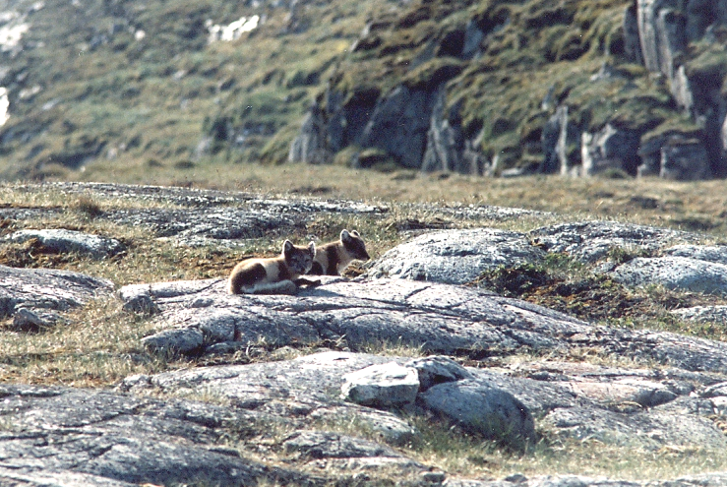
Photo: Arctic fox kits, Vulpes lagopus (Gabriela Ibarguchi, Nunavut, Canada)

1 Introduction and Background
Healthy Arctic ecosystems are of fundamental economic, cultural, and spiritual importance to Northern residents. Furthermore, the size and nature of Arctic ecosystems make them critically important to the biological, chemical, and physical balance of the globe. Dramatic changes in regional climates, and increasing industrial development and other activities, now underway, are threatening Arctic biodiversity, the resilience of species, the potential for human use, and the overall integrity of northern ecosystems . Moreover, continued rapid change in the Arctic will have repercussions for the ecosystems and biodiversity of the entire planet.
Currently, monitoring of Arctic biodiversity lacks the coordination needed to provide an integrated, pan-Arctic picture of status and trends related to key species, habitats, and ecological processes and services. Enhanced coordination would improve our ability to detect important trends, link these trends to their underlying causes, assess the effects of increasing anthropogenic activities, and provide critical information to decision makers. Information on how the Arctic is responding to pressures such as climatic change and human activity is urgently needed to allow decision makers, whether in local Arctic communities, regional or national governments, or international venues, to make timely and effective decisions regarding resource management, conservation actions, and adaptive management.
In response to these critical needs, the Conservation of Arctic Flora and Fauna (CAFF) Working Group of the Arctic Council created the Circumpolar Biodiversity Monitoring Program (CBMP). CAFF’s CBMP is working with scientists, Traditional Knowledge (TK) holders, and local resource users from around the Arctic to harmonize and enhance long-term Arctic biodiversity monitoring efforts (Fig. 1.1). The Terrestrial Expert Monitoring Group (TEMG) is one of four Expert Monitoring Groups (EMGs) created by the CBMP to develop integrated, ecosystem-based monitoring plans for the Arctic’s major biomes. Each of the groups (Marine, Coastal, Freshwater, and Terrestrial) functions as a forum for scientists, community experts, and managers to promote, share, and coordinate research and monitoring activities, and to use existing data and knowledge to facilitate improved, cost-effective monitoring that can detect and provide insight into emerging trends in Arctic biodiversity. These efforts will be coordinated through the implementation of integrated, pan-Arctic biodiversity monitoring plans.
The development of the Arctic Terrestrial Biodiversity Monitoring Plan (CBMP-Terrestrial Plan) comes at a critical time. The Secretariat of the Convention on Biological Diversity, having recognized that its 2010 goal to reduce the rate of loss of global biodiversity has failed, has established new 2020 targets (Aichi Biodiversity Targets) to reduce the rate of loss of biodiversity by focusing efforts on the underlying causes driving these losses. In most cases, the rate of loss has not been adequately measured yet. The recent report, Global Biodiversity Outlook 3 , noted the need for increased mobilization of resources for the research and monitoring of biodiversity. At the same time, while efforts to reach an international agreement on global climate change continue, there is broad acknowledgement that the polar regions are experiencing and are expected to experience rapid and dramatic impacts . The Intergovernmental Panel on Climate Change (IPCC) has concluded that climate change related to increased greenhouse gas concentrations will result in major physical, ecological, social, and economic impacts .
A number of Arctic Council assessments and reports have called for improved biodiversity information to support effective management of the Arctic environment. The Arctic Climate Impact Assessment recommended that long-term Arctic biodiversity monitoring be expanded and enhanced in the face of a rapidly changing Arctic. A key finding of Arctic Biodiversity Trends 2010: Selected Indicators of Change was that “long-term observations based on the best available traditional and scientific knowledge are required to identify changes in biodiversity, assess the implications of observed changes, and develop adaptation strategies.” Similarly, the Oil and Gas Assessment called for “…improved mapping of vulnerable species, populations and habitats in the Arctic…”.
All of these recommendations highlight the increasingly urgent need for improved Arctic biodiversity monitoring to support effective management of the Arctic environment. In addition, Arctic states have commitments through various regulatory regimes and associated legislation to protect their Arctic ecosystems and the biodiversity they support. Sub-national governments, including Aboriginal governments in some countries, also have mandates to ensure the maintenance of healthy Arctic ecosystems and wildlife. This CBMP-Terrestrial Plan for monitoring, a key component of the Conservation of Arctic Flora and Fauna (CAFF) Working Group’s Circumpolar Biodiversity Monitoring Program, will result in improved information on the status and trends of the Arctic’s terrestrial living resources, thereby directly supporting national and sub-national needs as well as international reporting mandates.

1.1 Benefits of Contributing to a Circumpolar, Coordinated Effort

The CBMP-Terrestrial Plan will facilitate more powerful and cost-effective assessments of Arctic terrestrial ecosystems through the generation of and access to improved, pan-Arctic data sets. This will, in turn, contribute directly to more informed, timely, and effective conservation and management of the Arctic terrestrial environment. While most Arctic biodiversity monitoring networks are—and will remain—national or sub-national in scope, there is considerable value in establishing circumpolar connections among monitoring networks. The development of the CBMP-Terrestrial Plan is designed to facilitate these connections and encourage harmonization amongst national and sub-national research and monitoring networks, including scientific and community-based knowledge networks, increasing their power to detect and attribute change. In addition, the increased power will come at a reduced cost, compared to the cost of multiple uncoordinated approaches. Metadata generated from the integrated monitoring approaches will provide insight on the status of Arctic biodiversity from a scientific perspective, and including awareness on the changing state of Arctic communities also.

1.2 Goals and Objectives of the Arctic Terrestrial Biodiversity Monitoring Plan

The overall goal of the CBMP Arctic Terrestrial Biodiversity Monitoring Plan (CBMP-Terrestrial Plan) is to improve the collective ability of Arctic Traditional Knowledge holders, northern communities, and scientists to detect, understand and report on long-term change in Arctic terrestrial ecosystems and biodiversity. Through coordination and harmonization of Arctic terrestrial biodiversity monitoring we aim to generate better quality long-term data to inform decision-making, to help plan and monitor industrial activities, to contribute toward understanding of ecosystem changes and underlying processes, underpin authoritative assessments of status and trends, and enhance the overall efficiency and effectiveness of Arctic terrestrial biodiversity monitoring. To meet these goals, the CBMP-Terrestrial Plan has a number of key objectives:

- Identify key agency, industrial, community, and traditional knowledge management needs for terrestrial biodiversity information and key ecological relationships.
- Identify a common suite of biological focal ecosystem components (FECs, see below), attributes, parameters and harmonizable methods to coordinate the monitoring of change across Arctic terrestrial ecosystems.
- Identify key abiotic drivers, relevant to terrestrial biodiversity, which should be monitored and integrated with biological parameters.
- Identify existing monitoring capacity and data that can be aggregated to establish baselines and form the backbone of a monitoring scheme.
- Identify new partners in government, industry, communities, and academia that could contribute to an evolving terrestrial monitoring effort.
- Identify a sampling strategy to meet identified monitoring objectives, making efficient use of existing monitoring capacity and planning for the future.
- Identify priority gaps (taxa, spatial, and/or temporal) in coverage and opportunities to address gaps where feasible
- Identify key monitoring methodologies and ways to incorporate traditional knowledge expertise and to build and extend collaborative initiatives and partnerships to identify priorities, needs, and knowledge gaps
- Facilitate communication and coordination among Arctic terrestrial biodiversity researchers and monitoring groups.
More specifically, the CBMP-Terrestrial Plan has been designed to answer a number of ‘key monitoring questions’ that were identified for each biotic group (refer to Chapter 4 for a list of these questions).

1.3 Scope of the CBMP-Terrestrial Plan

The boundaries of the CBMP-Terrestrial Plan are consistent with the geographic boundaries, species and ecosystem coverage as defined by the CAFF Arctic Biodiversity Assessment . The geographic scope is the High and Low Arctic (see Fig. 2.1, CAVM Map), and alpine Subarctic regions in proximity of the Arctic proper, consistent with the Circumpolar Arctic Vegetation Map’s subzones A-E ; further detail and definitions are explained in Chapter 2 by Christensen and colleagues . The CBMP-Terrestrial Plan is aimed at responding to questions and information needs at the circumpolar scale, but includes a scaled approach applicable at smaller spatial scales and thus, is designed to provide relevant information to serve decision-making at multiple scales.
The CBMP-Terrestrial Plan includes all ecosystems and species within them from the marine high-water mark and inland. The intertidal zone is considered part of the CBMP-Marine Plan . Fens and marshes are considered terrestrial while tarns, ponds, lakes and rivers are considered freshwater and are included in the CBMP-Freshwater Plan . All species that reproduce in the Arctic proper and/or have genuine populations in the Arctic proper are included in the CBMP-Terrestrial Plan scope.
The CBMP-Terrestrial Plan aims at identifying focal ecosystem components (FECs), indicators that are considered critical to the functioning and resiliency of Arctic ecosystems, which are representative of biodiversity, and also of ecosystem function and integrity. While the plan focuses on biological elements and develops sampling designs for biological components only, the plan also identifies critical abiotic parameters which affect and drive biological change which should be monitored as part of an integrated ecosystem approach. Where those abiotic parameters are appropriately layered with biological monitoring sites and stations they will be included in the CBMP-Terrestrial Plan, otherwise, developing a sampling strategy for these abiotic factors is outside the scope of the current plan. In those instances, the TEMG will rely on and communicate with other relevant organizations and programs that are responsible for abiotic Arctic monitoring (see below: Links and Relevance to Other Programs and Activities).

1.4 Integrated, Ecosystem-based Approach to Arctic Biodiversity Monitoring

The CBMP is adopting an integrated ecosystem-based approach to monitoring in its program design, organization, and operation (Fig. 1.1). The ecosystem-based approach integrates information on land, water, and living resources, and lends itself to monitoring many aspects of an ecosystem within a geographic region. This approach considers the integrity of entire ecosystems and their interaction with other ecosystems. Although the complexity and data/analysis requirements far exceed those of the species approach, the rewards of the ecosystem-based approach are significant. It identifies important relationships, bridging ecosystems, habitats, and species and the impacts of stressors and drivers on ecological function. The resulting information contributes directly to adaptive management, enabling effective conservation, mitigation, and adaptive actions appropriate to the Arctic. Lastly, by connecting biodiversity to its supporting abiotic drivers, it will be possible also to model future changes in biota as a result of anticipated changes in key drivers, thus providing decision makers with critical information to support proactive management approaches for the Arctic.

1.5 Definitions of Biodiversity, Focal Ecosystem Components, Attributes and Parameters

The Convention on Biological Diversity defines biological diversity, often shortened to biodiversity, as “the variability among living organisms from all sources including, inter alia, terrestrial, marine and other aquatic ecosystems and the ecological complexes of which they are a part; this includes diversity within species, between species and of ecosystems”. Biodiversity, therefore, must be viewed at the level of the gene, the species, and the ecosystem, ranging in scope from local to regional and, even, global systems.
In the context of Arctic biodiversity, CAFF’s CBMP recognizes the integral nature of global and human processes in the Arctic ecosystem. Arctic biodiversity depends, to a large extent, on conditions outside the Arctic, due to a high proportion of migratory species and the interconnections of Earth’s systems (e.g., global ocean circulation, contaminant pathways). In addition, humans and their cultural diversity are components of Arctic ecosystems, as well as beneficiaries of essential goods provided by Arctic biodiversity. Monitoring all elements of ecosystems—including species, habitats, ecosystem structure, processes, functions, and drivers to the ecosystems—is necessary to gain meaningful insight into the state of biodiversity in the Arctic, and to predict what may happen in the future.
The monitoring programme outlined here is based on a three-level hierarchical approach: Focal ecosystem components (FECs, and also known as indicators), attributes, and parameters, as exemplified in Table 1.1 below. Focal ecosystem components are critical to the functioning and resiliency of Arctic ecosystems and/or reflect the vital importance to the subsistence and economies of northern communities. The TEMG identified FECs on the basis of (a) consensus expert opinion which was described in conceptual ecological models that were used to clarify and communicate the ecological theory and critical system components and interactions supporting their selection, and (b) information needs of communities and managers/decision-makers. Key element selection followed the guidelines developed by CBMP (five-year implementation plan, strategy for developing indices and indicators, etc.) and which, as much as possible, can be scaled.

Each FEC then has a number of attributes, which describe various aspects or characteristics of the component. Lastly, each attribute has a number of potential parameters that are the actual metrics measured in the field. Working in concert, the hierarchical components (FECs, attributes, and parameters) build on one-another; that is, individual parameters inform the status of the attributes, and in turn, the attributes collectively inform the status of the FECs (e.g. Table 1.1).

To facilitate effective and consistent reporting, the CBMP has chosen a suite of FECs and related attributes that provide a comprehensive picture of the state of Arctic biodiversity—from species, to habitats, to ecosystem processes, to ecological services. The FECs have been chosen to represent key ecological species or functions, and have been identified via conceptual ecological modelling that reflects existing monitoring capacity and expertise, and through an expert-opinion consultation process. A full description of the FEC, attribute and parameter selection process is provided in Chapter 3.

Table 1.1. Structure of the monitoring program, here exemplified with caribou.
FEC | ATTRIBUTE | PARAMETER | FREQ. | LIKELY DRIVER | PROGRAM
Caribou | Abundance | Number | Annually | Forage; snow | CARMA
 | Demographics | Calf percentage | Annually | Forage; snow
 |  | Age composition
 |  | …
 | Health | Prevalence
 |  | …

1.6 Considerations for Monitoring Arctic Terrestrial Biodiversity

1.6.0 Species and Ecosystems included in the CBMP-Terrestrial Plan

Since there is no strict definition of the Arctic or Arctic species, we considered all ecosystems of the Arctic-proper (defined below, and see Chapter 2) and species that reproduce in the Arctic-proper and/or have genuine populations in the Arctic-proper, except for species with accidental or clearly insignificant appearance within the Arctic. Subarctic species and ecosystems are dealt with as described below.

1.6.1 Heterogeneity of Arctic terrestrial ecosystems

Although Arctic biodiversity is low compared to other regions of the world, the Arctic hosts a varied array of ecosystems and highly specialized and endemic species. Given this, and the large geographic extent of the circumpolar Arctic, the climatic, geological, and geophysical variability involved, it is not realistic to fully represent all Arctic terrestrial ecosystems and ecosystem components in a biodiversity monitoring program. A major task for the design phase of a monitoring program is to define the priority ecosystems and ecosystem components to be included, from plot to landscape scales, within each of the regions in the Arctic, and the feasibility of monitoring these components. Trade-offs exist between a scientifically ideal design, political and cultural interests, and available resources. However, with remote sensing techniques becoming more readily available, we can now look beyond the site level and use remotely-sensed information to better integrate and harmonize monitoring data across multiple scales of inquiry. In addition, complementing scientifically-designed monitoring with community-based monitoring and Traditional Knowledge (see below), which often include from local to regional scales, can greatly enhance the coverage of monitoring including direct observations, measuring, and data-gathering at finer temporal and spatial scales.

1.6.2 Drivers

The Arctic is currently undergoing rapid changes: cultural, political and socioeconomic transitions resulting in exploitation of natural and non-renewable resources, as well as physical development, changes in climate, and changes in pollution—both local and trans-boundary. These changes can interact and accelerate in the future, and in various ways, place increased pressure on biodiversity within the Arctic.

Generally, there is a strong correlation between biodiversity and temperature, directly in the form of freezing tolerance or productivity, but also indirectly through effects of thawing of permafrost, earlier snowmelt, drought, fires, and changes in trophic interactions, invasive species pest outbreaks and disease transmission. Therefore, it is expected that future warming will have a large and widespread impact on biodiversity throughout the Arctic. For some species currently limited by the short Arctic summer, longer growing seasons may be an advantage in terms of reproduction and growth; however, for specialized Arctic flora and fauna, the combined drivers may result in mainly negative effects .
Effects may be successional changes, such as the northward movement of the treeline which will affect not only Arctic biodiversity through shifting habitats and species, but also reduce albedo (surface reflectivity), further enhancing warming of the atmosphere. Similarly, the composition and distribution of plant communities is likely to change throughout the Arctic. To date, an increase in productivity over much of the Arctic has been reported , as well as an increase in the length of the growing season. While the number of plant species inhabiting the current Arctic may actually increase over the long-term, plants unique to the Arctic could decrease in abundance and diversity (e.g., high Arctic mosses and lichens are expected to suffer). Retreat of permafrost and changing soil moisture conditions will also affect plant communities. For example, mires, an important habitat, and alpine habitats, are at risk of drying out, leading to possible losses of associated arthropod and bird fauna. For estuarine and other lowland flora and fauna, sea level rise may cause substantial habitat loss. In addition, changing conditions may result in altered habitat structure (vegetation height, density, and openness), with important implications for animal communities including nesting birds .
Effects may also be abrupt which are more difficult to predict. Increased risk of extreme events, such as icing and severe wind and storms, and their cascading effects will contribute to more unstable and unpredictable conditions . An example is the fading-out of rodent cycles due to unstable winter conditions which has a cascading effect on the guild of mammalian and avian predators depending on these prey . Decreasing winter ice may be limiting the dispersal ability of large carnivores (e.g. polar bears) and other mammals . Indirectly, inability to disperse may be forcing the exploitation of novel prey and niche shifts by large carnivores and herbivores, which may have unpredictable long-term impacts on the predators themselves, prey species, vegetation, or foodwebs which may already be under stress . Other unpredictable and quick changes may include large-scale outbreaks in Arctic populations not previously exposed at the same levels to pathogens and parasites from southern climates, or at the same levels . Migratory Arctic species constitute a special case since they will not only be affected by changing conditions on their Arctic breeding grounds but also by global change effects operating on their staging and wintering grounds outside the Arctic. Arctic-breeding shorebirds are at particular risk from pressures on their intertidal habitats in their staging and wintering areas .
Human use of living resources in terms of harvesting, reindeer husbandry, and small-scale farming, harvesting of roots and greens, and collection of mushrooms and berries, affect certain species and ecosystems. Patterns and intensity of use will change with on-going cultural and technological transitions and warmer climate. Many Arctic communities are already changing their harvest strategies in respose to multiple drivers. For example, as Caribou migrations change due to warmer temperatures, interest in Caribou-hunting from outside users increases, and changes in vegetation and water levels occur, Arctic hunters now may travel further and longer to harvest Caribou .
With increasing global demands for resources, the Arctic is becoming a focal area for hydrocarbon and mineral development. Increasing industrial development to extract hydrocarbon, mineral and hydropower resources in the Arctic affect biodiversity directly due to physical development of infrastructures, transportation and traffic, disturbance, on-site and downstream pollution and/or, indirectly, via behavioural disturbances (via human activity in wildlife-use areas) , alteration of ground surfaces including vegetation and permafrost, or by opening up access to adjacent, previously remote areas . For example, reindeer herding in Siberia is impacted by increased resource development , and in northern regions, hydrocarbon development, resource extraction, and human disturbance have been shown to affect Rangifer populations . Large-scale mining proposals in Arctic Canada for metals including zinc, copper, gold, uranium, diamonds and other resources, are already undergoing evaluation, and some would require both on-land infrastructure and extensive road expansion, as well as include infrastructure for shipping (ports and fuelling), waste disposal, and for supporting communities employed by these larger industries in ecologically sensitive areas, or near calving ground for example (e.g. http://nunalogistics.com/services/bathurst.html).
Increasing industrialisation within and outside the Arctic releases contaminants which are being revealed in Arctic foodwebs and ecosystems (See http://www.amap.no/ for more information). While some volatile compounds are released in warmer regions around the globe where they evaporate, these contaminants travel via atmospheric transport into cold regions including the Arctic where they condense and are deposited into the environment, and may enter foodwebs through bioaccumulation . In addition, metal contaminants may be transported into terrestrial Arctic ecosystems via migratory species themselves , and include recent inputs from increasing industrialisation (e.g. mercury, cadmium, and other metals). Contaminants have been detected in species from polar bears to soil arthropods , and while the long-term effects of exposure are unknown in some taxa, negative effects such as eggshell thinning in endangered ivory gulls have been linked to contaminants .
In addition to the industrialization of the Arctic and climate change, tourism is increasing throughout the Arctic. On–shore activities from cruise ship tourists, self-funded explorers and individual-based hiking, are placing increased disturbance pressure on terrestrial flora and fauna in some places. Lessons from Antarctica demonstrate that, concurrent with warming temperatures and increasing traffic and tourism, the risk of colonisation and establishment of non-native species can increase .

1.6.3 Brief Overview of Monitoring and Limitations in the CBMP-Terrestrial Plan

Standardising protocols and sampling, knowledge-sharing through existing networks, and the integration of existing monitoring capacity where possible will greatly extend the reach and coverage of ecosystem components and ecological integrity that can be considered. Focal ecosystem components (that can be used as indicators), their characteristics of interest (attributes), and some ecosystem drivers that have been carefully selected by the TEMG as part of the CBMP-Terrestrial Plan are described in more detail in Chapter 3 (Monitoring Approach, Objectives and Methods), Chapter 4 (Sampling Design), and Chapter 6 (Data, Samples and Information Analyses). Briefly, indicators include biotic groups (vegetation including fungi, birds, mammals, and terrestrial invertebrates), some of their key attributes (e.g. abundance, diversity, spatial and temporal patterns, demographics, phenology, and health), and some drivers (e.g. abiotic such as climate, biotic such as nutrients, and anthropogenic such as land use). Suggested methods and analyses for monitoring range from direct sampling and observation from a local level following standard ecological protocols (e.g. direct measurement, capture-mark-recapture methods, analytics, etc.), scientific experimental design, and community-based monitoring, to pan-Arctic scales using remote sensing, data modelling, and conducting metadata analyses.

Currently, the CBMP-Terrestrial Plan does not include comprehensive coverage of some important functional groups or ecosystem indicators due to limited monitoring capacity, costs, logistics, or feasibility. For example, the TEMG acknowledges the crucial role of microorganisms in ecosystem processes including nutrient cycling (e.g. bacteria), functioning as primary producers in some harsh terrestrial environments (e.g. snow algae), and influencing the population dynamics of other species (as symbionts or pathogens). However, due to current limitations, microorganisms are only included for monitoring indirectly at this time (e.g. measurements of decomposition rates and nutrient cycling), or under particular key components (e.g. monitoring health and outbreaks in some cases). Through some limited sampling that can serve as a baseline (e.g. soil samples as part of the current CBMP-Terrestrial Plan; see Chapter 4), microorganisms can be included in future surveys using DNA-based identification and quantification methods. However, when opportunities exist to include microorganisms through collaboration or future surveys and expansion of monitoring capacity, it is strongly recommended that this functional group is included. Climate change is already influencing microbe-driven ecological processes, resulting in important positive and negative implications for food webs, disease transmission, nutrient cycling, and even Arctic greenhouse gas emissions .

Complementing field-based surveys, behavioural observations, and population monitoring (see Chapters 3, 4, and 6), genetic analyses can provide insight into population connectivity, reproductive success, systematics, population health, evolutionary history of lineages, and colonisation routes. Recent improvements in wildlife forensic protocols, ancient DNA methodology, sample processing and genotyping (e.g. third-generation sequencing), and bioinformatics (e.g. including DNA barcoding) are greatly expanding our ability to collect data using less intrusive methods for wildlife, and to obtain opportunistic samples for detecting the presence of taxa (and even the sex and genetic identity of individuals; see Chapter 6, Section 6.2.3). In addition, incorporating analyses of stable isotope and trace element signatures in conjunction or in addition to genetic analyses or other studies can provide insight into migratory patterns and diet preferences of species , and even how these may be affected by climate change . At the present time, the CBMP-Terrestrial Plan does include some use of these tools (see Chapters 4 and 6); however, limitations exist with respect to long-term sample storage and archiving, laboratory infrastructure, specialised equipment, and costs. Currently, contaminants could be monitored where capacity and infrastructure exist, but at this time stable isotope and trace element analyses are limited under the CBMP-Terrestrial Plan (see Chapter 4 and 6). Much contaminant monitoring is already coordinated under the auspices of the Arctic Council Arctic Monitoring & Assessment Program working group (AMAP: http://www.amap.no/). Advances in satellite tracking technology (data loggers), stable isotope signature and trace element analyses, and genetics show excellent potential to facilitate and complement future monitoring activities, and inclusion of such tools in current initiatives through collaborations is recommended where sampling and sample storage can be accommodated as a minimum.

1.7 Community Based Monitoring (CBM), Traditional Knowledge (TK), Citizen Science, and Historical Data

The Peoples inhabiting the various regions of the Arctic spend vast amounts of time on the land and at sea. Drawing on personal experience, information shared with others, knowledge handed down through generations, and their traditional knowledge (TK), residents of the Arctic are able to recognize subtle environmental changes and offer insights into their causes. They are community-based monitors by virtue of their day-to-day activities.
In addition to gaining a holistic understanding through information based on both traditional knowledge and science (see the following sections), Arctic residents have the ability to employ standard scientific monitoring procedures in the practice of citizen science, thereby extending the reach and effectiveness of programs which tend to rely solely on a limited number of trained scientists to carry out monitoring.
While endeavoring to understanding changes occurring within the Arctic, many challenges arise stemming from the remoteness of areas, cost of conducting scientific monitoring, incomplete data, complex systems, uncertainties about the effects of management actions and identifying what monitoring objectives should be according to both community based and scientific groups. Some of these concerns may be addressed through community based monitoring (CBM).
CBM refers to a range of observation and measurement activities involving participation by community members and designed to learn about ecological and social factors affecting a community. While CBM has gained attention in the last decade as its value is increasingly recognized , it is not a new concept. Throughout history, amateur scientists, or naturalists, and Aboriginal groups have taken in observations of change within their environment and addressed concerns as they arise (see below).
Many types of CBM approaches exist , with distinct plan goals, such as those that aim to gain baseline data, or those designed to monitor for ongoing changes. To better grasp changes occurring within the Arctic there is a need for obtaining information at many different spatial and temporal scales. Various types of monitoring techniques and tools may be employed to address these needs. Technology including satellite imagery may be used to determine species abundance and distribution patterns, or on the ground climatologically tools may be used to determine snow depth and coverage to better understand changes occurring in weather patterns.
Due to the high cost of research conducted within the Arctic and the remote locations, CBM plans are ideal for monitoring schemes which employ standardized scientific monitoring techniques. Citizen science may be utilized to man such monitoring techniques. Yet, another important source of understanding this unique environment comes from traditional knowledge of Arctic Aboriginal Peoples. Effective CBM plans employ both citizen science and traditional knowledge.
Citizen science is the collection of observations on the natural world often conducted by non-professional community members following recommended protocols. This technique has been used for some time , including in climatology, where members of the general public and trained volunteers keep records of measured precipitation rates, temperatures, or changes in weather as early as the 19th century. Citizen science has contributed valuable knowledge for over a century in remote areas, and in other fields including ornithology, where volunteers have recorded species observed during migration or at other times (e.g. the Audubon annual Christmas Bird Count, started in 1900: http://birds.audubon.org/about-christmas-bird-count ), and in surveys of other species such as wildflowers (e.g. http://www.thewildflowersociety.com/) and butterflies (e.g. http://www.butterfly-conservation.org/). Today many projects based on citizen science exist and there are a growing number of volunteer-based programs engaging local citizens in everything from monitoring water quality to community health . In addition to lowering costs of monitoring and research, and accessing remote areas, recruiting and training willing volunteers to use scientific monitoring techniques offers additional benefits, such as strengthening partnerships between communities and scientists, improving knowledge exchange, and building community awareness.
Traditional knowledge includes skills, knowledge and values which have been acquired through experience, observation, from the land or from spiritual teachings, and taught through generations. Children are taught from an early age about the world around them through epistemology, based on knowledge and trained with skill and keen senses. TK is a systematic way of knowing, transmitted through generations, and informs on physical and biological phenomena, and ethnic and cultural heritage. It tends to be collectively owned and takes the form of stories, songs, folklore, proverbs, cultural values, beliefs, rituals, community laws, and local language. Modern day observations can benefit from TK, and holders of this knowledge can observe anomalies within their environment. The participation of TK holders in field monitoring should not be viewed as a cost saving method. The usability of data generated from TK should not be viewed as observations made simply to further inform science. The objective within establishing CBM plans within the Arctic is to better understand changes that are occurring. Observations based on both TK and scientific understanding will be required to gain this understanding.
Effective CBM plans are collaboratively designed, flexible, adaptable and implemented to address locally determined information needs, and to provide contextual data for more informed decision-making; CBM is therefore most effective when it adopts a bottom-up approach. This scheme involves a holistic perspective and encourages an interdisciplinary approach. Applying a CBM plan within the Arctic can generate high quality data of both qualitative and quantitative observations and based on both scientific and traditional knowledge techniques.
The CBMP believes that community-based monitoring (CBM) and TK can make significant contributions to circumpolar monitoring efforts. Maximizing the contributions of circumpolar Peoples to the CBMP will help ensure that the program is relevant and responsive to local concerns. The participation and collaboration of community members in the collection of research and monitoring data leads to a greater investment in the effort itself and a greater understanding of the results. The CBMP-Terrestrial Plan includes varying levels of complexity for data collection methods (see Chapter 4) to engage participation in Arctic terrestrial biodiversity monitoring across a range of capacity levels. The CBMP TEMG will make use of the best available information on ecosystem and biodiversity states and changes. To this end, community based knowledge and TK will be incorporated into CBMP TEMG analysis and reporting products.
A wealth of historical data on various aspects of the Arctic terrestrial system, including biological measurements, exists in various forms, including scientific publications, gray literature (unpublished manuscripts, reports, technical papers, white papers, etc.), databases, photo libraries, archived records, field books, etc. Museum data collections exist for some Arctic terrestrial species. These data are often not readily accessible, but they represent, in many instances, cost-effective opportunities for establishing retrospective, long-term datasets. The potential use of these historical data repositories is described in more detail in Chapter 6.

1.8 Links and Relevance to Other Programs and Activities

A coordinated monitoring approach for Arctic terrestrial ecosystems serves a variety of mandates at several scales. The Arctic Council will be a direct beneficiary. The outputs of the CBMP-Terrestrial Plan will help populate Arctic Council assessments and identify issues that require a coordinated, pan-Arctic, or even global response. The CBMP-Terrestrial Plan will also benefit scientists directly, by improving cross-disciplinary collaboration and providing greater access to long-term and pan-Arctic data sets. This, in turn, will facilitate advanced research and publications on the mechanisms that drive environmental trends.
CBMP-Terrestrial Plan outputs will also be of direct value to national and sub-national governments and organizations charged with monitoring and reporting on the status of Arctic terrestrial ecosystems within their jurisdictions. In many Arctic countries, this responsibility is shared across a number of government agencies. Developing optimal sampling schemes and harmonized and integrated approaches to monitoring at a pan-Arctic scale will: (1) improve sub-national and national governments’ ability to understand trends and the mechanisms driving these trends; (2) support planning and monitoring activities around industrial and other developments; and (3) increase the capacity of individual agencies to respond effectively. Integration with international monitoring schemes will allow monitoring programs a multiple scales of effort to contextualize observed changes.
To the greatest extent possible, information developed under the CBMP-Terrestrial Plan will be provided at the local scale to serve local decision-making. This will be achieved partly through local-scale, community-based monitoring, but also through interpolation and modeling techniques to provide information that Arctic residents can use to make effective adaptation decisions.
The successful implementation of the CBMP-Terrestrial Plan depends upon effective links to a number of biotic and abiotic monitoring programs and initiatives, including those that are concerned with anthropogenic drivers. However, critical information could also be garnered from other monitoring efforts including other national, umbrella and extra-Arctic programs (see below). In turn, these programs can use the information generated by the CBMP-Terrestrial Plan and might provide opportunities for coordinated monitoring (e.g. shared sampling sites). Examples of potentially related abiotic, umbrella, and extra-Arctic monitoring programs, assessments, and initiatives include the following:
- Arctic Breeding Bird Conditions Survey
- International Tundra & Taiga Experiment (ITEX)
- CircumArctic Rangifer Monitoring Network (CARMA)
- PPS Arctic
- Program for Regional and International Shorebird Monitoring (PRISM)
- SCANNET/INTERACT
- Breeding Bird Survey (BBS)
- CALM (Circumarctic Active Layer Monitoring) Network
- Arctic Palaeoclimate and its Extremes (APEX)
- Global Observation Research Initiative in Alpine Environments (GLORIA)

1.8.1 Arctic Council Working Groups and Activities:

Examples of related programs in the Arctic Council include:

Arctic Biodiversity Assessment (ABA)
The ABA, led by the CAFF Working Group of the Arctic Council, is a three-phase assessment of the status of the Arctic’s biodiversity. The first phase, the Selected Indicators of Change report , was based on the suite of CBMP indicators and indices. The CBMP-Terrestrial Plan will benefit from the ABA’s full scientific assessment report. This assessment involves gathering and analyzing existing data on Arctic terrestrial biodiversity. The development of the ABA terrestrial chapters will provide useful baseline information from which the CBMP-Terrestrial Plan can build. The CBMP-Terrestrial Plan will use the ABA as the baseline from which it will periodically (every five years) reassess the state of the Arctic’s terrestrial ecosystems.
Other CAFF activities as related to the terrestrial environment including the work of the CAFF Flora Group. This group will also contribute to and benefit from the CBMP-Terrestrial Plan.

Arctic Council Arctic Monitoring and Assessment Programme (AMAP) Working Group
AMAP’s objective is “providing reliable and sufficient information on the status of, and threats to, the Arctic environment, and providing scientific advice on actions to be taken in order to support Arctic governments in their efforts to take remedial and preventative actions relating to contaminants.” As such, AMAP is responsible for “measuring the levels, and assessing the effects of anthropogenic pollutants in all compartments of the Arctic environment, including humans; documenting trends of pollution; documenting sources and pathways of pollutants; examining the impact of pollution on Arctic flora and fauna, especially those used by Aboriginal Peoples; reporting on the state of the Arctic environment; and giving advice to Ministers on priority actions needed to improve the Arctic condition.”
The information generated by AMAP on pollutants and their impacts on Arctic flora and fauna will be an important data element in interpreting Arctic terrestrial biodiversity trends in some cases. Opportunities for monitoring efficiencies between AMAP’s monitoring program and the CBMP-Terrestrial Plan should be investigated and, wherever feasible and desirable, coordinated monitoring should be implemented.
AMAP is also involved in climate assessment and led the Snow, Water, Ice and Permafrost in the Arctic (SWIPA) project. SWIPA was established by the Arctic Council in April 2008 as a follow-up to the 2004 Arctic Climate Impact Assessment, with the goal of assessing current scientific information about changes in the Arctic cryosphere, including the impacts of climate change on ice, snow, and permafrost. Of particular relevance is the assessment of snow cover and permafrost change as these are important physical elements that can influence many aspects of the Arctic terrestrial ecosystem.

Arctic Council Sustainable Development Working Group (SDWG) Working Group
The objective of the SDWG is to protect and enhance the economies, culture, and health of the inhabitants of the Arctic in an environmentally sustainable manner. Currently, the SDWG is involved in projects in the areas of children and youth, health, telemedicine, resource management, cultural and ecological tourism, and living conditions in the Arctic. The work of SDWG—in particular, development of indicators related to human-community response to changes in biodiversity—will be useful to the CBMP-Terrestrial Plan. In turn, it is anticipated that the outputs of the monitoring plan will directly benefit SDWG’s indicator development.
Sustaining Arctic Observing Networks (SAON) – An Arctic Council Initiative
SAON is composed of representatives of international organizations, agencies, and northern residents involved in research and operational and local observing. This initiative is developing recommendations on how to achieve long-term, Arctic-wide observing activities. The goal is to provide free, open, and timely access to high-quality data that will contribute to pan-Arctic and global value-added services and provide societal benefits. CAFF’s CBMP is the biodiversity component of SAON. The CBMP-Terrestrial Plan will both facilitate and benefit from the development of an integrated pan-Arctic observing network.

1.8.2 Other Programs

Group on Earth Observations Biodiversity Observation Network (GEO BON)
GEO BON is the biodiversity arm of the Global Earth Observations System of Systems (GEOSS). Some 100 governmental and non-governmental organizations are collaborating through GEO BON to make their biodiversity data, information, and forecasts more readily accessible to policy makers, managers, experts, and other users. GEO BON is a voluntary, best-efforts partnership guided by a steering committee. The Network draws on GEO’s work on data-sharing principles and on technical standards for making data interoperable. This global initiative is closely aligned with the CBMP, and the CBMP is the now the Arctic-BON of the global network. The CBMP’s outputs, including the outputs from the CBMP-Terrestrial Plan, will feed directly into the GEO BON effort. Correspondingly, pan-Arctic biodiversity monitoring will benefit from the information generated globally, providing context for the patterns and trends detected in Arctic ecosystems.
Biodiversity Indicators Partnership and the Convention on Biological Diversity
The CBD-mandated Biodiversity Indicators Partnership is the global initiative to promote and coordinate development and delivery of biodiversity indicators in support of the CBD, Multilateral Environmental Agreements (MEA), the Intergovernmental Platform on Biodiversity and Ecosystem Services (IPBES), national and regional governments and a range of other sectors. The Partnership brings together over forty organizations working internationally on indicator development to provide the most comprehensive information on biodiversity trends. The CBMP is a partner organization to BIP and the CBMP has identified a suite of high-level indicators and indices that will be used, in part, to track the Arctic’s progress towards some of the Aichi 2020 Targets. The data rescued, aggregated and generated by the CBMP-Terrestrial Plan will be used to directly populate many of these indicators and thus, the CBMP-Terrestrial Plan will be a direct contributor to the global assessment of trends in biodiversity.
The Global Biodiversity Information Facility (GBIF)
The Global Biodiversity Information Facility (GBIF) was established by governments in 2001 to encourage free and open access to biodiversity data, via the Internet. Through a global network of countries and organizations, GBIF promotes and facilitates the mobilization, access, discovery and use of information about the occurrence of organisms over time and across the planet, and provides a platform to standardize taxonomy (http://data.gbif.org/welcome.htm ).

Programs and Monitoring Networks in other global cold regions: Antarctica and Mountains
The Arctic is undergoing rapid change, along with other cold regions of the world including Antarctica and high alpine regions. Comparative data, monitoring capacity, infrastructure, and expertise already exist focusing on these cold regions elsewhere and on bipolar settings, and valuable contributions and knowledge can be exchanged via existing networks. As an illustration, IPY projects often resulted in Antarctic, Arctic, and bipolar collaborations, and outputs are often accessible, nationally and internationally (e.g. http://www.ipy.org/ ; even for the earliest IPY in the late 1800’s: http://www.arctic.noaa.gov/aro/ipy-1/). The Scientific Committee on Antarctic Research (SCAR: http://scar.org/ ) and the British Antarctic Survey (BAS: http://www.antarctica.ac.uk/) specialize in Southern regions, but include many bipolar initiatives also. For alpine regions, an international initiative for research, monitoring and assessment includes Diversitas - Global Mountain Biodiversity Assessment (http://gmba.unibas.ch/index/index.htm ).
Arctic Biodiversity & Assessment
Including but not limited to:
Indicators

Remote sensing

Community-based monitoring

Traditional knowledge
Species & habitat
networks
Site-based networks
Network of networks:
Abiotic,
extra-Arctic & umbrella networks
CAFF Management Board
CBMP Office &
Steering Committee
ARCTIC
Marine
Coastal
Freshwater
Terrestrial
Integrated ecosystem-based management approach
Data Integration
Management & Depiction
Global, National, Regional & Local
Communication, Education & Outreach
Reporting (Indicators & Regular Assessments)
Public, Scientists, Northern Communities, Decision-Makers
Figure 1.1 Organizational structure of the Circumpolar Biodiversity Monitoring Program (CBMP).

2 TEMG Focal Areas: Geographic Boundaries and Definitions

The TEMG closely follows the definitions, geographic boundaries, species and ecosystem coverage as outlined by the CAFF Arctic Biodiversity Assessment (Figure 2.1). The CBMP-Terrestrial Plan scope includes High and Low Arctic and alpine Subarctic regions in proximity of the Arctic proper.
The CBMP’s mandate is to measure biodiversity within an ecosystem perspective. Spatial integration is necessary to deliver meaningful information for the terrestrial monitoring program. To facilitate the development of the terrestrial monitoring program, spatial scales were outlined. ‘Region’ can be defined in several ways including political borders (territorial or settlements), socioeconomic categories, geologic regions, watersheds, or biogeography. Different regions will be affected by different drivers to varying degrees. In some cases, a given region can serve as a reference for another site (e.g., a remote site could be used as reference site for one to be impacted by development). Monitoring should be performed in a way to meet a given region’s specific issues or interests, but that allows comparisons among regions also.

2.1 Geographic Boundaries and Definitions

Arctic proper: From a geophysical point of view, the terrestrial Arctic may be defined as the land north of the Arctic Circle, where there is midnight sun in the summer and winter darkness. But from an ecological point of view, it is more meaningful to use the name for the land north of the treeline, which generally has a mean temperature below 10-12 °C for the warmest month. With this definition, the Arctic land area comprises about 7.5 million km², or some 5.5% of the land surface on Earth. The Arctic may be divided into a number of subzones based on floristic types, i.e., subzones A-E on the Circumpolar Arctic Vegetation Map . Here, the division between the High Arctic and the Low Arctic is most relevant, and we use the separation between subzones C and D on the CAVM.

High Arctic: The high Arctic comprises the Arctic land masses in the far north where mean July temperatures vary from 6°C in the south to only approximately 2°C in the north. Precipitation in the north is less than 50 mm per year and falls mainly as snow. The high Arctic consists of polar semidesert vegetation in the south (cryptogam–herb, cushion plant–cryptogam, and wetland communities which do not cover all of the ground) and polar desert (herb-cryptogam communities which cover only approximately 5% of the ground) in the far north.

Low Arctic: The Low Arctic is characterised by mean July temperatures between 6-12°C, more precipitation more evenly distributed during the year, both in form of snow and rain. The Low Arctic tundra has much more productive vegetation than the High Arctic, with shrub tundra, wetlands and, in the northern end, dwarf shrub–herb communities.

Subarctic (or Sub-Arctic): This is the ecotone between the Arctic and the taiga, i.e., the area between the timberline and the treeline. Hence, the Subarctic is not part of the Arctic. However, the Subarctic comprises low alpine and high alpine zones in mountainous areas closely connected to the Arctic, oceanic tundra (e.g., the Aleutian Islands) and the forest tundra (e.g., the Subarctic). The Subarctic is addressed because it comprises species of significance to the Arctic tundra and has an influence on this region, and it serves as a potential corridor for species movement into the current Arctic tundra region (e.g. due to global change). The coverage thus includes the Subarctic north of treeline. The TEMG group acknowledges the importance of ecotonal gradients including the Subarctic/Arctic interface.
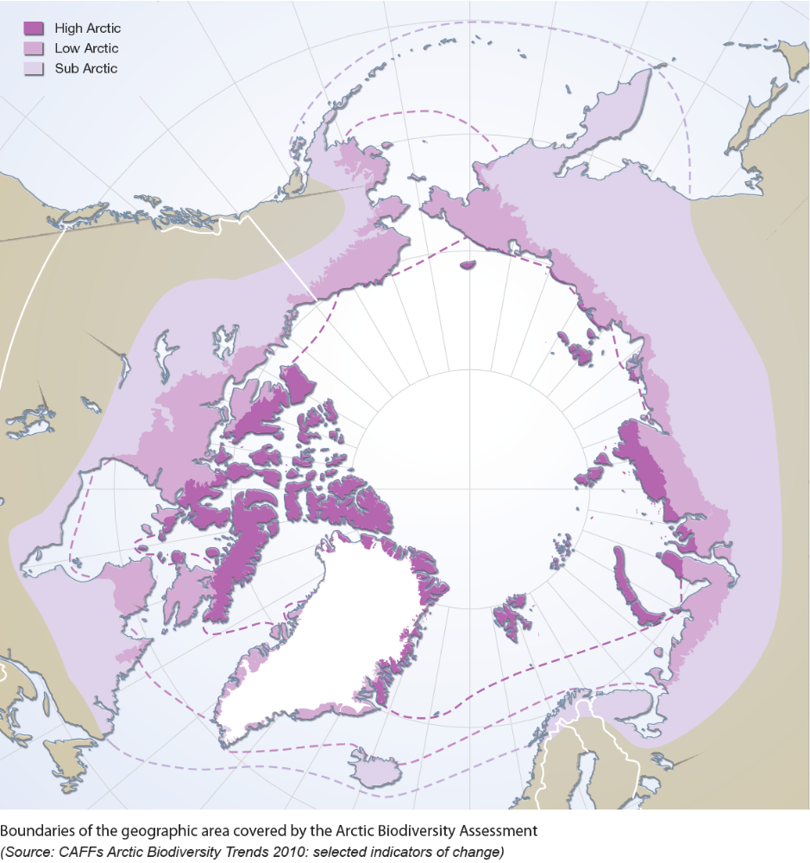
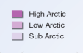
Figure 2.1. Boundaries of the geographic area covered by the Arctic Biodiversity Assessment and the terrestrial CBMP, defined by the division between High Arctic, Low Arctic and Subarctic according to the Circumpolar Arctic Vegetation Map (CAVM Team, 2003). Mostly the Arctic proper is covered in the CBMP-Terrestrial Plan, but with the inclusion of Eurasia, alpine regions in close proximity or with ecological linkages to the Arctic proper, Subarctic regions are included also. The Subarctic includes regions north of treeline (and may extend further south in some cases and may not be shown in detail on map as included areas). Map from: .

3 Monitoring Approach, Objectives and Methods

3.1 Overall Monitoring Approach

The CBMP TEMG will pursue a terrestrial biodiversity monitoring program following an ecosystem-based approach, which generates a comprehensive, system-based understanding to better inform decision-making related to the conservation and management of critical Arctic terrestrial biodiversity. Indicators, or Focal Ecosystem Components (FECs), which are made up of key biodiversity elements (and related composition, structure, and function elements), captured via multiple interacting parameters at various scales will be identified and integrated (via harmonization) to describe and report assessments of biodiversity and ecosystem status and trends and to diagnose potential drivers, processes at play, and implications of those trends.
The CBMP-Terrestrial Plan is focused on Arctic terrestrial biodiversity elements status and trends, but also on the ability to predict future potential changes in these elements and to facilitate the identification of the causal mechanisms driving these trends. A solid conceptual understanding of Arctic ecosystems, and clearly-articulated monitoring questions (see section 3.2 and Chapter 4), are essential to shape the selection and assessment of FECs and their associated attributes and parameters. Monitoring to address the priority questions (See 3.2) identified within the CBMP-Terrestrial Plan initially builds extensively from existing monitoring networks and local capacity to maximize the efficiency and likelihood of success. However, while much can be accomplished through existing networks and monitoring efforts, the CBMP-Terrestrial Plan also identifies monitoring needs which cannot be addressed through current capacities or existing efforts. Existing and new monitoring initiatives and partners will be considered at different spatial scales (from plots to landscapes, and from species to communities and/or populations) and temporal scales (from years to decades) and integrated through modeling. Figure 3.1 illustrates the overall conceptualization of the global TEMG monitoring and data harmonization scheme.
The CBMP TEMG is pursuing a balance of both (1) targeted, question-oriented, research-based monitoring and (2) survey-based, or surveillance, monitoring . Surveillance monitoring commonly focuses on a broad suite of ecological indicators to identify impacts of multiple drivers across a range of possible biological endpoints and ecosystem functions. Because surveillance monitoring is commonly applied at a broad scale and across multiple indicators, it is more likely to remain relevant over the long-term as ecological stresses arise and evolve and as drivers are impacted by climate change. Surveillance monitoring best supports general status and trend estimations and will likely not address why a change is occurring, although qualitatively derived cause/effect relationships may be hypothesized based on conceptual model formulation (and form the basis for future research needs). Surveillance monitoring, which includes traditional knowledge (TK) methodologies also, recognizes anomalies and is hypothesis-seeking (descriptive and exploratory, when patterns are first observed) rather than hypothesis-driven (experimental and systematically designed studies; pre-planned) . Question-oriented monitoring, on the other hand, targets specific indicators and their drivers, and is designed to address a specific set of hypotheses, usually at a finer scale of assessment than surveillance monitoring, to quantitatively build a mechanistic understanding of cause/effect relationships . A challenge for the CBMP-Terrestrial Plan is to develop a harmonization/analytical process that will allow for the integration of both survey and question-based monitoring to meet Arctic terrestrial biodiversity monitoring goals.
The CBMP-Terrestrial Plan development follows steps required to establish an effective, efficient, adaptive monitoring program . The key activities are outlined in Table 3.1.
Table 3.1. Key activities of the CBMP-Terrestrial Plan development processes, timelines, and chapter references.
Activity | When completed | Plan reference
Clearly define monitoring goals and objectives. | TEMG Workshop 1, 2, & 3 | Chapter 4
Compile and summarize existing information (TEMG Monitoring inventory) | Background Paper; on-going | Appendix
Develop conceptual models to elucidate and communicate understanding and interrelationships of key ecological components and interactions | TEMG Workshop 1 & 2 | Chapter 4
Identify and select indicators meaningful to management objectives and ecosystem priorities | TEMG Workshop 1 & 2 | Chapter 4
Identify and select monitoring parameters, methods, and develop overall sampling design | TEMG Workshop 2 & 3 | Chapter 4
Establish data management, analysis and reporting procedures | CBMP Data Management Strategy | Chapter 6, 7
Field test; analyze data | Implementation | Chapter 6, 8
Modify and adapt as required | Implementation | Chapter 6, 8

3.2 Central Questions to be addressed in the Monitoring

The CBMP-Terrestrial Plan aims to address the following overarching key monitoring questions:
- What are the status, distribution, and conditions (including thresholds of concern) of terrestrial focal species, populations, communities, and landscapes/ecosystems and key processes/functions occurring in the Arctic?
- How and where are these terrestrial focal species, populations, communities, and landscapes/ecosystems and key processes/functions changing?
- What and how are the primary environmental and anthropogenic drivers influencing changes in biodiversity and ecosystem function?
- Where are the areas of high ecological importance including, for example, resilient and vulnerable areas (related to the focal ecosystem components) and where are drivers having the greatest impact?

3.3 Scale of Monitoring and Reporting
Biological diversity operates at different scales and is generally understood to include species diversity, genetic diversity and ecosystem diversity (see Chapter 1). Correspondingly, the CBMP Terrestrial Plan aims to measure and report changes in biodiversity, as well as relevant structures, processes, and functions affecting diversity, at scales from local to landscape, to regions, and the circumpolar Arctic, as appropriate and feasible. Data collection and analytical methods and reporting will be multi-scale and will include plot-based ground measures, remotely-sensed products, and sampling of species, populations, and communities. At the local (plot or site) scale, data will be collected on individual species, life forms, or functional guilds as appropriate; at landscape scales, the composition, structure and diversity of populations, communities, or ecosystems will be measured; and finally, at the regional or pan-Arctic scale, measures will focus on landscapes and/or regions and relevant features therein.
Methods that detect change at scales from local to landscape and provide complementary information are essential. The various approaches can be designed as layers and combined during data collection, analysis, and/or reporting. Multi-scale integration between and among the monitoring efforts will increase the probability of detecting change, will support up- and down-scaling of identified effects, and will hence create a more effective monitoring scheme.
Monitoring Arctic biodiversity with ground-based sampling and a number of remote sensing platforms in an integrated manner offers an opportunity to complete a pan-Arctic assessment for a number of priority focal ecosystem components. Ground-based monitoring data will be used to derive local estimates of status, trend, and condition where robust data exist. These ground data can also be used to validate remote sensing products where applicable, which can then be used to extrapolate ground-based resource estimates to broader areas (especially for vegetation characteristics) which are logistically or financial difficult to access or completely inaccessible. Combining ground sampling with remote sensing observations will provide a regional context for detailed ground measurements. Fine spatial resolution remote sensing data and ground sampling can also be combined to better interpret coarse resolution (1km) satellite data so that pan-Arctic classifications are possible.
CBMP TEMG aims to identify and assess trends at the appropriate scale relative to the monitoring question, but attention will be given to scales from landscape to pan-Arctic, versus site-specific reporting (see Chapter 7).

3.4 Data and Modeling

3.4.1 Standardization and harmonization of protocols and data

The TEMG supports standardization of biodiversity monitoring methods, where appropriate (e.g., for new measures and for existing measures that are already close to standardized in their application). The adoption of robust monitoring protocols will ensure the validity and consistency of the data and demonstrate to end users that results are reliable. In some cases, however, the opportunity to standardize monitoring protocols will be limited due to natural heterogeneity of desired monitored parameters among regions or the existence of long-term data sets following differing protocols. In such cases where standardization is not possible or practical, harmonization of monitoring methodologies will facilitate integration and assessment of data across regions and scales. The TEMG also supports standardization of taxonomy and robust synonymy.

3.4.2 Modeling

Modeling will be used, where possible, to integrate and upscale/downscale identified trends. By combining local information, including traditional knowledge, on changes in biodiversity indicators and abiotic drivers with the geographic extrapolation abilities of remote sensing, modeling will serve to extend local results to broad areas of the circumpolar Arctic where direct monitoring information is lacking. Models are also useful to predict and test potential future scenarios and will further elucidate possible changes and inform proactive adaptive management.

3.5 Key Concepts of the CBMP-Terrestrial Plan

3.5.1 Monitoring supported by conceptual models

An integrated monitoring approach needs to reach across programs, jurisdictions, stakeholders, and agencies to manage for ecosystem sustainability. One way to achieve this goal is to identify both essential management questions, and key ecosystem elements (i.e. focal ecosystem components, FECs) and associated attributes and drivers, leading to the selection of priority monitoring parameters and methods. Of primary importance is that final parameter selection is based on key ecological functions or essential species demonstrated within common, accepted conceptual ecological models.

A conceptual model represents a working hypothesis about key system relationships, functions and organization . Developing a monitoring program based on a structured, discussed (amongst multiple experts and/or stakeholders), and well thought-out ecosystem-based conceptual model approach can generate a comprehensive, system-based understanding that provides the foundation to identify and assess a suite of key biodiversity elements and related, priority ecosystem components, structure, functions, and processes . Conceptual ecological models for the Arctic based on science and other expert input, are tools that can provide a “common language” that addresses to elucidate and communicate the critical components and processes of ecosystem sustainability within and across resource disciplines. Conceptual models allow for the identification and selection of priority monitoring elements that will meaningfully describe the status of many parts of the ecosystem with the least effort possible. This is especially critical when monitoring remote, difficult to access locations like much of the Arctic, where a program cannot monitor everything, everywhere, and all of the time. Once established and fully vetted, the conceptual models provide a basis for resource-use decisions predicated on maintaining or restoring ecosystem capacities through monitoring FECs, and functions, processes, and their associated attributes and parameters.

Resource scientists/specialists commonly will be able to employ expert knowledge to determine the most critical components and processes essential to their field of study, which was also true for members of the TEMG. The CBMP TEMG used both ecological theory based in conceptual models (section 3.5.3 and Chapter 4) as well as needs of management, industry, and communities (Chapter 4) to identify and rank the parameters and indicators of the focal ecosystem component in the CBMP-Terrestrial Plan.

3.5.2 Linkage to system drivers

Increasing cumulative pressures induced by, for instance, climate change and human activities are contributing to rapid changes in natural ecosystems in the Arctic and elsewhere. Hence, it is necessary to identify natural and anthropogenic drivers in the terrestrial monitoring program. An appropriate balance between monitoring of ecosystem FECs and system drivers must be developed to not only document change, but also to establish the causal relationships between changes in biodiversity and these pressures.
Understanding linkages between the drivers (non-biological as well biological) of the system and the potential FECs is critical to development of a successful, efficient monitoring program. Differential driver impacts, or strength of impacts, have direct relevance on what to monitor, where to monitor, and how often to monitor. Understanding what biodiversity elements are likely to be affected by a given drivers(s), may prioritize the element or driver(s) for monitoring. Understanding where priority elements exist (geographically), or which potential sampling strata are likely to be influenced first (or most heavily) by any given driver(s), may prioritize the sampling strata driver(s) for monitoring, or call for an intensive or extensive sampling approach to best understand the effects. Similarly, understanding that any driver may influence an element or location first or more heavily (compared to other elements or locations), may prioritize this element for more frequent monitoring compared to other elements that are likely to change more slowly through time. For these reasons, the CBMP TEMG clearly identified the drivers in the development of a global conceptual model (Fig 3.2; Table3.2) and biotic models (Chapter 4). Table 3.2 below illustrates the high priority drivers identified and how they will be monitored through the CBMP-Terrestrial Plan.

3.5.3 The CBMP TEMG Conceptual Model

Consensus opinion amongst TEMG members and associated experts was used to create a comprehensive conceptual model of the entire ecosystem, including key relationships and drivers affecting the ecosystem (Figure 3.2). Furthermore, ecosystem-based conceptual models for the broad focal ecosystem components (i.e., birds, mammals, vegetation, and invertebrates) at the broadest thematic scale (see Chapter 4) were developed by consensus at two expert workshops. The conceptual models integrate both key biological (biotic) and non-biological (abiotic) drivers affecting diversity as well as ecosystem function characteristics.
The conceptual models are generic enough to be applied across the entire Arctic landscape through a process of localization, where the general conceptual model is adapted to the local food web structure, local drivers, and other relevant local phenomena (see Case studies in Chapter 4; e.g. Box 4A-D).

Table 3.2. Monitoring high priority drivers as outlined in the CBMP-Terrestrial Plan and recommended additional drivers for monitoring as capacity permits (or where data exist from other networks).

TYPE OF DRIVER | HOW DRIVER WILL BE MONITORED
ABIOTIC DRIVERS (may be influenced by anthropogenic influences)
· Climate: Length of growing season | Phenology monitoring: (Chapter 4: vegetation)
· Climate: temperature air and soil | Collection of site data (Chapter 4); linkage with other networks
· Climate: precipitation (rain/snow, snow cover duration and extent; icing events) | Collection of site data (Chapter 4); remote sensing; linkage with other networks
· Site characteristics (soils, permafrost, soil moisture, topography) | Collection of site data (Chapter 4); remote sensing; linkage with other networks
· Hydrology | Collection of site data (Chapter 4); remote sensing; linkage with Freshwater plan
Other recommended abiotic drivers: cloud cover, solar radiation, treelines, storms, wind.
Climate change (rates of change) can be monitored indirectly from climate data
BIOTIC DRIVERS (may be influenced by abiotic and anthropogenic drivers)
· Competition from southern species and other interspecies processes | Species/community monitoring (Chapter 4)
· Invasive and non-native species | Species/community monitoring (Chapter 4)
· Shrubification | Species/community monitoring (Chapter 4)
· Grazing/foraging | Species/community monitoring (Chapter 4)
· Pollination | Species/community monitoring (Chapter 4: arthropods)
· Pathogens and parasites | Species/community monitoring (Chapter 4: mammals, birds)
· Habitat quality (connectivity, natural disturbance, nesting/breeding habitat, water resources) | Collection of site data and species/community monitoring(Chapter 4); remote sensing; for water resources see CBMP - Freshwater Plan
Other recommended biotic drivers: health of soil biota (rates of nutrient cycling, decomposition); drivers as required for species of special interest (e.g. affecting reproductive effort, rates of herbivory, etc.).
Changing species distributions due to climate change can be monitored indirectly through data-collection on species diversity, abundance and other from ecological data as above (and see Chapter 4)
ANTHROPOGENIC DRIVERS
· Harvesting, hunting, trapping, fishing (fish prey important for terrestrial species) | TK, CBM, data available from other networks (e.g. governments, migratory bird data from other regions, etc.)
· Anthropogenic disturbance (noise, trampling, increased visitors and traffic) | Land use monitoring (Chapter 4: vegetation); remote sensing; collection of site data; data from other networks
· Land use and habitat conversion within Arctic (including fragmentation, infrastructure, resource extraction, roads) | Land use monitoring (Chapter 4: vegetation) ; other drivers outside study scope: remote sensing; collection of site data; data from other networks
· Habitat conversion outside Arctic | Outside study scope; linkage with other networks
· Contaminants and pollution | Outside study scope; other networks (e.g. AMAP)
Other recommended anthropogenic drivers: Nutrification and enrichment (chemical analyses; vegetation C stock; CANTTEX manual); domestication; tourism (disturbance; non-native species movement)

3.5.4 Identification of Focal Ecosystem Components, Attributes and Parameters

The list of potential FECs was generated based on a combination of the conceptual models and management and community needs. During the first expert workshop, TEMG teams developed base conceptual models for each biotic group. In addition, TEMG teams identified key audiences for Arctic terrestrial biodiversity monitoring information, including resource managers and community members, and their needs for biodiversity information to answer key questions and manage/adapt to the environment. During the second expert workshop, these models and biodiversity information needs were refined and tables generated to identify (in list form) potential Focal Ecosystem Components (FECs). To each FEC a number of describing attributes were assigned, and to each attribute a number of parameters and attributes were assigned (e.g. Figure 3.3).
A process based on expert-opinion was then completed to rank and prioritize potential monitoring FECs and their attributes. Rankings were based on a simple sum of scores for several factors, including:
- Ecological Relevance
- Relevance to ecosystem services
- Relevance to Arctic Peoples
- Relevance to management and legislation
Highly-ranked FECs (greater than 75% of the potential score) plus several additional FECs, based on agreed management and/or community needs, were carried forward as priorities for the CBMP-Terrestrial Plan. Expert teams identified parameters to be measured in the field related to each identified attribute. At a minimum, the parameters were SMART (specific, measurable, achievable, results oriented and temporally defined). In addition, the following additional criteria refined the parameter selection:

- sensitivity to natural or anthropogenic drivers;
- relevance to Traditional Ecological Knowledge-based management
- validity;
- ecological relevance;
- availability and sustainability of monitoring capacity and expertise;
- relevance to targets and thresholds; and
- practicality.

A multi-scale sample and reporting design for the priority FECs, attributes and parameters was developed (see Chapter 4). The CBMP-Terrestrial Plan affords flexibility in the selection of locally relevant focal ecosystem components which best typify biodiversity and ecosystem integrity by focusing on functional ecosystem components, rather than specific species, as appropriate. In this manner, the plan aims to balance the need for standardized data collection for assessment and reporting with requirements for the adoption and use of locally relevant indicators.

3.6 Establishing Reference (Baseline) Conditions

Points of reference against which the status of populations, species, or ecosystems can be compared are required to assess change (and condition) in a meaningful way. Baselines provide a starting point for analysis of change . The baselines for trend analysis are parameter-specific.
Nielsen et al. identify four potential sources for establishing baselines or reference points: (1) protected areas or other spatial benchmarks (i.e., comparisons of areas unaffected by a given driver, such as a control site, to areas affected by the driver); (2) time-zero (arbitrary date or level); (3) desired goals or targets (management goals); and (4) modeled reference conditions using empirical estimates. Baselines may also be strengthened by incorporating knowledge from TK holders. For example, audio recordings from traditional knowledge holders, which describe changes over a period of time, can be a useful source of information for time-zero analysis. Other data sources include natural archives from pollen records and genetic material in sediment, and historical museum records and early published data and reports can also provide information to help develop baselines for time-zero analysis.
The Arctic is impacted by some drivers affecting the entire region including climate change and contaminants, for which a spatial baseline or “control” cannot be fully derived. Other drivers, such as anthropogenic footprint, are spatially differentiated so that spatial benchmarks can be used to assess changes between impacted and non-impacted sites.
In the absence of global management goals or targets for Arctic biodiversity, focal ecosystem attributes, and detailed empirical data on historical biodiversity trends from which modeled reference conditions could be derived, the CBMP TEMG is recommending baseline conditions be established using a combination of (1) current and historical data for analysis over time and (2) spatial benchmarks, as appropriate for a given attribute. Protected areas and appropriately situated field stations conducting integrative monitoring (e.g. SCANNET/INTERACT sites) could act as suitable spatial reference sites. The TEMG recommends seeking out and integrating the best available historical and current data as the basis for reporting indicator changes, and hence, changes in biodiversity and ecosystem integrity into the future (see Chapter 6 for more information).

3.7 Establishing Thresholds of Concern

In order to establish ecological relevant thresholds of concern, one must understand how resilient a system is and where the system’s ecological tipping points reside. Ecological tipping points are locations along a gradient of change where a small change in external conditions can result in a drastic change in the structure and composition of a system . Such changes are often abrupt and may be irreversible. In some cases, multiple stable steady states exist and systems may fluctuate between the two states without loss in ecosystem function. Changes between states may be driven by both anthropogenic and natural disturbance . Change in ecosystems is natural, but the pace, magnitude and cumulative impact of biodiversity drivers may push ecosystems beyond normal system variation.
Tipping points are scale-dependent. For example, the minimum number of individuals to maintain a viable population of a particular species is a biological tipping point. It is possible that a species could go locally or regionally extinct, without loss of overall ecosystem function and structure, if other species can perform a similar function or if other system compensation mechanisms exist. In the Arctic, there is little functional redundancy in avian and mammalian biota, so the likelihood of other species assuming similar functional roles of a vulnerable species is reduced. This may render Arctic systems more vulnerable to drastic ecosystem shifts.
Tipping points are difficult to identify, because ecological relationships are often non-linear and characterized by uncertainty. Some Arctic vegetation communities, for example, are resistant to change and it may not be possible to detect ecosystem level responses until after a threshold is crossed . An additional complication for determining tipping points is that many populations of species and species relationships follow a cyclical pattern of depending on, for example, interactions of weather factors, the abundance of the forage available, and the density of predator species (e.g. lemmings). Establishing the natural range of variation for ecosystems, their communities, and other key components is essential to identify and understand biologically relevant tipping points, and subsequently, to derive biologically relevant thresholds of management concern. Determining natural range of variation necessarily involves analysis of long-term information.
Thresholds can also be assigned based on management goals or targets. These targets may be made based on best available scientific knowledge for the appropriate management of a given ecosystem, as well as the values and trade-offs considered by ecosystem managers and society. Common goals and targets for Arctic biodiversity have not yet been well-defined.
The CBMP TEMG implementation plan will strive to understand the normal range of variation for each FEC-attribute parameter. For some parameters, sufficient information may already exist, while for others, establishing this variation will necessarily involve collection of data over a period of years, particularly through focused monitoring at the integrative research monitoring sites (see Chapter 4). Where biological thresholds are unknown, statistical thresholds may be identified as interim thresholds until sufficient data is collected to understand variability. Ecosystems are subject to a range of local pressures and drivers which may have a cumulative impact on biologically identified thresholds. A clear understanding of the range of historical variation will allow managers to identify, as best as possible, biological and ecological thresholds in their particular context and assist Arctic managers and communities with evidence-based decision-making.

3.8 Linkages between the CBMP-Terrestrial Plan and the CBMP Indices and Indicators

The CBMP has developed a suite of overarching indicators and indices characterizing Arctic ecosystems . The CBMP-Terrestrial Plan has tight linkages to the CBMP indicators and indices, and hence also to indicators outlined in the Convention on Biological Diversity (CBD) (Table 3.3).
Table 3.3. Linkages between the CBMP indicators and indices, and the CBMP-Terrestrial Plan and the CBD indicators. A “√” means that the indicator is supported, while an “X” means that the indicator is not supported by the CBMP-Terrestrial Plan.
CBMP biodiversity indices and indicators | Linkage to CBMP TEMG biodiversity indicators | Linkage to CBD indicators
Species composition
Arctic Species Trend Index | √ | √
Trends in indicators of Focal ecosystem Components | √ | √
Trends in abundance of Focal ecosystem Components | √ | √
Arctic Red List Index | √ | √
Change in Status of threatened Species | √ | √
Trends in Total Species Listed at Risk | √ | √
Ecosystem structure
Arctic Trophic Level Index | √ | √
Habitat extent and Change in Quality
Arctic Land Cover Change Index | √ | √
Trends in Extent Biomes, Habitats and Ecosystems | √ | √
Arctic Habitat Fragmentation Index | √ | √
Trends in Patch Size Distribution of Habitats | √ | √
Ecosystem Function and Services
Trends in Extent, Frequency, Intensity and Distribution of Natural Disturbances | √ | √
Trends in Phenology | √ | X
Trends in Decomposition Rates | X | X
Human-health and Well-being
Arctic Human Well-being Index | X | X
Trends in Availability of Biodiversity of Traditional Food and Medicine | √ | √
Trends in Use of Traditional Knowledge in Research, Monitoring and Management | √ | √
Trends in Incidence of Pathogens and Parasites in Wildlife | √ | √

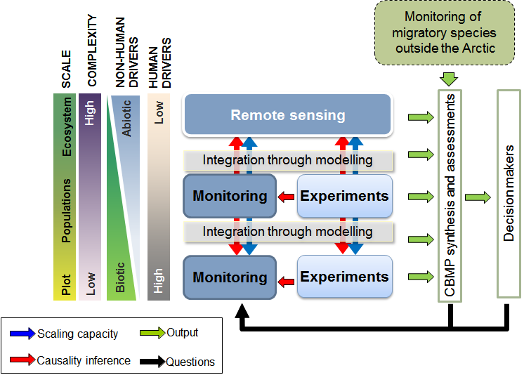
Figure 3.1. Conceptual visualisation of the TEMG monitoring scheme. Monitoring efforts at the various levels (unbroken frames) are integrated through modeling (blue arrows), and complemented with experimental research and monitoring efforts conducted outside the TEMG monitoring scheme. Causal linkages (red arrows) can be established through experimental work, and on the larger scale inferred from detailed data on the smaller scale. Monitoring outputs (green arrows) can be extracted on all levels, and feed into the assessment and decision-making processes, ultimately also feeding back into the TEMG monitoring scheme (black arrows).

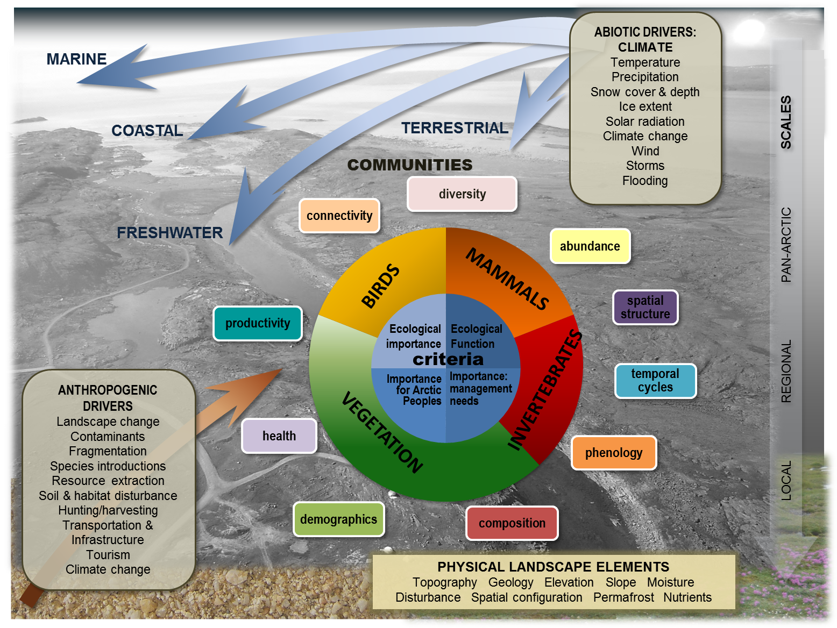

Figure 3.2. Overall conceptual model of the terrestrial biota showing the various compartments and their primary interactions.
FOCAL
ECOSYSTEM
COMPONENT
ATTRIBUTE
PARAMETER
Abundance
Spatial use
Demographics
Health
Genetics
Number
Density
Distribution of migratory herds
Sex and age structure
Mortality
Disease prevalence
Body fat
Heterozygosity
Large
herbivores

Figure 3.3. The nested structure of the TEMG monitoring scheme, here exemplified by a large herbivore.

4 Sampling Design

4.1 Sampling Design Overview

4.1.1 Introduction to CBMP-Terrestrial Plan sampling design

The sampling domain for developing a cost effective experimental design for the CBMP-Terrestrial Plan includes all of the area covered by the CAVM Team map (Figure 2.1) as described in Chapters 1 and 2. Across the vast CAVM area, tundra ecosystems change locally (with topography, soil conditions, disturbance history, and local-scale, abiotic driving processes such as riverine or estuarine flooding and slope seepage, ground ice processes, and snow effects), across watersheds and landscapes (with aspect, elevation, exposure, snow phenology, distribution, condition and depth, hydrology, mineralogy of bedrock and soil parent material), and across the circumpolar Arctic where vegetation physiognomy (low shrub, dwarf shrub, herb) changes along climatically-defined bioclimatic zones (south to north, east to west, and with elevation). Other factors that impact tundra vegetation composition, structure and productivity include biogeographic histories, dominant bedrock, and unique interactions with drivers such as rates and kinds of herbivory, pests and diseases, and various anthropogenic effects.
Capturing all of this variability in a randomized experimental design in an attempt to answer the questions outlined in Chapter 3 is clearly impossible given the vast areas under consideration, poor access, and limited resources. The TEMG conducted an inventory of long-term Arctic terrestrial biodiversity monitoring assessment to understand current monitoring capacity. As a matter of practicality, we have designed the sampling for the CBMP-Terrestrial Plan to take advantage of available resources (existing research stations, mandated and regulatory monitoring conducted by many government agencies and industry, community monitoring), and to reach out more broadly through modeling and remote sensing techniques to achieve some degree of randomization of reported results. Using this approach, the aim is to report valid and defensible assessments of terrestrial ecosystem change in the circumpolar Arctic, by implementing a practical and sustainable system that optimizes the use of all available resources and builds toward future harmonization of data collection.
The approach taken within the TEMG is ecosystemic at a range of scales from local to circumpolar (Figure 4.1). To this end, question-based monitoring conducted at research stations will anchor the program, and will be designed to link measured changes in FECs, attributes, parameters and indicators to measured changes in ecosystem drivers and processes to establish causal relationships for the changes observed. Such long term installations can also be used to integrate the key components of the CBMP-Terrestrial Plan (vegetation, mammals, birds, and arthropods) and to draw functional connections among these components and the physical environment by, as much as possible, co-locating monitoring measurements of all components at integrated, long term monitoring sites. These local scale results at research stations can be combined with broader scale monitoring (wide-ranging mammals, migratory birds and remote sensing) to develop a coherent picture of Arctic biodiversity change, and an understanding of the reasons for the changes reported (e.g. the presence of drivers including climate change, sifts in species ranges including changes in pathogens and more southern species, land use changes, and others).

4.1.2 Interpreting the sampling design tables

Although there is a clear need to integrate monitoring across terrestrial components, this chapter lists specific monitoring questions and sample design issues for each of the four main components of the CBMP-Terrestrial Plan – tundra vegetation, mammals, birds and arthropods. For each component, we recommend a series of essential and recommended attributes that should be monitored to contribute to the program. Essential attributes are those components of the FECs that we recommend should be measured at any given monitoring location to capture a minimum set of biodiversity information relative to the focal ecosystem component under study. Recommended attributes may be measured at some sites with additional capacity and intensity of design in order to provide more comprehensive information on the nature of the observed changes and to better understand processes driving biological change. We also distinguish between basic and advanced protocols – where basic protocols are simple methods that could be used by sites with minimum monitoring capacity to provide scientifically robust results, and advanced protocols are those that require a higher level of scientific expertise and oversight for proper application.
Some additional methods have generally insufficient power to provide scientifically robust answers to management question, due to low accuracy, biases, or lack of systematic sampling. However, they can provide useful supporting information to conclusions based on data derived using basic and advanced methods. Simplified methods will be common in opportunistic data collection, TK data, community based monitoring, short-term surveys and check-list based surveys. In some cases, opportunistic data collection may be outside the scope of the CBMP-Terrestrial Plan, but may provide valuable information where knowledge gaps exist, or where future monitoring is required. For example, monitoring immigrating non-native species at initial low densities may be effort-intensive, but opportunistic data collection within or just beyond Arctic boundaries may be helpful in identifying sites that may be affected or at greater risk in the near future.

4.1.3 Sampling Metadata

Metadata collected at the site should be consistent with metadata collection standards. Along with the target data suggested in the tables in Chapter 4 and the site establishment metadata, this metadata should be recorded with each monitoring event.
- Date of monitoring event
- Location name
- Name(s) of monitors
- Experience/capacity of monitors and impact on data quality (e.g. taxonomic expertise)
- Time of day
- Weather
Description of the handling, sharing and archiving of data and metadata is described in Chapter 5.

4.2 Vegetation

The vegetation component of the CBMP-Terrestrial Plan has, as a fundamental goal, to monitor and report on important changes in Arctic/tundra vegetation. Vegetation is essential to the terrestrial component of tundra ecosystems in that it forms the habitat structures and resources that support the other elements of tundra ecosystems considered under the CBMP-Terrestrial Plan – namely mammals, birds and arthropods. In turn, the composition, structure and composition of the tundra vegetation that makes up these habitat attributes is largely determined by the direct and indirect influences of key biotic and abiotic drivers. From a monitoring design perspective then, question-based monitoring at long term sites should be established to enable spatial and temporal integration of monitoring results so that causative relationships among abiotic and biotic components can be established, measured and reported. These relationships may also help inform changes reported from other types of mammal, bird and arthropod monitoring.

4.2.1 Vegetation sampling approach and design issues
4.2.1.1 Vegetation monitoring questions
Development of the CBMP-Terrestrial Plan is guided by the broad set of priority management questions/issues presented in Chapter 3, and a conceptual understanding of key vegetation attributes (Figure 4.1) including specific examples of vegetation composition, structure, function, and drivers which were selected through an ecosystem-based conceptual modeling process. Priority vegetation-based monitoring questions that guided the vegetation monitoring scheme are:
- How are the diversity, abundance, productivity, composition, location and pattern of vegetation species and communities changing across the circumpolar Arctic? Specifically;
  - How is vegetation changing along major physiognomic ecotones, e.g., treeline, shrubline?
  - How and where are the productivity, local abundance, and distribution of Arctic shrubs changing, and how is this affecting ecosystem function and biodiversity?

- How are important foods and forage vegetation species/communities changing?
  - How is quality and availability of forage changing in key areas?
  - How are plant-based subsistence foods changing?

- Where are the locations of high native plant species richness and other important habitats and how are these changing?
  - What is the pattern of native plant species richness across the landscape?
  - How are the composition, structure, distribution and extent of landscapes changing?

- Where and how abundant are non-native plant species on the landscape and how are they changing?

- How are the distribution, status and extent of plant species of conservation concern changing?
  - How is plant productivity changing across the Arctic? Are there hot spots of plant productivity?

- How is vegetation phenology changing across the Arctic?

- How are soil fungal (mycorrhiza and decomposers) composition and relative abundance changing and what is the impact on soil ecosystem function, structure and stability?

4.2.1.2 Vegetation Conceptual Model in relation to monitoring
The vegetation conceptual model (Fig 4.1) was developed by the vegetation expert teams as described in Chapter 3. The model illustrates the scaled conceptualization of vegetation biodiversity from species and life form diversity operating at local scales, to changes in communities and focal species operating at landscape scales, to changes in vegetation types or landscapes operating at regional scales, to changes in regions operating at the scale of the entire Arctic.
4.2.1.3 Potential contributors to the vegetation monitoring scheme
A partial list of stations, networks and monitoring groups that could contribute to the CBMP-Terrestrial Plan vegetation component includes:
- the network of Arctic field stations (SCANNET/INTERACT) and other seasonal or permanently manned research and monitoring installations;
- the International Tundra and Taiga Experiment (ITEX) network;
- industry/agency local and regional cumulative effects monitoring associated with resource development;
- national parks and other protected areas;
- PPS Arctic network;
- on-going vegetation research and monitoring conducted by governments, academia, non-governmental organizations, and community groups;
- historical vegetation research, monitoring or inventory sites and data;
- other on-going research and monitoring where vegetation monitoring could be co-located, and;
- Arctic community members, including TK holders, who could contribute to existing or new community-based monitoring schemes;
These sources represent a wide variety of potentially-useful monitoring information that ranges from repeated, protocol-based monitoring, to station-based research and monitoring, to industry and community monitoring. It will be a major challenge to organize all of this potential information to create a coherent and repeatable assessment of Arctic vegetation change.
4.2.1.4 Vegetation design principles and components
The CBMP-Terrestrial Plan will utilize an initial stratification of the circumpolar Arctic into the high-Arctic, low-Arctic, and alpine areas of the Subarctic (see Definitions). Vegetation based sampling, analyses, and reporting will be stratified by Bioclimatic Subzones as delineated by the Circumpolar Arctic Vegetation Map (CAVM; Figure 2.1).
The CBMP-Terrestrial Plan will maximize the use of existing monitoring investments through efficient, effective designs integrated across multiple scales by applying the following approaches:
- establish intensive monitoring of both essential and recommended field monitoring attributes at a core network of long-term, integrated monitoring sites including both basic and advanced protocols;
- for the essential attributes, establish a core set of basic field monitoring protocols to be implemented as broadly as possible through engagement and collaboration with the monitoring schemes listed above
- conduct spatial up-scaling from local to broader geographic scales through (a) modeling, and (b) integration of field or high resolution spatial data with broader scale, coarser-resolution remote sensing.

- Ground-based (or remote-sensing), question/cause-and-effect, intensive sampling
What: The CBMP-Terrestrial Plan recommends intensive monitoring of both essential and recommended attributes at a core network of long-term, integrated monitoring stations and other sites as capacity allows. Monitoring will include both the core set of basic parameters as well advanced parameters that can help to elucidate cause and effect relationships. Ideally there should be a minimum of three intensive monitoring stations within each CAVM bioclimatic subzone (Fig. 2.1) to allow for spatial variability in tundra change. Monitoring study design should include the range of tundra ecosystems, and be statistically valid with sufficient power at the site level. The design should include, for example, stratified, randomly placed long-term plots and transects as capacity allows. It is understood that all ground stations will not meet these specifications through current monitoring although some will, and these can stand as a reference sites as monitoring capacity expands (see Box 4A), and as existing stations re-implement their monitoring programs. Monitoring related to other terrestrial biotic groups (mammals, birds, arthropods) as well as relevant abiotic factors/physical drivers necessary for improving understanding of processes driving biodiversity change should be conducted at these stations in an integrated fashion. The CBMP-Terrestrial Plan also recommends deploying high resolution, remote sensing tools to address detailed or targeted questions, where appropriate and required. Specific sampling parameters are listed in section 4.2. Intensive monitoring will serve many purposes including:
- understand cause-and-effect relationships and specific process-based monitoring questions
- training and validation of multi-scale remote sensing
- contribute to status and trend (surveillance), extensive sampling
- modeling observed changes and relationships from local to broader geographic scales
Who: Research facilities including participating INTERACT/SCANNET sites, ITEX sites, GLORIA sites, PPS sites, protected areas and other partners as capacity allows
Scale of analysis: local to watershed. Locally derived results can be extended to broader geographic regions through integration with remote sensing and with extensive monitoring (see Box 4A).
Where: An inventory showing the locations of potential contributors is shown in Figure A1.

- Ground-based, status and trend , extensive sampling
What: Extensive monitoring generally employs a less rigorous set of monitoring methods and sample sites are not organized to answer questions around key drivers and identifying the reasons for change in the FECs. Extensive sampling conducted by a range of collaborating partners greatly increases the geographic range over which the CBMP-Terrestrial Plan can detect changes. Extensive monitoring recommended by the CBMP-Terrestrial Plan includes:
  - Implementation of an essential set of basic monitoring attributes
  - Targeted sampling for rare and invasive species and vegetation phenology,
  - Use and expansion of community based monitoring networks (e.g., invasive species, phenology, red-listed species, and other targeted monitoring)
  - Validation of pan-Arctic remote sensing models
Specific sampling parameters are listed in section 4.2.
Who: Current and potential Arctic vegetation monitoring contributors including governments at various scales, industry partners, academia, protected area monitoring practitioners, and communities.
Scale of Analysis: Regional to Pan-Arctic.
Where: Use remote sensing to understand representativeness of all sample locations within each stratum. Compare these sites/facilities and their geographic and thematic distributions and propose new sample locations to fill critical gaps in relation to bioclimatic subzone/strata and national boundaries.
- Remote-sensing, mid- to low-resolution, status and trend extensive sampling
What: Monitoring Arctic vegetation with ground-based sampling and a number of remote sensing platforms collected at a variety of spatial (cm-km) and temporal scales (Figure A1) in an integrated manner offers an opportunity to expand the results of ground based sampling to the complete pan-Arctic area for a number of focal ecosystem attributes and related drivers. Using these data, functional relationships between abiotic drivers and biotic response measures developed at experimental sites can be extrapolated to broader areas using the range of available remote sensing platforms. Fine spatial resolution remote sensing data and ground sampling can also be combined to better interpret coarse resolution (1km) satellite data so that pan-Arctic classifications are possible. Remote sensing derived information on weather, climate, sea ice, and the coastal marine environment can also support terrestrial biodiversity monitoring modeling activities. Remote sensing technologies continue to rapidly evolve and the CBMP-Terrestrial Plan aims to take advantages of these emerging technologies when possible and where appropriate
Synoptic, time series mapping of measurable attributes and abiotic drivers will be used to understand both broad-scale cause and effect relationships and to detect general trends. We aim to collect boundary information (explanatory variables) to initialize models. As much as possible, the CBMP-Terrestrial Plan has recommended the use of free or nearly free imagery to facilitate sustainable remote sensing product creation. We recommend the use and development of Digital Elevation Models (DEMs) as critical to interpretation of remote sensing products and other data. The CBMP-Terrestrial Plan recommends taking advantage of evolving technologies in remote sensing through an adaptive approach. Specific sampling parameters are listed in section 4.2.
Who: Current and potential Arctic vegetation monitoring contributors with appropriate expertise. This may involve teams of sub-national, national and international remote sensing specialists working together to develop analyses that support different jurisdictions and taken together can represent the whole Arctic area.
Scale of Analysis: Regional to Pan-Arctic.
Where: Remote sensing approaches can be applied across the entire circumpolar Arctic, or sampled using stratified random approaches.
4.2.1.5 Existing capacity to deliver the CBMP-Terrestrial Plan
In addition to opportunities that may arise to conduct sampling and observations, collect data, and conduct monitoring as part of collaborations with international governments, academic institutions, museums and herbaria, Aboriginal partners, and Arctic communities, monitoring capacity already exists in the form of long-term programs, infrastructure, and international initiatives (see Appendix A: Metadata and Sampling Coverage Maps). The TEMG is compiling a database of facilities and long-term monitoring programs based out of all of nine circumpolar regions (Norway, Finland, Sweden, Russia, Iceland, Greenland and the Faroe Islands [Denmark], Canada and the United States [Alaska]), and including monitoring sites from more southern alpine regions in the Subarctic, to Svalbard and the High Arctic (Appendix A). The comprehensive database includes information on the type of program, location, and on the components that are monitored or the type of data that is collected (including contaminants, soils, fauna, flora, and data such as observations of components of importance to Arctic communities and traditional knowledge). The data will become part of the Polar Data Catalogue (http://www.polardata.ca/). Integrated monitoring as part of the CBMP-Terrestrial Plan can build on existing capacity as part of these programs.
Other types of contributions that can facilitate and complement long-term monitoring already exist through programs that use remote sensing (see Appendix B: What can we monitor with satellite data in the Arctic?). Data obtained through such programs can provide invaluable information on land cover, climate, and how the landscape is changing, and will be indispensable to complement and extend the coverage of data-collection through monitoring as proposed in the CBMP-Terrestrial Plan for vegetation and other biotic groups.

4.2.2 Sampling protocols
4.2.2.1 FECs, Essential Attributes, and Parameter summary
A summary list of FECs, essential and recommend attributes and monitoring parameters that were developed through the TEMG workshop process are listed in Tables 4.1 (Essential Attributes) and 4.2 (Recommended Attributes). Each FEC may have one or more attributes, and attributes may have a number of monitoring parameters. Both plot scale and remotely sensed parameters are listed. The tables also suggest a sampling methodology, classify the attribute as advanced or basic, and provide a temporal frequency for the sampling. The attributes listed in the tables are the heart of the CBMP-Terrestrial Plan, and their implementation according to the design principles outlined in this chapter would provide a comprehensive assessment of tundra vegetation change in a given sample area. The proposed protocols can be applied to answer a number of different monitoring questions, depending on the study design, yet generate standardized information that can be integrated at broader scales.

4.2.3 Site establishment data

The following plot level information should be collected when establishing a monitoring site (when relevant and where possible):
- Site latitude and longitude
- Description of topographic setting
- Elevation
- Aspect
- Slope angle at plot locations
- Local hydrology (proximity to streams, rivers, lakes and ocean)
- Soil parent material, slope, aspect
- Soil description including
  - Substrate lithology
  - Depth and homogeneity of soils across the study area
  - Soil total carbon and nitrogen content (if possible)
  - Patterned ground type
  - Soil class
- Depth of active layer
- Plot digital photographs should be taken at every plot, following standardized procedures
The following information landscape and regional-level information is required to effectively interpret biodiversity information. This information should be derived from existing or new remote sensing products.
- Hydrology
- Topography using Digital Elevation Models (DEMs)

4.2.4 Vegetation sample processing, archiving and DNA analysis

Plot photographs must be accurately labeled and archived so that plot data is associated with the photo. Where species identification is required, for example to complete a plot species list, identify an unknown species or document a rare plant species, standardized procedures should be followed.
Collection of representative plot vegetation species samples, also known as vouchers, when first establishing a plot is recommended where capacity to process and store the monitoring samples is available. When capacity is not available, collection of vouchers for unknown species is recommended to facilitate identification. At a minimum, high resolution digital photographs of the species in question should be taken. To preserve the integrity of the plot, voucher collection should occur outside the plot. . Careful study of specimens under a dissecting microscope is often required to properly identify an unknown plant species. To document a rare plant species, voucher specimen could be collected provided the local rare plant population has more than 100 individuals and the specimen will be donated to a Herbarium.. Plot establishment data should be shared and integrated into national and international efforts to establish an international database of vegetation plots to support research and decision-making, such as the International Arctic Vegetation Database .
Voucher sample collections should follow best practices and standardized procedures for collecting, pressing, rapidly drying, storage and shipping, identification, mounting and archiving. Voucher specimens should be deposited with an appropriate herbarium, such as at a museum or university, where it will be mounted and archived. For both specimen photographs and voucher samples, it is essential to ensure the specimen are appropriately labeled with key information which should include name of the plant, location of collection/monitoring event, habitat, associated species collector, collection number, collection date, and the name of the person who identified the plant. Specimen identification should be verified by an expert , as required. These records are then available for future reference or DNA analysis, as required. Standardized procedures for preparation of vegetation samples for DNA analysis are available . The samples can be integrated into international efforts to develop a DNA database for polar regions (International Barcode of Life Project, 2011).
Standardized taxonomies should be used for species identification. The TEMG recommends using the Annotated Checklist of the Panarctic Flora –Vascular Plants for describing taxonomies, in conjunction with available volumes of the Flora of North America series. A project is currently underway to develop a new Arctic Flora of Canada and Alaska , which will eventually serve as the standard reference for Arctic plant taxonomy in the region. The proposed CAFF Arctic Red List species could serve as the basis for identification of rare species . Further, the CAFF Flora Group has recommended development of a standardized set of protocols for monitoring Red Listed plants throughout the Arctic .

4.2.5 DNA analysis of fungi from soil samples at the vegetation plots

Collection of soil samples for DNA analysis is essential for tracking changes in soil fungal (mycorrhiza and decomposers) composition and relative abundance. Collection of the soil samples for DNA-analysis for fungi should be conducted at the same time as the vegetation is sampled. The analysis will identify and be used to assess the abundance of fungal taxa, hence also measure species richness and species composition. The functional properties of the fungi, hence effects on ecosystem processes, may be possible to infer from linking identified soil fungi to documented life-forms, such as different mycorrhizal forms, saprotrophytic and parasitic fungi . The sampling may be coordinated with the collection of soil cores taken for DNA-barcoding of soil animals (4.5.2 and 4.5.3). Sampling should follow best practice and standardized protocols for sampling, processing and analysis of fungal DNA, procedures that quickly are developed and improved . For each site, 10 soil cores are recommended to provide a measure of the more abundant species and their frequencies (each with 50 ml soil, minimum sampling is the A-horizon, preferably down to 5 cm) and directly in the field conserved by being put into 70% ethanol or CTAB, allowing for long-term storage without breakdown of DNA at storage above zero degrees, or if possible frozen . Fungal DNA-barcoding will be accomplished using high throughput sequencing approaches with fungal-specific rDNA primers . Even though environmental barcoding will not presently enable all taxa to be taxonomically identified, all distinguished DNA sequences, irrespective of whether they have been identified or not, will enable monitoring in space and time. Initially unidentified sequences can be grouped phylogenetically and will over time increasingly be identified. The analyzed samples should be integrated into international efforts to develop a DNA database for Polar Regions or used for other kinds of research.
BOX 4A. From Local Scale Monitoring to the Circumpolar Arctic – An Example for the Vegetation Biomass Indicator
A key premise of the CBMP-Terrestrial Plan design is that the results of local scale, question-based monitoring can be projected broadly across the Arctic, through the development of remote-sensing based models that extrapolate causative relationships derived locally to a wide area using a similar, driver-indicator relationship. Vegetation biomass is one attribute in the CBMP-Terrestrial Plan that may be increasing both locally , and across broad areas of the Arctic tundra . Vegetation biomass has also been used to predict the quality of habitat factors such as caribou forage during the post-calving period , and thus links to other CBMP-Terrestrial Plan components.
Vegetation biomass is measured in quadrats of known area, through destructive sampling of above- and below-ground plant components (species or species group), field-weighed to estimate total fresh weights of all components, and developing fresh weight-dry weight relationships from sub-samples dried in a field laboratory . Biomass can also be calculated based on community composition and height of representative plants. Sample sites are selected to be relatively uniform in vegetation composition and structure, and vegetation dry weight/m² is estimated. Sampling is repeated to account for spatial variability within a site, and estimates are linked to the imagery through regression analysis with the different radiometric bands and indices in the imagery, often scaling through high resolution to lower scales of resolution for broader coverage. Sampling is generally conducted across the range of tundra ecosystems (e.g., tall shrub, low shrub-herb, dwarf shrub herb, herb, herb-moss lichen, and rock-lichen) to account for variability in vegetation biomass across a tundra landscape, and to facilitate scaling-up from the destructive ground sampling to high, medium and low resolution satellite imagery.
The CBMP-Terrestrial Plan proposes that biomass sampling occurs concurrently in areas where abiotic drivers such as soil and air temperatures, wind, depth of thaw, nutrient availability, and snow conditions, are monitored. Causative relationships are interpreted between biomass change and these drivers. Recent work has shown that vegetation biomass change varies across the landscape, and is greatest in moist or seepage-affected tundra ecosystems where soil moisture and nutrients are sufficient to support the increased productivity made possible by increasing summer warmth . Models would be parameterized for each ecosystem (or ecosystem groups) with similar driving ecosystem processes and vegetation biomass production. Remote sensing models predicting changes in vegetation biomass could be developed that use the same causative drivers and relationships identified in the local scale modeling, and then applied widely using the imagery. Model prediction can be refined using non-destructive, photographic methods .
Correlating localized ground observations to remote sensing and other regional data can achieve broad coverage – a critical consideration in the vast and remote Arctic. Options for extrapolation to remote sensing imagery include a broad census of the circumpolar Arctic, imagery transects along climatic gradients, or imagery tiles sampled according to a stratified random design. Reliable models can be extrapolated in time as well as space. Future conditions of vegetation biomass, or other vegetation/landscape indicators (vegetation functional groups, active layers, and caribou forage production) can be predicted for a range of climate scenarios – a very useful tool for anticipating change and supporting proactive management decision making.

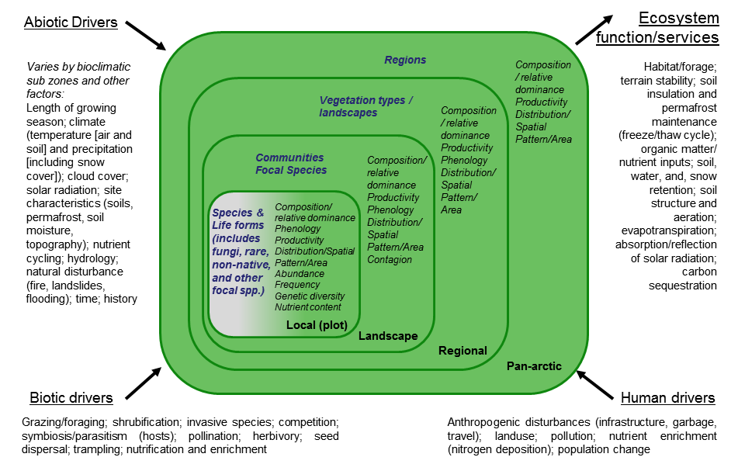
Fig. 4.1. The Arctic vegetation monitoring conceptual model showing key drivers, attributes and geographic scales of biodiversity and analysis.

Table 4.1. List of focal ecosystem components for vegetation (FECs: major biodiversity elements), their attributes (compositional, structural, and functional aspects), monitoring priority of attributes, parameters of attributes (individual measures/methods to quantify attributes), geographic scale, method (monitoring technical approach or reference to methods), protocol complexity (basic or advanced) and temporal recurrence (how frequently monitoring should be conducted).
FOCAL ECOSYSTEM COMPONENT | ATTRIBUTE | PRIORITY | PARAMETER | SCALE | METHOD | PROTOCOL COMPLEXITY | TEMPORAL RECURRENCE | COMMENTS
All vegetation components
All plants (Species, life form groups and associations/ communities) | Composition; Horizontal & vertical structure; abundance | Essential | Percent cover by life form | Local | Point intercept/line point intercept | Basic | 5 years
 | Composition; Horizontal & vertical structure; abundance | Essential | Canopy gap | Local | U. S. Bureau of Land Management | Advanced | 5 years
 | Composition; Horizontal & vertical structure; abundance | Essential | Percent cover by species | Local | Point intercept/line point intercept | Advanced | 5 years
 | Composition; Horizontal & vertical structure; abundance | Essential | Alpha Diversity | Local | Plot species list | Basic | 5 years
 |  |  |  | Local | DNA soil sampling | Advanced | 5 years
 |  |  |  | Local | Plot photograph | Basic | 5 years
 | Composition; Horizontal & vertical structure; abundance | Essential | Height of representative life forms | Local | Mean of 5 representative plants | Basic | 5 years
 | Composition; Horizontal & vertical structure; abundance | Essential | Beta/gamma diversity | Regional/ pan-Arctic | Low resolution remote sensing: MODIS | Basic | Annual
 | Composition; Horizontal & vertical structure; abundance | Essential | Beta/gamma diversity | Landscape/ regional | Med resolution remote sensing: Landsat | Basic | 10 years
 | Composition; Horizontal & vertical structure; abundance | Essential | Beta/gamma diversity | Landscape | High resolution remote sensing (e.g. Quickbird) | Advanced | As req.
 | Area (amount), location, spatial pattern, composition, abundance | Essential | Pattern: fragmentation/ connectivity | Landscape/ regional | Remote sensing | Basic | 5 years
 |  | Essential | Area: total area by community | Landscape/ regional | Remote sensing | Basic | 5 years
 |  | Essential | Distribution of communities | Landscape/ regional | Remote sensing | Basic | 5 years
 | Productivity | Essential | NDVI/ FPAR/ LAI/ EVI | Landscape/ regional | Remote sensing | Basic | Annual
 | Productivity | Essential | Aboveground Biomass | Local | Harvest sampling; clip plots (destructive) | Basic | 5 years
 | Productivity | Essential | Aboveground Biomass | Local | Photo digital photograph classification (non-destructive) | Advanced | 5 years
 | Productivity | Essential | Total biomass | Local | Harvest and root clipping (destructive) | Advanced | 5 years
 | Productivity | Essential | Biomass | Landscape/ regional | Remote sensing | Advanced | Annual
 | Productivity | Essential | Biomass | Local | TK: Harvest observations related to food abundance | Basic | As req.
 | Phenology | Essential | Date of leaf-out (species) | Local (plot) | Direct observation | Basic | Annual
 |  |  |  |  | Direct observation | Basic | Annual
 | Phenology | Essential | Date of flowering (species) | Local (plot) | Direct observation | Basic | Annual
 | Phenology | Essential | Date of senescence (species) | Local (plot) | Direct observation | Basic | Annual
 | Phenology | Essential | Date of senescence (species) | Local | TK: Morphological observation | Advanced | Annual
Species of special interest
Rare species, species of concern | Species abundance/ occurrence/ location | Essential | Presence/ absence; number of individuals /population size | Local | Direct count observations | Basic | 10 year
Rare species, species of concern | Genetic diversity; neutral diversity | Recommended | Gene flow, effective population size, migration rate and directionality, population growth rates, bottlenecks; evolutionary potential | Regional | DNA analysis | Advanced | As req.
Rare species, species of concern | Population viability | Recommended | How many populations, locations (meta-populations) | Landscape | Direct observation | Basic | As req.
Rare species, species of concern | Population viability | Recommended | Abundance of individuals within a populations over time | Local | Direct observation | Basic | As req.
Rare species, species of concern | Health/ Pathogen load (disease, parasites, insects) | Recommended | Presence/ absence of population with condition | Local | Direct observation | Basic | As req.
Rare species, species of concern | Health/ Pathogen load (disease, parasites, insects) | Recommended | % of population with condition | Local | Direct observation | Basic | As req.
Rare species, species of concern | Health/ Pathogen load (disease, parasites, insects) | Recommended | Community observed changes in plant health | Local | Direct observation | basic | As req.
Rare species, species of concern | Location and spatial pattern | Recommended | Pattern: fragmentation/ connectivity | Landscape | Remote sensing | Basic | 5 years
Rare species, species of concern | Location and spatial pattern | Recommended | Area: total area by community | Landscape | Remote sensing | Basic | 5 years
Rare species, species of concern | Location and spatial pattern | Recommended | Distribution of communities | Landscape | Remote sensing | Basic | 5 years
Non-native species | Abundance/ occurrence/ location | Essential | Presence/ absence | Local | Direct count observations | Basic | As req.
Non-native species | Abundance/ occurrence/ location | Essential | Population size | Local | Direct count observations | Advanced | As req.
Non-native species | Spatial pattern | Essential | Extent | Landscape | Remote sensing | Advanced | As req.
Non-native Species | Health (pathogens and disease, reduced resilience); population viability | Recommended | Presence/ absence of population with condition | Local | Direct observation | Basic | As req.
Non-native Species |  | Recommended | % of population with condition | Local | Direct observation | Basic | As req.
Non-native Species | Phenology | Recommended | Date of leaf-out (species) | Local (plot) | Direct observation | Basic | Annual
Non-native Species | Phenology | Recommended | Date of leaf-out | Landscape/ regional | Remote sensing | Basic | Annual
Non-native Species | Phenology | Recommended | Date of flowering (species) | Local (plot) | Direct observation | Basic | Annual
Non-native Species | Phenology | Recommended | Date of senescence (species) | Local (plot) | Direct observation | Basic | Annual
Non-native Species | Phenology | Recommended | Date of senescence | Landscape/ regional | Remote sensing | Basic | Annual
Non-native Species | Genetic diversity | Recommended | Gene flow, effective population size, migration rate and directionality, population growth rates, bottlenecks; evolutionary potential | Regional | DNA analysis | Advanced | As req.
Food/ forage species
Food/ forage species | Food/ forage species composition, abundance and occurrence/ location | Essential | See above
Food/ forage species | Food/ forage species productivity/ biomass | Essential | See above
Food/ forage species | Food/ forage species nutrient content | Essential | Species Mix | Local | TK; direct observation | Basic | As req.
Food/ forage species | Food/ forage species nutrient content | Essential | Size-distribution | Local (plot) | TK; direct observation | Basic | As req.
Food/ forage species | Food/ forage species nutrient content | Essential | Palatability; secondary compounds | Local (plot) | Phyto-chemical analysis (Laboratory analysis) | Advanced | As req.
Food/ forage species | Food/ forage species phenology | Essential | Date of leaf-out (species) | Local (plot) | Direct observation | Basic | Annual
Food/ forage species | Food/ forage species phenology | Essential | Date of leaf-out | Landscape/ regional | Remote sensing | Basic | Annual
Food/ forage species | Food/ forage species phenology | Essential | Date of flowering (species) | Local (plot) | Direct observation | Basic | Annual
Food/ forage species | Food/ forage species phenology | Essential | Date of senescence (species) | Local (plot) | Direct observation | Basic | Annual
Food/ forage species | Food/ forage species phenology | Essential | Date of senescence | Landscape/ regional | Remote sensing | Basic | Annual
 |  |  |  | Local | TK: Morphological observation | Advanced | Annual
Food/ forage species | Productivity, biomass | Recommended | Aboveground Biomass | Local | Harvest sampling; clip plots (destructive) | Basic | 5 years
Food/ forage species | Health/ Pathogen load (disease, parasites, insects) | Recommended | Presence/ absence of species with condition | Local | Direct observation | Advanced | As req.
Food/ forage species | Health/ Pathogen load (disease, parasites, insects) | Recommended | % of pop with condition | Local | Direct observation | Advanced | As req.
Food/ forage species | Health/ Pathogen load (disease, parasites, insects) | Recommended | Community observed changes in plant health | Local | Direct observation | Basic | As req.

4.3 Birds

The goal for avian monitoring is to track and report on changes in bird abundance and distribution in relation to biotic and abiotic drivers, and monitor and report how these changes may affect other functional groups in the ecosystem.

The ecosystem approach design in relation to birds will enable spatial and temporal integration of monitoring results to establish, measure, and report on causative interrelationships among abiotic and biotic components. Identifying links among such abiotic and biotic components, and relationships between these components and changes in avian populations may also provide a basis to understand changes reported from other components included in the vegetation, mammal and arthropod monitoring sections (see Box 4B, Zackenberg Research Station).

The CBMP-Terrestrial Plan establishes an important aim from a management perspective: to maintain the current levels of biological diversity in the Arctic. This includes enhancing the conservation status of populations showing evidence of declines caused by factors that are preventable. In relation to birds, establishing baselines and acquiring data on the status of populations can be achieved by compiling information on flyway population sizes, documenting the temporal changes in flyway populations, and tracking the drivers implicated in causing the observed changes. These baselines and data may facilitate the interpretation of trends so that improved management recommendations can be made to reverse declines where appropriate.

Avian flight enables migrants to exploit seasonal pulses of food in different parts of the globe to survive and reproduce. Utilising the brief Arctic summer to raise their young, some of the most extreme long-distance migrants such as the Arctic tern travel to southern polar regions to exploit resources in the Austral summer during the northern polar winter. Many (but not all) Arctic birds are long-distance migrants, mere visitors to a feeding resource made available by the short summer melt. A few, such as the raven and ptarmigan, are resident throughout the year. Hence, factors affecting the status and well-being of birds may occur on the breeding areas in the Arctic or many thousands of miles away (in the Antarctic in the case of the Arctic tern). These contrasting patterns result in great challenges to population monitoring, but also great potential advantages. Species breeding at very low density in the Arctic (such as the shorebirds) may aggregate in vast groups on their wintering grounds in temperate or tropical areas, where they can be counted more effectively to track overall changes in population size rather than trying to track small changes in highly variable local breeding densities. Species of particular significance for human communities in the Arctic and elsewhere, such as important harvestable species like ducks and geese, may be already very well monitored for their abundance and population trends because of their shared cultural values outside of the Arctic. This may even be to the extent that there is good knowledge over many years, as well as information on factors regulating and limiting those populations, and their demographics. For example, annual survival rates can be derived from capture-mark-recapture studies of duck, goose and swan populations, and assessments of annual production of young based on age categories of individuals shot by hunters through so called “wing surveys” or “tail surveys”(see Table in Box 4C). For non-migrant species, population size and change will have to be assessed through sampling approaches at some stage during the year. Climate change may not only affect the overall size of populations, but also their distributions, as the climate template that shapes their habitat and food resources shifts in time and space. It is therefore important to combine flyway population monitoring with breeding avian community composition studies, an objective that can also be achieved through sampling on the breeding grounds.

Not all avian species can be covered in a circumpolar monitoring programme at all stages of their life cycle, so the challenge is to be able to achieve coverage of as many species as possible in relation to reporting on parameters that will answer specific management questions in the future. This should be done in a representative, but pragmatic and cost-effective way. Fortunately, there are very many on-going monitoring mechanisms in existence. For example, the global waterbird monitoring coordinated by Wetlands International (http://www.wetlands.org/ ) already attempts to make an annual midwinter count of all species and undertakes a three year cycle of audits of the geographical flyways, population sizes and trends of all waterbirds around the world. The quality and quantity of data varies between regions, but these mechanisms are in place. For other bird groups, such as birds of prey, carnivores, piscivores and passerines, the data-collection is less systematic, and we need to assess the best methods of deriving annual indices of their numbers and how we might begin to track changes in their abundance over time (see Box 4D on Lapland Buntings). This is especially important for the status of those bird species that provide insight into ecosystem process or the functioning of such processes. For example, some species such as the snowy owl and Pomarine skua show major annual variations in distribution and abundance in response to prey cycles. Small passerines such as Lapland buntings may show similar fluctuations in relation to their arthropod prey (such as moth larval abundance, which also have impacts on vegetation), which in turn affect predators of small birds. However, for widespread and common species, such as snow buntings which winter in remote areas where they are difficult to count, it may be more expedient to sample breeding densities, abundance and breeding success at a range of different focal areas throughout the Arctic.

Hence the shaping of a pan-Arctic terrestrial avian monitoring programme needs to identify the monitoring needs for such a programme, establish the parameters that need to be collected to fulfil those needs and, to some extent, select the most suitable species for monitoring, accepting that some species present insurmountable problems with regard to their monitoring. The CBMP-Terrestrial Plan recognises the potential to coordinate Arctic bird monitoring activities in a way never envisaged before, combining the efforts of existing mechanisms with innovative means of collecting relevant data, using agreed best practices for dissemination at the pan-Arctic, regional and local scales, and via the CAFF portals to a range of stakeholders and end users of the data.

The primary objectives are:

- To estimate current sizes of Arctic bird populations and locate the best available information and sources of annual data that would enable some assessment of the recent trends in flyway population sizes;
- To structure a future monitoring framework that would improve on and continue to provide better data on overall population sizes for all flyways of all avian populations in the Arctic;
- To gather existing data on changes in annual survival and productivity of as many Arctic breeding flyway populations as is possible and to begin to coordinate and standardize the collection and collation of such data following the best available protocols to inform and understand the reasons behind changes in overall numbers;
- For Arctic keystone species, to integrate the monitoring in a site-based ecosystem monitoring system to understand how Arctic abiotic and biotic factors affect bird population abundances and breeding success;
- To integrate the above into abiotic and biotic factors for monitoring that may affect Arctic birds inside and outside the Arctic to facilitate the interpretation of changes, with particular reference to providing informed knowledge to management agencies in the appropriate countries that could effect change to improve the conservation status of species currently in unfavourable status.

4.3.1 Avian monitoring questions and design issues
The CBMP-Terrestrial Plan is guided by the broad set of priority management questions/issues presented in Chapter 3. However Arctic birds constitute a special case with regard to monitoring populations and causes of change. Firstly, with few exceptions, Arctic-breeding birds are migratory and causes of change in population sizes are often due to factors outside the Arctic, such as hunting, development, habitat changes in wintering and staging areas, pollution and disturbance. However, Arctic-breeding species are subject to pressures in their polar region as well, including climate change. Secondly, many species have a patchy, but wide breeding distribution; hence, it is difficult to capture but a few populations with a site-based approach, particularly given that the CBMP-Terrestrial Plan will be based primarily on the existing station networks.
Any strategy to monitor avian populations must recognise logistic limitations and prioritise accordingly. Hence, monitoring effort should be concentrated on species with (i) keystone functions in Arctic ecosystems, (ii) indicator species of particular value because of correlations with specific variables (e.g. snowy owl, rough-legged buzzard, and Pomarine skua in relation to lemming cycles), (iii) rare, threatened or rapidly declining species, (iv) species of cultural or exploitative value to human communities (e.g. huntable species), (v) flyway populations for which there are legal obligations (national or international) to monitor, and (iv) non-native species.
Traditional Ecological Knowledge is most relevant to include in this regard since knowledge holders quickly will be able to assess potential changes within the environment. For instance, assessments can be conducted on unusual species spotted in new areas, or reporting can be included on locally-observed declines on harvested or non-harvested populations.
The management questions related to birds comprises a two-tier approach, from the standpoint of requirements under existing international conventions and national legislation (usually in relation to single species), and with respect to monitoring of the health and diversity of terrestrial ecosystems . Many of the core questions are related to a conceptual understanding of key attributes (Figure 4.2) including specific examples of structure, function, and drivers which were selected via expert opinion through an ecosystem-based conceptual modeling process.
However questions related to birds can also be connected to specific conservation issues. In this case, more tailored monitoring follows. Where wild bird populations function in the human food supply chain, there is a need to secure a long-term sustainable harvest, as well as fulfill information needs related to reporting required under international (or national) obligations such as the Ramsar Convention, Convention on Biological Diversity (CBD), Agreement on the Conservation of African-Eurasian Migratory Waterbirds (AEWA), Migratory Birds Act, etc., as well as reporting on national and internationally red-listed species (partly related to the international obligations). The CBMP-Terrestrial Plan therefore divides the “bird management questions” into two types:
- Questions that are focused on a conceptual understanding of key attributes related to birds. This is the site-based integrated ecosystem monitoring approach, targeted to understand causal relationships. Related questions to be addressed are:
- What and how are the primary biotic, abiotic and anthropogenic stressors influencing changes in avian diversity and ecosystem function (within and outside the Arctic) and how are these stressors changing?
- What are the implications of changes in stressors for birds and other species (phenology, structure, productivity)?
- For bird species of concern or that are declining, are the factors affecting phenology, distribution and abundance acting inside or outside of the Arctic?
- How are populations and communities changing?
- What can we do about negative trends (including related to food security)?

- Questions that lead to a more tailored and species oriented approach. This is the overall population monitoring approach, including monitoring conducted at staging or wintering sites where birds congregate and the coverage is generally higher than in the Arctic. Related questions to be addressed are:
- What are the status (in terms of abundance, richness and diversity), trends and distributions of the priority (as established above) Arctic avian species at the population flyway level? Specifically:
  - Within a global perspective: Conventions like CBD and Ramsar
  - Within a regional/ national perspective: For legislation
- Are the protected site networks living up to their intended criteria for conservation?
- How many birds can be harvested?
- Where and how are populations and communities changing?
The two approaches are interlinked; for example, demographic parameters such as breeding success collected in the wintering quarters can be related to changes in snow conditions in key breeding areas, detected by a combination of local snow coverage measurements and remotely sensed data.

4.3.2 Potential contributors to the avian monitoring scheme

In the interests of efficiency and effectiveness, it is essential to recognise the activities of many existing mechanisms that already collate monitoring data relating to birds that breed in the Arctic.
Some of these sources of information are vital cornerstones to any future CBMP construction, since many of these already deliver the results of monitoring data or analysis of such data at the flyway population levels. Pre-eminent amongst these is the Wetlands International Waterbird Monitoring Programme (http://www.wetlands.org/Whatwedo/tabid/55/Default.aspx), which globally monitors all waterbird populations and provides a three year reporting cycle of population sizes, trends and the reliability of the census data.
The Arctic Birds Breeding Conditions Survey (ABBCS: http://www.arcticbirds.net/) is a joint venture of the International Wader Study Group and Wetlands International's Goose and Swan Specialist Groups, and collates annual information on environmental conditions on the breeding grounds of Arctic nesting birds.
For data on changes in abundance of non-waterbird avian species, a number of regional schemes exist that monitoring winter bird abundance on the winter quarters, such as the Christmas Bird Count and Breeding Bird Surveys in Canada and the U. S., which generate annual abundance indices for species not otherwise covered by annual surveys (http://birds.audubon.org/data-research).
Information collected through previous and on-going subsistence monitoring programs can be used also. Thus, in some countries information and reporting systems already exist , including TK monitoring.
A regularly updated database that includes syntheses of analyses of data on bird numbers and breeding performance during the Arctic summer in relation to climatic, predatory and other relevant factors can give insights into the ecological processes and drivers acting at wide scale, as well as providing valuable information for the conservation of sites and species. Other networks provide guidance on best practices and monitoring protocols, for example:
The Arctic Shorebird Demographics Network Breeding Protocol (http://www.manomet.org/arctic-shorebird-demographics-network);
The ArcticWOLVES (http://www.cen.ulaval.ca/arcticwolves/index.html);
Some active field stations and their programs, such as the Zeckenberg Research Station (Box 4B below: http://www.zackenberg.dk/; http://www.zackenberg.dk/monitoring/biobasis/ );
Arctic Program for Regional and International Shorebird Monitoring (Arctic PRISM, http://www.ec.gc.ca/reom-mbs/default.asp?lang=En&n=FC881C1B-1);
International Waterbird Census (IWC, http://www.wetlands.org/Whatwedo/Biodiversitywaterbirds/InternationalWaterbirdCensusIWC/tabid/773/Default.aspx);
Northwest Territories/Nunavut Bird Checklist Survey (http://www.ec.gc.ca/reom-mbs/default.asp?lang=En&n=60E48D07-1);
International Shorebird Surveys (ISS, http://www.pwrc.usgs.gov/iss/iss.html);
Australasian Wader Studies Group (AWSG, http://www.awsg.org.au/);
U. S. Fish and Wildlife Service and Canadian Wildlife Service Waterfowl and Breeding Bird surveys (http://www.fws.gov/migratorybirds/NewsPublicationsReports.html; http://ec.gc.ca/rcom-mbhr/default.asp?lang=En&n=762C28AB-1)
Birdlife International (http://www.birdlife.org/ )
The Ornithological Council (based in the U. S., but supporting societies and networks in the Americas and internationally: http://www.nmnh.si.edu/BIRDNET/orncounc/index.html )

4.3.3 Avian conceptual model in relation to monitoring
An avian conceptual model is provided in Figure 4.2. Birds as keystone consumers in Arctic ecosystems are highly affected by the processes and drivers (biotic, abiotic and anthropogenic) that affect their food base. For example, in common with mammalian herbivores, grazing herbivores (primarily geese) are greatly influenced by spring conditions, the length of growing season, and the climate template for graminoid production upon which they depend for energy and nutrition . Likewise, the birds that consume the flush of invertebrates during the short summer season (such as grouse, waders and passerines) are also affected by climatic factors that shape the abundance of such organisms . However, these same species are also affected by top-down control, for instance through the influence of raptors and mammalian carnivores, which may shift between alternative prey in response to differential prey availability, or other factors .
Human exploitation of populations, both within and outside the Arctic, may also have a major effect on population trajectories. Furthermore, for many of the long distant migrant species, the major factors affecting the abundance of avian species may operate outside the part of the annual cycle when the birds are present in Arctic regions. For this reason, it is absolutely essential that in considering the functional significance of specific avian species, monitoring of avian attributes is closely integrated into those of other relevant taxa. Hence, if expansions in geese are causing cascade effects on vegetation, such as snow geese grubbing of Hudson Bay lowlands , as a keystone avian species, it is vital that the botanical monitoring is closely integrated with that of the geese (e.g. see Box 4C). Likewise if a species monitoring protocol is designed around reflecting changes in key variables, such as snowy owl abundance, Arctic foxes and lemmings , it is essential that these elements are integrated into a cohesive monitoring programme that includes all facets of the functional ecosystem components.

4.3.4 Terrestrial avian monitoring design principles and components

The bird fauna of the Arctic terrestrial ecosystem can be divided into four major functional groups (focal ecosystem components, FECs) as follows:
• Insectivores (shorebirds/waders, passerines)
• Carnivores (diurnal birds of prey, owls, skuas/jaegers, ravens)
• Herbivores (geese, swans, ptarmigan)
• Omnivores (piscivores, cranes, ducks)

These functional groups are widely distributed throughout the Arctic inhabiting most regions with the exception of the northernmost polar desert ecosystems. In spite of similarity in ecosystem functions, each of the four groups includes taxonomically distinct bird species, which differ in many aspects of their biology, representing specific challenges when developing unified monitoring methods even for a single FEC. Typical bird densities in the Arctic are lower over vast areas of suitable habitat compared with many temperate and tropical ecosystems which represents another challenge for their effective monitoring.
For monitoring under the CBMP-Terrestrial Plan, the terrestrial Arctic bird fauna has been grouped into these functional groups above. The CBMP-Terrestrial Plan specifically does not cover seabirds and sea ducks, which are covered in the CBMP-Marine Plan. Some overlap may occur between the CBMP-Terrestrial Plan and the CBMP-Freshwater Plan. The Freshwater plan includes all birds that can have an effect to the freshwater ecosystem on a site-based level including divers and grebes, which will not be considered under the CBMP-Terrestrial Plan. The CBMP-Freshwater Plan does not divide bird species into functional groups as does the Terrestrial Plan.

4.3.4.1 Avian terrestrial functional groups
1. Insectivores
The functional group of insectivores in the Arctic includes most species of shorebirds also known as waders (sub-order Charadrii) and most species of passerines (order Passeriformes). The term "insectivores" is to a certain extent inappropriate, because these birds also consume many other invertebrates on the breeding areas and, particularly, on non-breeding grounds, many passerines consume a diet of seeds. Insectivores constitute the dominant component of avian fauna in the terrestrial part of Arctic, both in terms of numbers of species and of their population densities, although none of the species in this FEC attain large body size. Insectivores play a role in the ecosystem as consumers of invertebrates and as a prey (including adult birds, eggs and chicks) for mammalian and avian predators. Because of their dependence upon invertebrates as a primary food source insectivores are subject to the impacts of adverse weather conditions that greatly affect their food availability.
Several larger species of shorebirds are harvested, but generally insectivores are less subject to hunting or other forms of exploitation by humans both in the Arctic and on non-breeding grounds compared in contrast to herbivores and omnivores. During recent decades, large population declines have been observed in Nearctic and Palearctic shorebird populations, and some species have become critically endangered . The reasons for these more or less well documented declines are not known, but habitat loss and change, as well as other anthropogenic impacts in the temperate and tropical non-breeding areas are suspected to contribute .
Many species of insectivores are inconspicuous incubators with the result that assessment of their densities on the breeding grounds using nest searches can be challenging and labour-intensive. At the same time, the complex mating systems of many shorebird species do not permit inference about nest or bird abundance based on territory mapping alone, even if a species exhibits territorial behaviour during the breeding period. The challenges of making effective breeding density assessment of shorebirds stimulated development of double-sampling techniques for density estimation. Unlike other bird FECs, for shorebirds there are no appropriate methods to assess fledging success on the breeding grounds.
All avian species in this FEC are migratory, allowing assessment of population sizes and demographic parameters for several species of shorebirds on the non-breeding grounds. For the passerines, information is sparser and estimating population size and annual breeding success can be far more challenging.

2. Carnivores
The functional group of Arctic avian carnivores includes diurnal birds of prey (families Accipitridae and Falconidae), true owls (Strigidae), skuas/jaegers (Stercorariidae) and ravens (Corvidae). Carnivores play a role in the ecosystem as top predators and may be a regulating factor of other functional groups of birds and small mammals. Population cycles of lemmings and voles have a strong impact on the local abundance and reproduction of most avian predators, which may in turn radically affect predation rates on alternative prey, making these important components in Arctic food webs.
However, the degree of specialization of predatory birds on small mammals varies, with snowy owl and Pomarine skua showing strong responses to fluctuations in small mammal abundance (e.g. see Box 4B). Several species aggressively protect their nests from other predators, a behaviour which is exploited by some species of arctic geese to gain protection from mammalian predators. Generally, there is no systematic harvest of avian carnivores, although they can locally suffer from occasional catching/shooting, disturbance by humans and falconry. A few species have shown recent range expansion and/or population increase while others may have recently declined , but generally information about trends is very scarce.
Many species are conspicuous during the breeding season which makes assessment of their local population size relatively straightforward based upon mapping of territorial pairs and nest searches. However, breeding densities are much lower compared with other functional groups, which require surveys conducted across much larger areas. Most species are migratory but their wide dispersal throughout vast winter ranges do not allow for the use of bird counts on the non-breeding grounds for assessment of population numbers.

3. Herbivores
The herbivore functional group in the Arctic includes geese and swans (Anatidae) and ptarmigan (Tetraoninae). These medium to large-sized birds have diverse roles in the ecosystem as they can have a major grazing impact on habitats, make a substantial contribution to nutrient cycling, and provide a prey base to support populations of mammalian and avian predators. Breeding efforts of herbivores are often limited by abiotic conditions early in the season.
There is large-scale harvest of many herbivore species both in the Arctic and on the non-breeding grounds. This is undoubtedly the most important group of birds for maintaining traditional livelihoods of people living in the Arctic. Apart from hunting, egging by humans can have locally strong impacts on the reproductive output of breeding populations. During recent decades, several species have shown large increases in abundance, some apparently due to improved feeding conditions and protection on the non-breeding grounds. In several areas, goose densities have apparently exceeded the local capacity of the ecosystem, leading to local habitat degradation. However, there are also populations with known declining trends and are therefore of conservation concern .
Some species (e.g., swans) are highly conspicuous, which allows their efficient census on the breeding grounds using ground or aerial surveys. Several species of geese nest in colonies where breeding effort and demographic parameters can be efficiently assessed. Geese and swans are long-distant migrants, while ptarmigans undertake relatively short-distant seasonal movements, mostly within Arctic areas. Population size and certain demographic parameters of most species of geese and swans are already assessed on the non-breeding grounds.

4. Omnivores
The functional group of onmivores includes divers/loons (Gavidae) cranes (Gruidae) and ducks (Anatidae). With the exception of the divers that are specialist piscivores (and therefore primarily affect freshwater systems), these taxonomic groups of birds are less specialized in their ecosystem functions compared with the previous three FECs and accordingly play a less distinct role in the ecosystem. Generally, onmivores play a similar role in the ecosystem to that of insectivores and herbivores, as consumers of invertebrates and plants. While cranes occasionally function also as top predators they do not show the dependence on fluctuations in animal prey abundance that typifies the carnivores. Ducks, similar to insectivores and herbivores, also play a role as prey for mammalian and avian predators.
Some general estimates of overall population sizes and trends for species are available in addition to some estimates at local sites. Sandhill Cranes are subject to a regulated harvest in the Nearctic. Ducks are being hunted in the Arctic and on non-breeding grounds, and are similar to herbivores as an important hunting resource. The population of Sandhill Cranes is currently increasing and they are known to be expanding their range in the Russian Arctic. Siberian Cranes continue to be critically endangered, and threats continue at stop-over and wintering sites . During recent decades several species of ducks have shown decreases in their abundance, while others have shown long term increases in overall population size .
Omnivores are medium to large size birds which permit an assessment of numbers through counts on the breeding grounds using ground or aerial surveys. All species are migratory. Populations of cranes and ducks can be also assessed on migration and wintering grounds.

4.3.4.2 Attributes for avian monitoring
For all four functional groups, six common attributes have been selected for monitoring. The parameters to be monitored, the drivers of change as well as methods and scale are largely the same for all functional groups, with some variations (specified in Table 4.2). As mentioned in the introduction to Chapter 4, the CBMP-Terrestrial Plan recommends a series of essential and recommended attributes that should be monitored to contribute to the program. Based on criteria developed from the management questions (e.g. “ecological relevance”, relevance for “ecosystem services”, importance for “Arctic Peoples”, and relevance for “legislation based information needs”), various experts have assisted the TEMG to categorize avian-related attributes during two Workshops (Appendix C).
The attributes and their overall priority are:
1) Abundance. From an overall monitoring perspective, the key attribute is abundance from which trends in population sizes can be inferred; for Arctic resident species, this has to be done on the Arctic breeding grounds based on networks of monitoring sites, while for migratory species, a combination of breeding bird monitoring and surveys outside the Arctic can be applied, dependent on the population in question. For a wide range of species, the most efficient way to monitor trends in population size is by standardized surveys on the staging or wintering grounds, in some cases supplemented by surveys of birds on passage at migration hotspot areas. Essential
2) Distribution. Birds are expected to rapidly shift breeding ranges northward with ongoing climate change. Due to fragmentary coverage in terms of site-based station networks, it will be difficult to quantify the rate of change over wide areas. The terrestrial station network can be used to provide data on detailed rates of settlement and ecosystem consequences. Monitoring under the CBMP-Terrestrial Plan can be complemented through the use and linkage to software such as eBird, geo-referenced information for recording distribution changes which will be applicable for a citizen science approach as well as for expeditions visiting remote areas; standards for recording will have to be developed. Essential
3) Demography. Monitoring trends in demographic parameters is important to assess causes behind observed population trends, in order to provide the basis for management actions. Such monitoring for instance can directly feed into inferences about the impacts of harvest on huntable populations. At local scale, data on breeding output can be monitored in terms of nest success rates; at population level by standardized counts of the proportion of juveniles in the observed flocks on migration or staging or even on the winter quarters. Survival rates can either be derived from population surveys (e.g. geese) or by specific mark capture-recapture studies which are, however, in most cases costly in terms of man-power and effort. Essential
4) Community structure. Monitoring the composition and diversity of bird communities can give a first indication of ecosystem structure and habitat quality; for example, the density, abundance and composition of the predatory bird guild will reflect rodent cycle persistence. If collected in a standard way over a variety of climatic gradients and habitats, the composition of communities can indicate general effects of climate change. In the CBMP-Terrestrial Plan context it is regarded as a supplement to species-specific monitoring as well as providing a regular measure of local biological diversity and insights into changing trophic relationships. Community structure can be monitored indirectly from essential attributes such as abundance and demography; where feasible it can be monitored directly also. Recommended
5) Health. With climate change, zoonoses are expected to become more prevalent in Arctic birds which may affect the health of populations; in some species, the combined effects of climate change, zoonoses and contaminant load may aggravate the impacts. Furthermore, since most species are migratory, birds may increasingly be a pathway for the transmission of vectors to Arctic ecosystem and human populations (see Chapter 1). Prevalence and impacts of zoonoses can be investigated at field stations or specific studies with programs for capturing birds for ringing. Recommended
6) Body condition. Body condition is a measure of the fitness of an organism at a given time and state. Monitoring trends in body condition of birds in a standardized way can provide useful information that can be related to the health of a population and can be linked to changes in the environment. Monitoring of body condition can be carried out at field stations or part of specific studies where standardized capture of birds or field observations of body condition indexes are performed. Recommended

4.3.5 Monitoring on non-breeding grounds

For many migratory species that breed in the Arctic, particularly those travelling thousands of kilometers and crossing several international jurisdictions (e.g. many with wintering grounds in southern continents), monitoring within breeding grounds only provides information on a fraction of the yearly cycle of these species. Some species are presently well covered by aerial sampling on the breeding grounds to assess the precise abundance of nesting birds to generate an annual index of abundance (e.g. http://www.flyways.us/status-of-waterfowl/population-estimates/2012-total-breeding-duck-population-estimates). However, for the majority of terrestrial birds in the Arctic, this is difficult, expensive or simply not possible. Identifying factors that may influence reproduction and survival, recruitment, and changing abundance and distributions, must include monitoring during migration and overwintering outside the Arctic also. Conducting surveys on the non-breeding areas when birds are far more aggregated may be easier than on Arctic breeding grounds, and may facilitate estimating total population counts with some degree of certainty and accuracy or annual indices which provide a robust measurement of annual changes in population size . Information on the reproductive success of entire flyway populations may also be available from existing monitoring programs on the winter quarters as well . Several of the most threatened Arctic breeding species are also the subject of detailed monitoring programs outside the Arctic breeding areas (e.g. Spoon-billed Sandpiper: http://www.saving-spoon-billed-sandpiper.com/ ).
Fortunately, data on many additional species are collected systematically and/or opportunistically as part of existing research efforts, international networks, and citizen science initiatives (see above and Chapter 1). In addition to existing networks already mentioned in Section 4.3.2 above and in Chapter 1, opportunities exist for knowledge exchange through additional groups already working throughout the Americas, their partners, and their research and community outreach tools (e.g. MANOMET: http://www.manomet.org/; Western Hemisphere Shorebird Network: http://www.whsrn.org; Cornell Laboratory of Ornithology, http://www.birds.cornell.edu, and their tools such as eBird: http://ebird.org; and Bird Studies Canada: http://www.bsc-eoc.org/). At a global scale, smaller focal networks include partners conducting research or monitoring at least including some migratory Arctic species (e.g. Global Raptor Information Network: http://www.globalraptors.org). Additional information to track avian populations outside their breeding grounds may be obtained through bird observatories (e.g. migrants) and banding offices (e.g. the Bird Banding Laboratory: http://www.bsc-eoc.org/; EURING: http://www.euring.org/index.html ).
Monitoring species within and outside the Arctic can be facilitated by incorporating data derived from technology-based tools that can complement observations and site-based studies (see Chapter 1 and Chapter 6). Recent advances in satellite tracking technology and data loggers have facilitated the collection of information including the location and type of activity of individuals (e.g. accelerometers, temperature and pressure recorders), and coupled with remote sensing (Appendix B), such tools can provide valuable data on natural history and distributions of species that are difficult to follow or of special concern . In addition, improved protocols and a growing body of knowledge to enable comparative studies of genetics, trace elements, and stable isotope signatures, are expanding our knowledge on diet and trophic levels, population connectivity, migratory routes, contaminant levels and sources, and the conservation status of species (see Chapter 1 and 6). Together, using these technology-based tools can greatly extend our potential for monitoring species within and outside the Arctic, complementing censuses and focal studies on the wintering grounds and stop-over sites, and for providing insight into some of the emerging threats to Arctic breeders.

4.3.6 Existing Capacity and future needs to deliver the CBMP-Terrestrial Plan
NOTE for readers – Work ongoing: Map with sites of intensive bird monitoring in the Arctic (divided into categories) – in progress with metadata database undergoing updates for final completion (Appendix A).
Future monitoring needs must be related directly to management questions, but this in turn reflects several different levels of knowledge requirements and the necessity for a process to secure capacity and adequate coverage. Hence, the first priority for a monitoring programme to cover all flyway populations of Arctic breeding bird species is to review the existing available extent of monitoring programmes to deliver (i) an assessment of contemporary population size and (ii) whether this population is increasing, decreasing or stable. This should be an immediate major priority in coming years, to synthesise the available knowledge on Arctic breeding birds to produce a clear statement about the number of species that breed in the Arctic, their current distribution and abundance and their trends in population change, with an assessment of the reliability of the information upon which this is based. This synthesis will rely entirely on existing monitoring mechanisms, but will include, in the short-term, an assessment of addition monitoring needs to fill gaps in our current ability to deliver the necessary data to CAFF on the status of breeding birds in the Arctic. This will be a particular problem for species which we cannot count on the winter quarters (e.g. the very common species such as Lapland bunting or those that winter mainly in the Arctic such as ravens or snowy owl) and these species may require a dispersed sampling approach using coordinated data collected from monitoring station networks specifically designed for this purpose.
Having established current knowledge, sources of information and gaps in coverage, the challenge will be then to fill those gaps and use the knowledge of keystone, indicator, rare, threatened, protected, exploited and non-native species as model species to examine the causes of change in abundance. This will require a further period of assessment to determine the demographic explanations for changes seen in overall abundance of flyway populations which will enable identification of the phase in the life cycle where factors affect population size. Hence, where falling reproductive success is found to be responsible for declines in a population where survival has been stable, causes of the decline can be sought with confidence on the Arctic breeding grounds. Such an appraisal across species of importance and those of unfavourable conservation status will provide a road map to better understand the causes for these declines and also highlight further gaps in the ability of monitoring programmes to deliver information about populations and their trophic interactions.
Changes in breeding distribution may constitute an especially challenging area of monitoring – the prediction is that many species will be expected to shift their distributions northwards and those that already breed to the northern edge of their continents will have nowhere to go. However, it is difficult to achieve this through a network of dispersed monitoring stations, most of which were designed for other purposes, and impossible to achieve with sufficient statistical power to demonstrate effects. For this reason, it is necessary to promote other innovations to generate extensive data, for example by encouraging collation of casual visiting species lists and vagrants, preferably through a centralised collation of citizen science observations (for example though eBird; http://ebird.org/content/ebird/ ). Large scale research based studies could use spatial modelling approaches to predict species distributions based on biotic and abiotic envelopes, using remote sensing and other data layers, reliant on field surveys to validate model predictions.

4.3.7 Sampling protocols

A wide variety of methods have been used for bird monitoring across the Arctic; sometimes different methods are used to monitor the same parameters in the same functional groups due to regional differences in bird biology (e.g., density and behaviour). Methods vary in accuracy and precision as well as in implementation costs. It is difficult to suggest a single unified method to monitor an attribute, because of prohibitive time costs or effort requirements, and may be unfeasible to implement in frameworks of traditional ecological knowledge observations, citizen science, etc.
Table 4.2 includes a list of focal ecosystem components for terrestrial birds. The table also describes attributes, their monitoring priority and references to method designs. As described in section 4.1.2, two categories (basic or advanced) of methods were defined to address an issue of differences in resources and expertise available at different monitoring localities.
Basic methods form a core of monitoring schemes. The data collected using basic methods are sufficiently accurate and precise to provide scientifically robust answers to management questions. Advanced methods can be implemented at a portion of sites where basic methods are being employed, and where time, labour and technical resources allow for the collection of additional information. This information can be used to further enhance precision of basic methods and to answer additional questions that can aid interpretation of casual relationships in monitoring data.

BOX 4B. Site-based Bird monitoring at Zackenberg Field station
– Part of a bigger picture.

Zackenberg Research Station is located in the High Arctic at Zackenberg in Northeast Greenland (74°30' N, 21°00' W; http://www.zackenberg.dk/). The Station, owned by the Government of Greenland and operated by Aarhus University in Denmark, is an ecosystem research and monitoring facility. The long-term monitoring program Zackenberg Basic was initiated in 1995, with the objective to provide long time-series of data on a High Arctic ecosystem. This has been accomplished through monitoring of selected biological and physical parameters. Biobasis, the biodiversity component of the Zackenberg field station monitoring program (http://www.zackenberg.dk/monitoring/biobasis/), includes 35 elements of terrestrial plant, arthropod, bird and mammal dynamics in Zackenbergdalen and adjacent valleys .
The aim is to have a monitoring program that is simple, comprehensive (covering a wide range of organisms and processes) and at the same time standardised. Currently, the station and program are facilitating data acquisition on typical High Arctic plant and animal populations and their interactions, that can be expected to be sensitive to inter-annual variation, and to long-term changes in the local ecosystem .
Zackenberg: A bird monitoring program also
Emphasis is on populations, phenology, reproduction and predation. Annually during June and July, the bird populations, their breeding phenology, and their hatching success are monitored in a 15.8 km² census area. In mid-June, the main effort is directed towards coverage of the potential breeding populations, while the work in late June and July concentrate on searching for nests and broods in order to monitor nesting success and breeding phenology. In total, about 400 territorial pairs are found within the census area, with the waders (shorebirds) being the most numerous group .

Monitoring birds: Part of a bigger picture
Six species of waders breed with an average of 260 – 300 pairs in the Zackenberg bird census area. Their inter-annual variability in population density together with timing of reproduction and breeding success have now been monitored for more than 15 years. Studies have uncovered that early spring food availability is the most important determinant of timing of egg-laying, followed by snow-cover in years with less than average snow-free land in early June . The data series show that clutch size in a period from 1998 to 2005 has decreased during June–July and the total length of the laying period has shortened in years of late snowmelt, meaning that the chances for re-laying in case of failure were limited in such years. These data indicate reduced breeding success in late breeding seasons.

Waders are not the only species monitored at Zackenberg. Changes have been observed also in two highly specialized lemming predators: snowy owl and stoat (see Fig. 4.2). Regional observations extending over a decade until 2010 indicated that following a lemming cycle collapse, snowy owl fledgling production declined by 98 per cent, and a severe local population decline of stoats occurred. The less specialized long-tailed skua and the generalist arctic fox were more loosely coupled to the lemming dynamics, but suffered decreased reproductive success.
The disruption of lemming population cycles in northeast Greenland has already affected the tundra ecosystem, here demonstrated by reduced reproductive performance and declining populations of high-arctic predators. If the lemming populations remain at the same non-cyclic, low-density state as during the last decade, the result will probably be population extinctions of endemic predators and further impoverishment of these Arctic communities.
Ultimately, disruption of predator-prey dynamics and extinctions may cause cascading impacts on the entire tundra food web, with unknown consequences, and demonstrate that the nature of such trophic cascades is contingent on the health of tundra ecosystems. Thus, improving the ability to predict the impacts of climate change on the vulnerable arctic ecosystems will require enhanced and coordinated spatial replication of long-term monitoring programs, like Biobasis in Zackenberg .
BOX 4C. Goose target-oriented monitoring.
Results from breeding/ staging/ wintering regions contribute to overall assessment of status and trends

Abundance and trends: In the case of Arctic nesting geese, because of their cultural importance as major huntable species and recent interactions with agriculture, there has been a long term interest in monitoring the size and conservation status of the different flyway populations. This information is centrally collated and provided on a three year reporting cycle for all waterbird populations by Wetlands International; the last tabulation is available on the web . This synthesis (see Table BOX 4C) is achieved through inventory work on the wintering areas, which gives rise to an annual index and a flyway population estimate in the case of the North American populations , periodic assessments of Eurasian continental populations, and in exceptional cases, total counts also .

Distribution: Many of the inventory schemes generate data on local wintering density, presence/absence, and in rarer cases habitat utilisation also, for most flyway populations on the wintering grounds and staging areas. Information is less forthcoming from the breeding areas, where there may be infrequent extensive aerial surveys .

Demography: Age specific survival rates are available for some populations even to the extent of understanding the effects of density on emigration/immigration rates . Breeding success is regularly sampled on an annual basis and published for many flyway populations .

Community structure, health and body condition: Attributes under these subjects are important but of lower priority and data availability varies greatly among flyways. Generally, little is collected or collated on community structure because species typically breed in low densities over large areas of the Arctic, although such information is available in areas where nesting density is high (e.g. Yukon-Kuskokwim Delta Alaska). Health is often screened periodically, typically checking for blood, feather and faecal parasites, but data are rarely collated or centrally reported . Most capture programmes (such as those associated with capture-mark-recapture studies of population dynamics) take measurements of mass at capture which can be related to linear body measurements to generate indices for fat content and to factors affecting fitness .

Table BOX 4C below – CONTINUED

TABLE BOX 4C. Example showing the conservation status of the entire set of circumpolar flyway populations of the Greater White-fronted Goose Anser albifrons. Results of respective monitoring schemes from around the different breeding, staging and wintering regions contribute to the overall assessment of abundance and trends (literature resources provided where appropriate).

English and scientific name | Subspecies and Population | Breeding range | Wintering, or core non-breeding range | Europe | Asia | North America | Population estimate | Trend | Literature sources | Notes
Greater White-fronted Goose Anser albifrons | albifrons, Baltic - North Sea | European Arctic Russia & NW Siberia | NW Europe | X | X |  | 1,000,000 | STA |  | Increases in 1990s leveled off in 2000s, as indicated by lower breeding success of birds wintering in W Europe.
 | albifrons, Pannonic | European Arctic Russia & NW Siberia | Central Europe | X | X |  | 10,000-40,000 | DEC
 | albifrons, Pontic/Anatolian | European Arctic Russia & NW Siberia | SE Europe, Turkey | X | X |  | 350,000-700,000 | STA
 | albifrons, Caspian, Iran, Iraq (non-bre.) | European Arctic Russia & NW Siberia | Caspian, Iran, Iraq | X | X |  | 15,000 | DEC
"Greenland White-fronted Goose" | flavirostris | W Greenland | Ireland, Scotland, Wales | X |  | X | 27,000 | DEC |  | Numbers peaked at 35,500 in late 1990s, declined to <27,000 by 2002 . Production of young in 2003 remained below that necessary to maintain a stable population. Population estimated at 24,000 in spring 2005.
 | frontalis, E Asia | E Siberia | East Asia |  | X |  | 150,000-200,000 | DEC |  | 144,917 recorded by AWC in 1999. 40,000 migrate through the Kamchatka Peninsula in spring
 | frontalis, Pacific | Yukon-Kuskokwim Delta, Alaska | Central Valley, California |  |  | X | 443,900 | INC
 | frontalis, Mid-Continent | C & NW Alaska across Arctic Canada to Foxe Basin | Louisiana, Texas & Mexico |  |  | X | 644,300 | STA
"Tule White-fronted Goose" | gambelli | Alaskan Taiga | California, USA |  |  | X | 5,100 | INC
 | elgasi | SW Alaska | San Clemente Valley, California |  |  | X | 5,000 - 10,000 | UNK |  | Recently described; recognised by AOU (1998) and Clements (2000); see online updates.

BOX 4D: Lapland bunting - Fluctuations of local density and breeding success can be linked to trophic relationships
Abundance and trends: By comparison with Arctic nesting geese, data are lacking on the abundance and trends of Lapland Bunting (or Lapland Longspur, Calcarius lapponicus) populations. This represents the other end of the spectrum with regard to tracking abundance, distribution and diversity of Arctic breeding birds. The species has a circumpolar Arctic and Subarctic breeding distribution, wintering in the temperate zone to Japan, Korea, China, across central Eurasia and around North Sea coasts, and right across continental North America. Little is known about changes in sub-population abundance and distribution around the globe on the breeding, staging or wintering areas.
Because buntings are not perceived to have equal cultural importance to other species that are harvested, despite extraordinarily high abundance and ubiquity throughout the Arctic, limited information about the species abundance is available, but the species has been estimated to include approx. 150 million individuals (http://rmbo.org/pif_db/laped/PED4.aspx). The relationship between breeding, staging and wintering areas is poorly known, and few assessments of long term changes in annual winter distribution and abundance have been conducted. The North American continental population is estimated to be 70 million (http://rmbo.org/pif_db/laped/PED4.aspx), but the population trends are not well known. Some winter surveys based on the Christmas Bird Count in the U. S. suggest declines, but the large mid-continent wintering concentrations show no change. The species can aggregate into enormous flocks which roam in search of food making censuses extremely challenging.
The Lapland Bunting thus represents a species which presents challenges for developing global or flyway monitoring programmes that can deliver a simple status report on the instantaneous conservation status for the species as a whole. However, conducting regular monitoring to obtain key abundance measures may be possible at a series of sites where sufficiently high breeding densities exist and monitors with expertise are available. Monitoring can help to generate a useful time series to examine fluctuations in local density and breeding success, and investigate links to trophic relationships, and biotic and abiotic factors affecting the populations at local scales.
Distribution: Almost nothing is known about changes in density and distribution on the breeding areas, apart from results from local studies, which suggest retractions in the southern parts of the range in Hudson Bay, Canada and parts of Finland, balanced by expansion in Kola Peninsula in Russia . However, to be able to design a protocol of data collection relating to such an abundant and widespread species is challenging, since data would need to be collated from a very large number of sites over many years before the study would have sufficient statistical power needed to detect changes in abundance at large spatial scales. In contrast, long time series to track local changes in density, in concert with collations of species lists and casual records over many years and across many sites may enlighten long term changes, and would therefore merit monitoring actions across many different Arctic regions. As above, this long term monitoring would illuminate the relationship of the species with its local environment and help separate any short term noise (driven by food supply or weather) from long term signals (trends in local population development).
Demography: Annual adult survival rates are available for very few populations (estimated at 43-45%) or for breeding success at egg, nest and fledging stages . Although obtaining good measures of survival and reproduction parameters from intensive monitoring effort may be insufficient to generate population models to track changes in abundance, there is great value in collecting such data on a regular basis at sites where the species is common, and possibilities for large samples sizes offers very exciting monitoring opportunities to link annual reproductive success to local environmental conditions to gain deeper insight into factors affecting breeding. It is known from studies that late snow and prey availability affects the timing of breeding and reproductive success , so gaining a deeper understanding of these types of processes from regular monitoring would greatly contribute to our ability to understand factors affecting the distribution and abundance of this species throughout the Arctic.
Community structure, health and body condition: These attributes are currently of lower priority, until serious declines in abundance signal the need for further investigation. The species is common throughout the Arctic wherever the habitat is suitable, and so its disappearance would be evident from key areas, and would likely have ecosystem consequences, both as a consumer (e.g. of arthropods) and prey (e.g. of generalist predators such as Arctic foxes but also of specialist predators, such as peregrine falcons, where declines could have local consequences). At least in other species, disease and parasite infestations, and observations of body mass changes throughout the annual cycle are being documented (see Chapter 1; drivers), but data are currently lacking for buntings. Such data however can contribute in the future to a robust monitoring programme for this species. Investigating health and body condition in response to a specific hypothesis in a situation where it is known a local breeding population is showing adverse change may be more cost effective than using precious monitoring resources in gathering regular monitoring data without purpose that is not likely to be used.
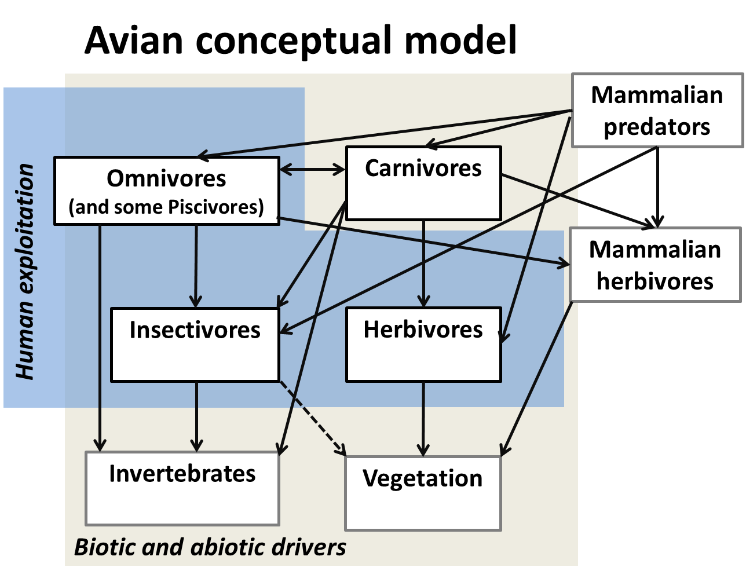

Fig. 4.2. The Arctic terrestrial birds monitoring conceptual model showing focal ecosystem component examples, key drivers, attributes and their inter-relationships.
Table 4.2. List of focal ecosystem components for terrestrial birds (FECs: major biodiversity elements), their attributes (compositional, structural, and functional aspects), monitoring priority of attributes, parameters of attributes (individual measures/methods to quantify attributes), geographic scale, method (monitoring technical approach or reference to methods), protocol complexity (basic or advanced) and temporal recurrence (how frequently monitoring should be conducted).
FOCAL ECOSYSTEM COMPONENT | ATTRIBUTE | PRIORITY | PARAMETER | SCALE | METHOD | PROTOCOL COMPLEXITY | TEMPORAL RECURRENCE | COMMENTS
Herbivores (geese, swan, ptarmigan) | Abundance and trends | Essential | Population size, number, habitat selection | 1) local - global; 2) regional; 3) regional - global; 4) local | 1) Various aerial and ground surveys; 2) non-breeding census; 3) banding (Capture-Mark-Recapture); 4) citizen science (TK) | BASIC and ADVANCED | 1) annual; 2) annual; 3) annual; 4) continuous | Must be included; ptarmigan may be poorly covered by these methods
Herbivores (geese, swan, ptarmigan) | Distribution | Essential | Local density; presence/absence, habitat selection, migration patterns | 1) local - global; 2) regional; 3) regional - global; 4) local | 1) Various aerial and ground surveys; 2) non-breeding census; 3) banding (Capture-Mark-Recapture); 4) citizen science (TK) | BASIC and ADVANCED | 1) annual; 2) annual; 3) annual; 4) continuous | Must be included
Herbivores (geese, swan, ptarmigan) | Demography | Essential | Propensity; clutch size; brood size; age ratio; nest success; age specific survival; genetic diversity; breeding behavior; phenology | 1-2) regional to global; 3) local; 4) local | 1) banding (Capture-Mark-Recapture); 2) hunter collected: wing surveys (see Glossary); 3) site-specific studies; 4) egg collectors | BASIC and ADVANCED | 1) annual; 2) annual; 3) annual; 4) annual | Demography feeds directly into population size and is of high priority. Often, it is the only measurable attribute at the flyway scale.
Herbivores (geese, swan, ptarmigan) | Community structure | Recommended | Diversity index, habitat selection | See rows above | See rows above | ADVANCED | See rows above | Relative abundance of all species within defined area. Lower priority but data can be obtained from population abundance parameters.
Herbivores (geese, swan, ptarmigan) | Health | Recommended | Prevalence pathogens, parasites, contaminants | 1) local, 2) regional to global; 3) local - global | 1) specific projects; 2) citizen science; 3) opportunistic or targeted samplings as needed | ADVANCED | 1) as req; 2) annual; 3) as req; | Under some circumstances, this may become imperative requiring policy changes (i.e.. H5N1 outbreak).
Herbivores (geese, swan, ptarmigan) | Body condition | Recommended | Diet, fat index, feeding rate | 1) local, 2) regional to global; 3) local - global | 1) specific projects; 2) citizen science; 3) opportunistic or targeted samplings as needed | ADVANCED | 1) as req; 2) annual; 3) as req; | Could be considered an aspect of health
Insectivores (shorebirds, passerines) | Abundance and trends | Essential | Population size, numbers, habitat selection | 1, 3) regional (North America); 2) regional / global; 4) global; 5) local - global; 6) local | 1) Arctic PRISM: shorebirds; 2) non-breeding surveys: flyway; 3) CBC: passerines; BBS; 4) Arctic-breeding Birds Conditions Survey; 5) single-species surveys; 6) local knowledge (TK) | BASIC and ADVANCED | 1) every 15 - 20 years; 2) annual; 3) annual; 4) annual; 5) annual; 6) continuous | Must be included; statistically valid.
Insectivores (shorebirds, passerines) | Distribution | Essential | Local density; presence/ absence, habitat selection, migration patterns | 1) regional / global; 2) local; 3) see above; 4) regional - global | 1) citizen science (eBird, TK, BBS); 2) research stations; 3) see row above except CBC; 4) banding and tracking studies (refers to migration pattern) | BASIC and ADVANCED | Various (annual to continuous) | Must be included. Data should be gathered through population abundance parameters and doing so on a long term standardized basis is important.
Insectivores (shorebirds, passerines) | Demography | Essential | propensity; clutch size; brood size; age ratio; nest success; age specific survival, genetic diversity, breeding behavior, phenology | 1) regional / global; 2) global; 3) local; 4) regional / global; 5) regional / global | 1) ASDN; 2) ABBCS; 3) Specific projects; 4) citizen science (incl. TK); 5) non-breeding ground surveys (CBC, MAPS, juvenile ratios) | BASIC and ADVANCED | 1) annual; 2) annual; 3) as req.; 4) continuous; 5) annual | Demography feeds directly into population size - It has to be high priority. Often it is the only measurable attribute at the flyway scale
Insectivores (shorebirds, passerines) | Community structure | Recommended | Diversity index, habitat selection | See rows above | See rows above | ADVANCED | As req.; annual if possible | Relative abundance of all species within defined area.
Insectivores (shorebirds, passerines) | Health | Recommended | Prevalence pathogens, parasites, contaminants | 1) local; 2) regional; 3) regional - global; 4) local - global | 1) specific projects; 2) ASDN projects; 3) citizen science; 4) opportunistic or targeted samplings as needed | ADVANCED | 1) as req.; 2) annual; 3) continuous; 4) as req. | Under some circumstances, this may become imperative requiring policy changes (i.e.. H5N1 outbreak).
Insectivores (shorebirds, passerines) | Body condition | Recommended | Diet, fat index, feeding rate | 1) regional; 2) local; 3) regional - global | 1) ASDN; 2) specific projects; 3) citizen science (harvest information) | ADVANCED | 1) annual; 2) as req.; 3) annual | Could be considered an aspect of health. However - if the bird is in hand low cost monitoring contributing to long term perspective.
Carnivores (raptors, jaegers, ravens and owls) | Abundance | Essential | Population size; numbers, habitat selection | 1-2) regional; 3) regional; 4) global | 1) boat surveys (raptors); 2) aerial surveys (jaegers, owls, some falcons); 3) ground migration surveys (raptors); 4) ArcticWOLVES Observatories Network | BASIC and ADVANCED | 1-2) annual; 3) annual; 4) annual | Must be included. Limited harvest in various places in some countries.
Carnivores (raptors, jaegers, ravens and owls) | Distribution | Essential | Local density; presence/absence, habitat selection, migration patterns | 1-2) regional; 3) regional; 4) global; 5) regional | 1) boat surveys (raptors); 2) aerial surveys (jaegers; owls, some falcons); 3) ground migration surveys (raptors); 4) ArcticWOLVES Observatories Network; 5) citizen science (eBird, TK) | BASIC and ADVANCED | 1-2) annual; 3) annual; 4) annual; 5) annual | Must be included
Carnivores (raptors, jaegers, ravens and owls) | Demography | Essential | propensity; clutch size; brood size; age ratio; nest success; age specific survival, genetic diversity, breeding behavior | 1) global; 2) regional; 3) local | 1) ArcticWOLVES Observatories Network; 2) citizen science (Cornell TK); 3) site specific study | BASIC and ADVANCED | 1-3) annual | Demography feeds directly into population size - It has to be high priority. Often it is the only measurable attribute at the flyway scale
Carnivores (raptors, jaegers, ravens and owls) | Community structure | Recommended | Diversity index, habitat selection | See rows above | See rows above | ADVANCED | As req.; annual if possible | Relative abundance of all species within defined area. Low priority but data will be gathered through population abundance parameters.
Carnivores (raptors, jaegers, ravens and owls) | Health | Recommended | Prevalence pathogens, parasites, contaminants | 1 )regional; 2) local | 1) citizen science (Cornell TK); 2) site specific study | ADVANCED | 1-2) annual | Under some circumstances, this may become imperative requiring policy changes (i.e.. H5N1 outbreak). Elevated relevance because of the high trophic level.
Carnivores (raptors, jaegers, ravens and owls) | Body condition | Recommended | Diet, fat index, feeding rate | 1) regional; 2) local | 1) citizen science (Cornell; TK); 2) site specific study | ADVANCED | 1-2) annual | Could be considered an aspect of health
Omnivores (ducks, cranes) | Abundance | Essential | Population size; numbers, habitat selection | 1) local - global; 2) regional; 3) regional - global; 4) local | 1) various aerial and ground surveys; 2) non-breeding census; 3) banding (Capture-Mark-Recapture); 4) citizen science (TK) | BASIC and ADVANCED | 1) annual; 2) annual; 3)annual; 4) continuous | Must be included
Omnivores (ducks, cranes) | Distribution | Essential | Local density; presence/absence, habitat selection, migration patterns | 1) local - global; 2) regional; 3) regional - global; 4) local | 1) various aerial and ground surveys; 2) non-breeding census; 3) banding (Capture-Mark-Recapture); 4) citizen science (TK) | BASIC and ADVANCED | 1) annual; 2) annual; 3) annual; 4) continuous | Must be included
Omnivores (ducks, cranes) | Demography | Essential | propensity; clutch size; brood size; age ratio; nest success; age specific survival, genetic diversity, breeding behavior | 1-2) regional to global; 3) local; 4) local | 1) banding (Capture-Mark-Recapture); 2) wing surveys; 3) site specific studies; 4) egg collectors | BASIC and ADVANCED | 1) annual; 2) annual; 3) annual; 4) annual | Demography feeds directly into population size - It has to be high priority. Often it is the only measurable attribute at the flyway scale
Omnivores (ducks, cranes) | Community structure | Recommended | Diversity index, habitat selection | See rows above | See rows above | ADVANCED | As req.; annual if possible | Relative abundance of all species within defined area. Low priority but data will be gathered through population abundance parameters.
Omnivores (ducks, cranes) | Health | Recommended | Prevalence pathogens, parasites, contaminants | 1) local; 2) regional to global; 3) local - global | 1) site-specific projects; 2) citizen science; 3) opportunistic or targeted samplings as needed | ADVANCED | 1) as req.; 2) annual; 3) as req. | This could under certain circumstances (i.e.. H5N1 outbreak) quickly elevate to high and may result in legislation.
Omnivores (ducks, cranes) | Body condition | Recommended | Diet, fat index, feeding rate | 1) local; 2) regional to global; 3) local - global | 1) site-specific projects; 2) citizen science; 3) opportunistic or targeted samplings as needed | ADVANCED | 1) as req.; 2) annual; 3) as req. | Could be considered an aspect of health
Piscivores (loons, merganser and grebes) | Abundance | Essential | Population size; numbers, habitat selection | 1) local - global; 2) regional; 3) local | 1) various aerial and ground surveys; 2) non-breeding surveys; 3) Citizen science (TK) | BASIC and ADVANCED | 1) annual; 2) annual; 3) continuous | Must be included; grebes may not be represented in a defined Arctic region.
Piscivores (loons, merganser and grebes) | Distribution | Essential | Local density; presence/absence, habitat selection, migration patterns | 1) local - global; 2) regional; 3) local | 1) various aerial and ground surveys; 2) non-breeding surveys; 3) citizen science (eBird, TK) | BASIC and ADVANCED | 1) annual; 2) annual; 3) continuous | Must be included.
Piscivores (loons, merganser and grebes) | Demography | Essential | propensity; clutch size; brood size; age ratio; nest success; age specific survival, genetic diversity, breeding behavior | 1, 2) local; 3) regional | 1) site-specific studies; 2) egg collectors; 3) aerial surveys for propensity | BASIC and ADVANCED | 1-2) annual; 3) annual | Demography feeds directly into population size - It has to be high priority. Often it is the only measurable attribute at the flyway scale
Piscivores (loons, merganser and grebes) | Community structure | Recommended | Diversity index, habitat selection | See rows above | See rows above | ADVANCED | As req.; annual if possible | Relative abundance of all species within defined area. Lower priority but data can be obtained from population abundance parameters.
Piscivores (loons, merganser and grebes) | Health | Recommended | Prevalence pathogens, parasites, contaminants | 1, 2) local; 3) local | 1) site-specific studies; 2) citizen science; 3) opportunistic or targeted samplings as needed | ADVANCED | 1-2) annual; 3) as req. | Under some circumstances, this may become imperative requiring policy changes (i.e.. H5N1 outbreak). Elevated relevance because of the high trophic level.
Piscivores (loons, merganser and grebes) | Body condition | Recommended | Diet, fat index, feeding rate | 1, 2) local; 3) local | 1) site-specific studies; 2) citizen science; 3) opportunistic or targeted samplings as needed | ADVANCED | 1-2) annual; 3) as req. | Could be considered an aspect of health.

4.4 Mammals

The mammal species in the Arctic are a variety of sizes, occupy various trophic positions and assume a variety of life strategies. While many of the Arctic species resides in the same area year-round (e.g. lemmings), some species are either true migratory species (reindeer/caribou) or roam over vast areas (e.g. wolf). Unlike the Arctic birds (see section 4.3), the Arctic mammal species are generally widely distributed year-round and therefore cannot be censused at aggregation areas. Some species, such as the reindeer/caribou, are hunted by local people, and their abundance and demographics are therefore often monitored by the local communities. Population monitoring of the Arctic mammal species therefore includes an array of methodologies and approaches.
The on-going monitoring of mammal populations in the Arctic is highly fragmented, and only the reindeer/caribou populations are monitored across the pan-Arctic following standardised protocols through the CARMA network (Circum Arctic Rangifer Monitoring and Assessment Network). For the remaining mammal species, some countries may have well-developed monitoring programs for some species or groups of species. However, the vast majority of mammal species in the Arctic are currently either not sufficiently monitored or the on-going monitoring is not sufficiently coordinated to allow for a pan-Arctic assessment of status and trends. Moreover, there are only few examples of mammal species being monitored in an ecosystem framework.
The CBMP-Terrestrial Plan aims at coordinating, expanding, and harmonising the on-going monitoring of mammals on the pan-Arctic scale in order to fulfil the needs of stakeholders and other end-users. This will be achieved through the presentation of a generic mammal monitoring scheme, based on an ecosystem approach and based on methodologies of agreed best-practices.

4.4.1 Mammal monitoring questions

Many of the core management questions related to mammals are related to understanding the interactions in the ecosystem centered on mammals, and hence to understand the key attributes such as abundance, demographics and health, but also likely stressors. The selection of the latter is based on expert opinion in connection with the development of the ecosystem-based conceptual models. Other management questions are related to specific conservation issues, such as securing sustainable hunting or meeting the international requirements for reporting on biodiversity issues (e.g. in connection with the Convention on Biological Diversity (CBD)).
The elements in the mammal monitoring programs are selected during the process of conceptual model formulation, whilst also taking into account logistic limitations etc. The mammal monitoring program should therefore be focused on species that are the focal ecosystem components (FEC; see Chapter 3), species that acts as indicators for other species or processes, species that are rare, threatened or rapidly declining species, species that are exploited by man, and finally species that are invasive.
Specifically, the overall management questions related to the mammals are:
- What are the status and trends of the relevant mammal populations (species or groups of species, i.e. FEC’s) in the Arctic?
- Where in the Arctic are the populations changing?
- What and how do the primary biotic, abiotic and anthropogenic drivers influence the various mammal species/FECs, and hence, influence the mammal diversity and ecosystem function?

4.4.2 Potential contributors to the mammal monitoring scheme

The present mammal monitoring scheme is based on existing monitoring supplemented with new coordinated initiatives. Though some countries have developed extensive programs for the monitoring of mammals, generally the current monitoring of mammals in the pan-Arctic is fragmented. One exception is the pan-Arctic coordinated monitoring of reindeer/caribou conducted within the CARMA network (http://caff.is/carma).
Generally, the mammal monitoring in the Arctic is conducted at permanent field stations/sites. The aim of the present monitoring plan is therefore to utilize for example the INTERACT project, an existing network of field stations in the Arctic (http://www.eu-interact.org/ ), to improve the coordinated monitoring within the CBMP-Terrestrial Plan. Also, this will allow the monitoring program to be truly ecosystem-based, as seen at Zackenberg in Northeast Greenland.

4.4.3 Mammal conceptual model in relation to monitoring

Mammals are affected by processes that affect their food base. Grazing herbivores may be affected by, for example, the start of the growing season, which is influenced by the climate (bottom-up). The same species may be influenced/controlled by predator species (top-down). Also, the anthropogenic influence on, for example, caribou/reindeer may have a major impact at a population level. Therefore it is sometimes necessary to monitor not only the species in question but also other relevant taxa. These interactions around a key species are projected in a food web or a conceptual model. The mammal conceptual model (Fig. 4.2a) was developed by the mammal expert team and it illustrates the conceptualization of the six functional mammal groups operating at a Pan-Arctic scale. The three most important functional groups are the large herbivores, the medium-sized predators and the small herbivores. In several geographic distinct areas not all functional groups are present. We therefore also illustrate two localized conceptual models with only some of the functional groups included (Fig. 4.2b and 4.2c). The models help to illustrate other taxonomic groups that may interact with mammals, such as birds, and vegetation groups.

4.4.4 Terrestrial mammal monitoring design principles and components

The classification into the six FEC groups is based upon the theory that different-sized mammals (functional groups) interact differently with other ecosystem components, i.e. occupy different positions in the food web. Thus, one can outline a conceptual model where the interactions between the mammal FECs (and those with other FECs) are visualized as a food web (Figs. 4a-c). The Arctic terrestrial ecosystems have relatively few mammalian species, and hence only few food web links.
- Large herbivores (reindeer/caribou, musk ox, moose)
- Medium-sized herbivores (hares)
- Small herbivores (lemmings, voles)
- Large predators (wolves, bears)
- Medium-sized predators (wolverine, lynx, foxes)
- Small predators (small mustelids)
As shown in Figs. 4a-c there are some FECs that occupy more central spaces in the conceptual model, than others. For instance, small herbivores play an important role, as they interact with a comparatively high number of other FECs. However, how many and which of the mammal FECs that are present in any given geographical region vary across the Arctic. Therefore, localized conceptual models are outlined in Figs. 4b and 4c (and section 4.1.8).

4.4.4.1 Large herbivores
The large herbivore functional group in the Arctic proper includes caribou/reindeer (Rangifer tarandus) and Musk ox (Ovibus moschatus), while in the alpine ecosystems the Moose (Alces alces) is also included. This group is widely distributed across the Arctic. The large sized herbivores are long-lived (more than 10 years) and produce normally only one young every year or every other year. The large herbivores are important in many parts of the Arctic, both as consumers but also as prey (including carcasses) for the large and medium-sized predators. Caribou/reindeer in particular have especially strong linkages to human communities in the Arctic.
4.4.4.2 Medium-sized herbivores
The medium-sized herbivore functional group in the Arctic includes three hare species (i.e. Arctic hare (Lepus arcticus), Snowshoe hare (Lepus americanus) and Mountain hare (Lepus timidus). Hares are widely distributed across the Arctic. The medium-sized herbivores has a lifespan of approximately 4-5 years, and may reproduce once a year with litters of varying size. Besides being important herbivores, the medium-sized herbivores function as important prey for mainly the medium-sized predators.
4.4.4.3 Small herbivores
The small herbivore functional group in the Arctic includes species of lemmings (Dicrostonyx sp. and Lemmus sp.) and voles (Microtus sp. and Clethrionomys sp.). This group is widely distributed across the Arctic, and is the key prey for a number of both avian and mammalian predators. Lemmings and voles are short-lived, but can reproduce fast because they can produce several, large litters per year. The population dynamics of voles and lemmings is often characterised by large inter-annual fluctuations. The Arctic Ground Squirrel (Spermophilus parryi) is a true hibernating species, and this sets it somewhat apart from the other small herbivores. In general, the small herbivores function as prey for a wide spectrum of predator species.
4.4.4.4 Large predators
The large predator functional group in the Arctic proper only includes the Grey wolf (Canis lupus), while in the alpine ecosystem the Brown bear (Ursus arctos) and the American black bear (Ursus americanus) are also included. The group is distributed across most of the Arctic. However, only the wolf is present in Greenland, and no species of large predators are found in Iceland or on Svalbard. Population densities are generally very low. The large predators are generally long-lived, and while the wolf may reproduce every year, the brown bear reproduces only every two to three years. Polar bear, an important predator on land also, (Ursus maritimus) is considered under the CBMP-Marine Plan.
4.4.4.5 Medium-sized predators
The medium-sized predator functional group in the Arctic consists of Wolverine (Gulo gulo), Eurasian lynx (Lynx lynx), Canada lynx (Lynx canadensis), Red fox (Vulpes vulpes) and Arctic fox (Vulpes lagopus). The group is truly circumpolar in its distribution; especially so for the Arctic fox. As for large predators, population densities are generally low, especially in the High Arctic. The medium-sized predators are of varying longevity, may reproduce every year, with varying litter sizes. The litter size of the Arctic fox in particular is linked to the availability of voles and lemmings.
4.4.4.6 Small predators
The small predator functional group in the Arctic proper consists of Stoat/Weasel/Ermine (Mustela erminea) and Least weasel (Mustela nivalis). The small mustelids are distributed across the Arctic, and with generally low densities. The small mustelids are short-lived, and reproduce frequently depending on the availability of their vole and lemming prey.

4.4.5 Existing monitoring capacity

Currently, as described above, comprehensive and integrated circumarctic mammal monitoring is lacking, but through existing programs and infrastructure, the capacity exists to implement monitoring strategies (see Appendix A). In addition, opportunities exist for knowledge exchange through existing expert groups and initiatives through academic (several universities that also have research stations), community, and government groups (for example, in North America, Alaska Department of Fish and Game: http://www.adfg.alaska.gov/; Canadian Territorial governments: http://env.gov.nu.ca/, http://www.env.gov.yk.ca/ and http://www.enr.gov.nt.ca/_live/pages/wpPages/home.aspx ).

4.4.6 Mammal sampling protocols

For each of the mammal FECs, a number of attributes have been identified (see section 4.1.7 below). The sampling protocol includes a number of essential and recommended attributes that should be monitored in the mammal program. For each of the attributes, a number of parameters have also been identified.
The attributes are summarized below:
- Abundance
Knowing the abundance of a given species is essential for the overall monitoring as this attribute allows for the evaluation of status and trends of a given species/group of species. Depending on the species, the most efficient tool to monitor population abundance is through standardized censuses / counts in designated / well-defined areas of interest.
- Distribution and spatial use
As most mammal monitoring in the Arctic is based on permanent field stations, the spatial coverage is inherently fragmented. It is therefore hard to assess changes in the spatial distribution of most mammal species. Knowledge of the spatial distribution is therefore recommended only in all species except for the migratory reindeer/caribou populations, where it is essential. Changes in spatial use by migratory populations are a likely in a changing Arctic.
- Demographics. Changes in abundance are likely to be caused by changes in the demographics of given species, i.e. attributable to changes in fecundity, mortality etc. Knowledge on mammal demographics is therefore regarded as essential for large and medium sized herbivores and large predators. For the small herbivores and predators, which have the ability to reproduce at a high rate, information on demographic is only recommended.
- Health. Both changes in abundance and demographics may ultimately be attributable to changes in the health of individuals in a population. Knowledge on the prevalence of zoonoses and diseases, level of contaminants, and body condition in general, is possible at field stations or with designated projects and is regarded as essential.
- Genetics. Low genetic diversity may result from population bottlenecks or metapopulation dynamics that reduce the level of diversity thus resulting in reduced ability to survive at the population level. Genetic diversity information may provide relevant information about the demographics of a population also. Knowledge on genetics is recommended.

4.4.7 Sampling protocols

Not all the mammal functional groups are represented across the whole pan-Arctic area, and this is even more evident when it comes to the individual species within each functional group. Thus, identifying which FEC to monitor will depend largely on geography and, hence, local conditions. Nevertheless, it is possible to highlight three of the functional groups, which play a major role in the ecosystem and a Pan-Arctic (or near Pan-Arctic) distribution. These are the large and small herbivores, and the medium-sized predators. Consequently, these three functional groups are considered most important to monitor, from a Pan-Arctic perspective. However, when feasible, one should also endeavour to monitor the other functional groups. Metadata and abiotic data should be gathered at each monitoring location, where this is feasible.
Table 4.3 summarizes the minimum recommended key parameters and indicators to monitor for each focal ecosystem component (FEC). Also, recommended types of methods are included. Where there are existing detailed protocols, such as the CARMA program, these should be used as guidelines.
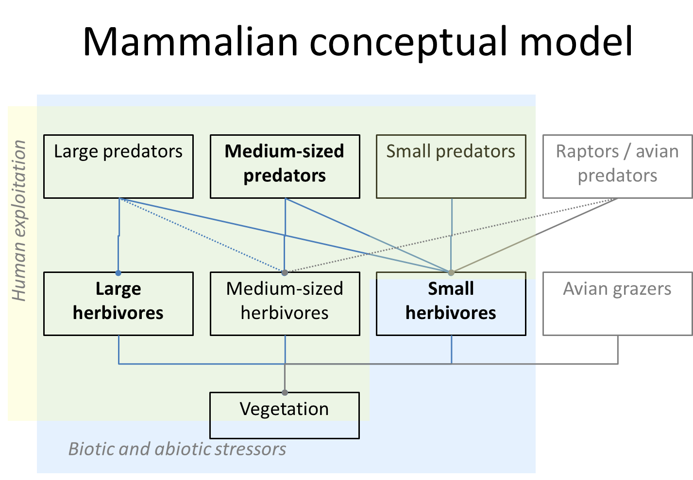
Fig. 4.3a. The Arctic terrestrial mammals conceptual model for monitoring showing focal ecosystem components and interactions.

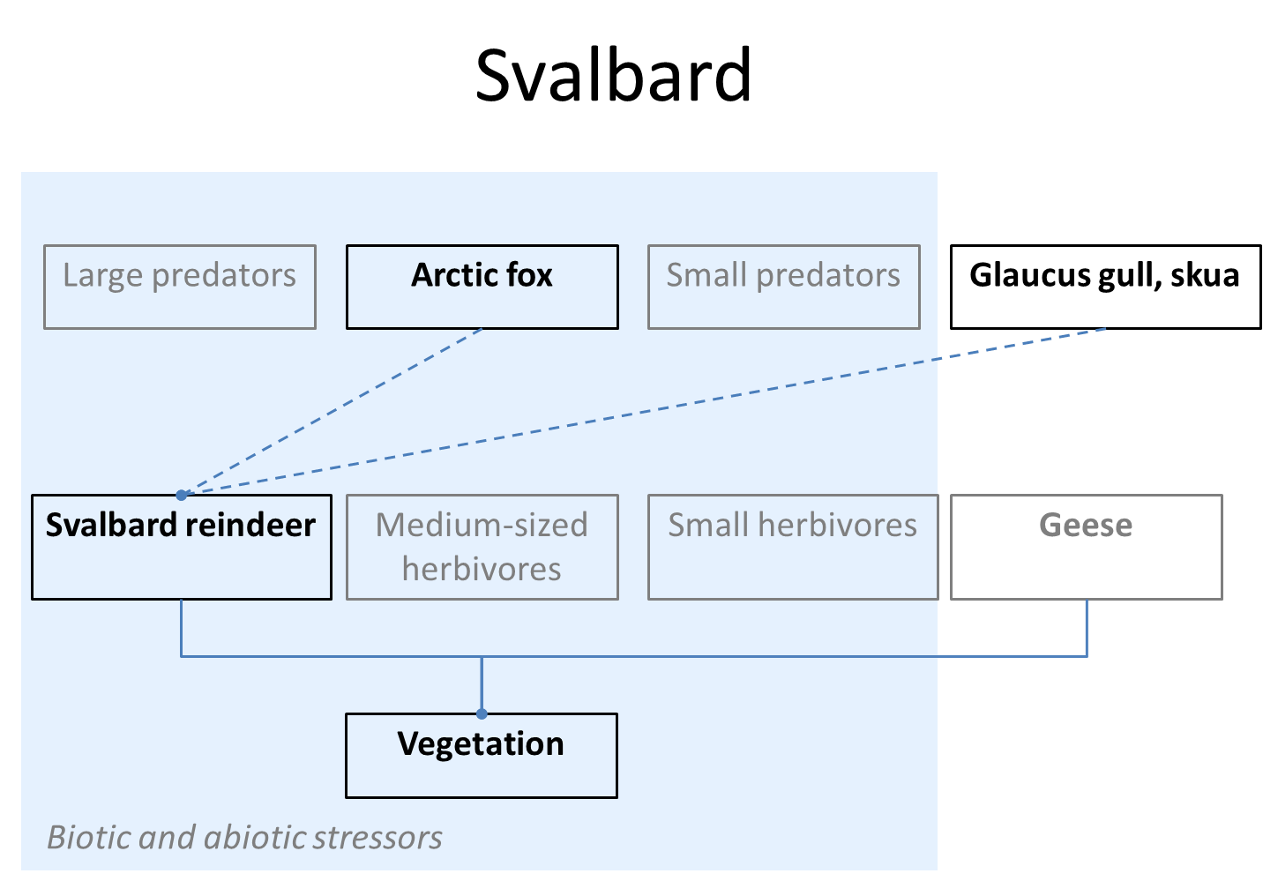
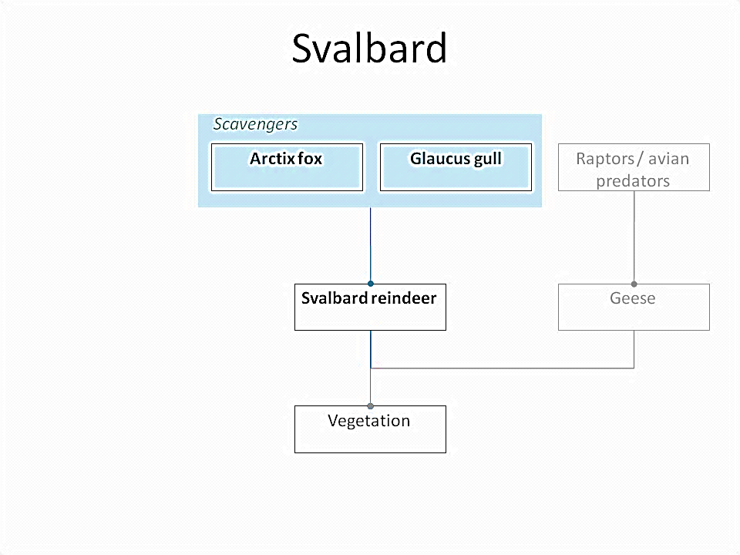

Fig. 4.3b. Conceptual model for Arctic terrestrial mammals monitoring on Svalbard.

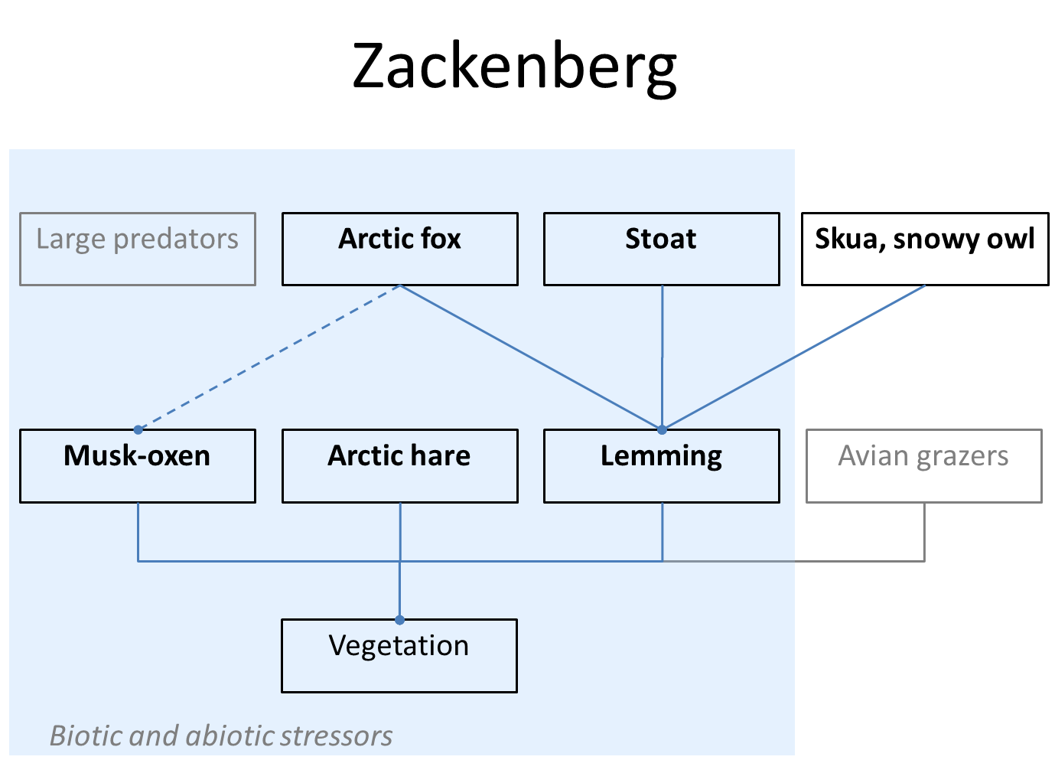
Fig. 4.3c. Conceptual model for Arctic terrestrial mammals monitoring on Zackenberg.
Table 4.3. List of focal ecosystem components for terrestrial mammals (FECs: major biodiversity elements), their attributes (compositional, structural, and functional aspects), monitoring priority of attributes, parameters of attributes (individual measures/methods to quantify attributes), geographic scale, method (monitoring technical approach or reference to methods), protocol complexity (basic or advanced) and temporal recurrence (how frequently monitoring should be conducted). Where there are existing detailed protocols, such as CARMA (the CircumArctic Rangifer Monitoring and Assessment Network; http://caff.is/about-carmahttp://caff.is/about-carma), these should be used as guidelines. Methods that are particularly recommended are in italics. Although the identified FECs are all considered very important, the most critical are in written in all capitals.
FOCAL ECOSYSTEM COMPONENT | ATTRIBUTE | PRIORITY | PARAMETER | SCALE | METHOD/ REFERENCE | PROTOCOL COMPLEXITY | TEMPORAL RECURRENCE (Minimum) | COMMENTS
LARGE HERBIVORES (caribou/ reindeer, musk ox, moose) | Abundance | Essential | Number, density | Local/ regional | Aerial/land-based surveys, cue counts | Basic | 3 years
LARGE HERBIVORES (caribou/ reindeer, musk ox, moose) | Demographics | Essential | Age structure, mortality, fecundity | Local/ regional | Aerial/land-based surveys, telemetry, cue counts | Basic | 3 years
LARGE HERBIVORES (caribou/ reindeer, musk ox, moose) | Spatial use | Essential | Distribution of migratory herds | Local/ regional | Telemetry; aerial/ land-based surveys, harvest records, tissue samples | Basic/ advanced | Varies (from seasonally and upwards)
LARGE HERBIVORES (caribou/ reindeer, musk ox, moose) | Health | Recommended | Prevalence | Local/ regional | Harvest records, tissue samples, fecal analysis | Basic/ advanced
LARGE HERBIVORES (caribou/ reindeer, musk ox, moose) | Genetics | Recommended | Heterozygosity | Local | DNA analysis | Advanced
Medium-sized herbivores (hares) | Abundance | Essential | Number, density | Local/ regional | Land-based surveys, cue counts | Basic | Annually
Medium-sized herbivores (hares) | Demographics | Essential | Age structure, mortality, fecundity | Local/ regional | Land-based surveys, harvest records, tissue samples | Basic/ advanced | Annually
Medium-sized herbivores (hares) | Spatial use | Recommended | Temporal distribution | Local/ regional | Land-based surveys, telemetry, cue counts | Basic
Medium-sized herbivores (hares) | Health | Recommended | Prevalence | Local/ regional | Harvest records, tissue samples, fecal analysis | Basic/ advanced
Medium-sized herbivores (hares) | Genetics | Recommended | Heterozygosity | Local | DNA analysis | Advanced
SMALL HERBIVORES (lemmings, voles) | Abundance | Essential | Number, density | Local | Land-based surveys, cue counts | Basic | Annually
SMALL HERBIVORES (lemmings, voles) | Demographics | Recommended | Age structure, mortality, fecundity | Local | Land-based surveys, telemetry, cue counts | Basic
SMALL HERBIVORES (lemmings, voles) | Spatial use | Recommended | Temporal distribution | Local | Live/ snap trapping | Basic
SMALL HERBIVORES (lemmings, voles) | Health | Recommended | Prevalence | Local | Tissue samples | Advanced
SMALL HERBIVORES (lemmings, voles) | Genetics | Recommended | Heterozygosity | Local | DNA analysis | Advanced
Large predators (brown bear, black bear, grey wolf) | Abundance | Essential | Number, density | Regional | Cue count, aerial/land-based surveys | Basic | 3 years
Large predators (brown bear, black bear, grey wolf) | Demographics | Essential | Age structure, mortality, fecundity | Regional | DNA analysis, den surveillance | Advanced | 3 years
Large predators (brown bear, black bear, grey wolf) | Spatial use | Recommended | Temporal distribution | Regional | Telemetry | Basic* |  | * Methods are not difficult but require specialised technology (can be expensive)
Large predators (brown bear, black bear, grey wolf) | Health | Recommended | Prevalence | Local/ regional | Harvest records, tissue samples, fecal analysis | Basic/ advanced
Large predators (brown bear, black bear, grey wolf) | Genetics | Recommended | Heterozygosity | Local | DNA analysis | Advanced
MEDIUM SIZED-PREDATORS (wolverine, Eurasian lynx, Canada lynx, red fox, Arctic fox) | Abundance | Essential | Number, density | Local/ regional | Den surveillance | Basic | Annually
 | Demographics | Recommended | Age structure, mortality, fecundity | Local/ regional | Den surveillance | Basic
 | Spatial use | Recommended | Temporal distribution | Regional | Telemetry | Basic* |  | * Methods are not difficult but require specialised technology (can be expensive)
 | Health | Recommended | Prevalence | Local/ regional | Harvest records, tissue samples, fecal analysis | Basic/ advanced
 | Genetics | Recommended | Heterozygosity | Local | DNA analysis | Advanced
Small predators (mustelids) | Abundance | Essential | Number, density | Local | Cue counts, land-based surveys | Basic | Annually
Small predators (mustelids) | Demographics | Recommended | Age structure, mortality, fecundity | Local | DNA analysis, live trapping | Basic/ advanced
Small predators (mustelids) | Spatial use | Recommended | Temporal distribution | Local | Telemetry | Basic/ advanced
Small predators (mustelids) | Health | Recommended | Prevalence | Local | Tissue samples, fecal analysis | Advanced
Small predators (mustelids) | Genetics | Recommended | Heterozygosity | Local | DNA analysis | Advanced

4.5 Arthropods and Invertebrates

4.5.0 Introduction and scope

Arctic invertebrates exhibit high diversity are biologically fascinating , and there is an increased recognition that arthropods play key ecological roles in northern systems: they pollinate plants , are tightly linked to the decomposition process in the Arctic , are pests of wildlife , and are prey to highly valued vertebrates . In a broader food-web context, there is growing evidence about the role of arthropods in the north . Research is starting to show how arthropods are being affected by shifts in global temperatures, including (for example) effects on wildlife parasites , shifts in the biomass of vertebrate prey , changes in parasitic wasp assemblages and shifts in the sexual dimorphism of spiders . It is essential that these effects do not go unnoticed, and that additional research, including long-term monitoring, be completed on key species in northern systems including invertebrates – a topic that remains as critical today as when Callaghan et al. and Danks discussed it 20 years ago.
For the purposes of this report, the focus is on invertebrates that occur in terrestrial environments, although some taxa have aquatic larval stages. Of these, the benthic invertebrates are largely covered by the CBMP- Freshwater Plan , although we will cover some aspects of biting flies (i.e., some families of Diptera) with a slightly different focus. Overall, this chapter focuses on the ecological functions of aboveground arthropods, i.e., insects and spiders, and soil living invertebrates, e.g., microarthropods, enchytraeids and earthworms.

4.5.1 Pan-Arctic sampling approach
4.5.1.1 Key arthropod monitoring questions:
- What is the status (abundance, diversity) of functionally important terrestrial invertebrate taxa occurring in the Arctic?
- What are the main trends in the status of these taxa (i.e., changes in the diversity, distribution, abundance) and relevant ecological functions?
- What are the key drivers behind the trends in key invertebrate taxa and associated ecological function
- What is the status and trends of invertebrate species of special interest, including invasive and introduced species, occurring in the Arctic?

4.5.1.2 Arthropod conceptual model
Invertebrate sampling is developed from the perspective of key ecosystem processes (see conceptual model, Fig. 3.2) in the Arctic. For invertebrates we highlight the following processes as being highly relevant: decomposition and nutrient cycling, herbivory, invertebrates as prey for birds, pollination, and blood-feeding (e.g., biting flies). There are complex food-webs embedded within each of these processes as illustrated by Figure 4.4 for soil-based food webs.
Other processes are also important (see conceptual model, Fig. 3.2), but not included in detail in this monitoring report. For example, parasitic wasps play a key role in Arctic systems, as one type of top-down control on various arthropods (e.g. spiders ; caterpillars ). These wasps will, however, be collected as part of the required plan (see below) and can be stored long-term and available for scientists in the future. We have also excluded monitoring of parasitic arthropods of large and small mammals, such as bot and warble flies, blood-feeding lice and ticks. Although these taxa and processes are important in the Arctic it is expected that mammal health will be monitored as part of the mammal monitoring plan (see section 4.4).
The decomposer ecosystem of the soil has a trophic structure spanning a broad range of taxonomic groups including microorganisms, mites, hexapoda and earthworms. The food web holds microbial feeders, detritivores and predators also characterized as primary and secondary decomposers, as they may form detritus food-chains with a few links before being eaten by a predator (decomposer food web, Fig. 4.4). Although monitoring capacity is limited at this time for these important microbes (Chapter 1), we suggest requiring the monitoring of the mesofauna with collembolans at the species level, as this group hitherto is the most feasible concerning availability of expertise and equipment . The vertical distribution and corresponding contrasting life-forms guarantees capturing environmental changes.

4.5.1.3 Existing capacity to deliver the CBMP
Monitoring of terrestrial invertebrates is rare in the Arctic (Figure A1); with the exception of Zackenberg (Eastgreenland), Nuuk (Westgreenland), Svalbard (Norway) and some recent efforts to monitor arthropod biomass in North America . There are other regional models of arthropod monitoring in other parts of the world (e.g., Alberta Biodiversity Monitoring Institute, http://www.abmi.ca/abmi/home/home.jsp) and these can be used as model in the development of an Arctic monitoring program.
There are also some important areas in which arthropod research occurs (Figure A1), but presently these areas do not have long-term monitoring in place. Existing monitoring programs are often based on specific research projects, or monitoring for specific and focused research questions (e.g., biomass sampling in Bylot, Nunavut, for assessment of prey availability for shorebirds ). Greenland monitoring is an exception, as methods at these sites include broad taxonomic coverage, diversity, abundance, phenology, and many ecosystem processes (biotic, abiotic) (e.g., see Box 4B and http://www.zackenberg.dk/ ).

4.5.1.4 Arthropod monitoring design principles & components
Given the limited coverage of monitoring programs for invertebrates, it is very difficult to prioritize locations and habitats for future monitoring. Instead we suggest invertebrate monitoring be included with other monitoring efforts as a required sampling 'module'. In other words, whenever vegetation, bird, or mammal monitoring occurs, so should invertebrate sampling. We also suggest that all active research stations in the Arctic consider adding a monitoring program for invertebrates. After invertebrate monitoring has been initiated at a pan-Arctic scale, it will be possible to prioritize for additional key locations and habitats. At a local scale, terrestrial invertebrate monitoring should ideally be done at more than one location, and more than one habitat, with plant communities and moisture gradients as key considerations in selecting habitats.
The monitoring can be approached with different levels of detail, and the capacity of individual monitoring programs depends on personnel, funding and infrastructure. Given these constraints, we have considered a sub-set of all possible attributes for each function as being required, meaning they should be part of any monitoring programs (Table 4.4). However, it is recognized that some monitoring programs may not be able to complete all required monitoring of invertebrates, and thus should pick and choose (i.e., from Table 4.4) the key attribute given logistical or financial constraints and/or if more specific management questions are a focus for a given monitoring location.

4.5.2 Sampling protocols and design

4.5.2.1 Frequency of monitoring
Invertebrate abundance and diversity varies from year to year in the Arctic , and a single season of monitoring will not provide answers to the management questions. It is therefore recommended that required sampling protocols be done on a yearly basis until yearly variation is tracked for several seasons. Once the natural range of variation is tracked, it may be possible to move into a five-year cycle of monitoring.
4.5.2.2 Sampling protocols
Protocols outlined below are separated by Essential and Recommended methods. Additional specifics about methods can be found in the included references (and see Chapter 9). When multiple traps are required per site (e.g., pan or pitfall traps), it is recommended that at least 10 traps be used per habitat. Addition of a preservative is required to allow for subsequent DNA extraction. Duration of trapping depends on specific methods. If possible, taxon sampling curves (see Buddle et al. 2005) should be used to assess whether sampling has been sufficient in reference to number of taxa collected, and in reference to sampling effort (e.g., whether 10 or more traps would be required).
The required set of protocols is considered as covering a 'minimum set' of attributes, but we advocate for a larger set of attributes to be collected if logistically possible and/or if specific management or research questions trigger the need for additional invertebrate data. We have included some of these additional protocols as recommended in a monitoring program (Table 4.4, and references therein). This strategy includes broader taxonomic coverage, but more notably, phenology and abundance or density estimates of many taxa. Critical thresholds and ecological tipping points, however, may not be detected with sampling that only completes the required protocols.
We recognize much potential in engaging local communities, schools, amateur entomologists, and other interested peoples in a 'citizen scientist' approach to monitoring aspects of invertebrates. For example, date(s) of first appearance of butterflies or biting flies, range extensions of native species, and species introductions could be tracked. On model could be something akin to the "e-butterfly" on-line resource (http://ebutterfly.ca/), or a 'bug-guide' (http://bugguide.net/) with a northern focus.

4.5.2.3 Essential protocols:
1) Blood-feeding insects. Attribute: species richness
Metric: species richness per sampling location - taxonomic resolution - species; DNA Barcoding (COI barcode, or additional barcodes)
Methods: larval and pupal Simuliidae and Culicidae collected by hand from lotic and lentic waters, respectively. Minimum of 6 streams/rivers and six ponds/pools required. Emphasis should be on sampling as many different habitats and microhabitats as possible. For simuliids, these include streams of various sizes and velocity, pond outlets, and flows that originate from groundwater or ice melt. Substrate from which larvae and pupae should be sampled includes trailing grasses, rocks, and submerged twigs. For culicids, standing water of various sizes and with different types of emergent vegetation should be sampled, including small pools in hummocky terrain or in rock crevices. For aquatic sampling, minimum of 30 minutes per habitat (e.g., individual river or pond). When sampling culicids from exceptionally small bodies of water (e.g., water-filled depressions in hummocky terrain), then 30 minutes should be devoted to collecting larvae and pupae from multiple pools in a particular area. All specimens should be fixed in 95% ethanol to facilitate DNA barcoding. Adults of simuliids and culicids, and those of other families (e.g., Tabanidae) can be collected opportunistically using a sweep-net or aspirator, or will be collected in malaise traps as part of other protocols (see below)

2) Pollination: Attribute 1: Species richness
Metric: flower (or inflorescence) visitation per hour, recorded by plant species; taxonomic diversity per visitation period, number of pollinators per pan trap; COI barcodes (or other barcodes); taxonomic resolution: dependent on expertise for Diptera, but species is required for Apoidea (i.e., including the families Megachilidae, Colletidae, Halictidae, Andrenidae and Apidae)
Methods: flower visitation rates; flower visitation should be done with dominant flowering plants, standardize by time per plant, or by area depending on habitat structure. Standardize grids of yellow, white and blue pan traps (minimum 10 traps, placed > 10 m apart), or vane traps (blue/yellow), opportunistic sweep-net collections with floral hosts recorded when possible.

Attribute 2: Pollination success
Metric: grains per stigma, % fruit set, % fruit yield
Methods: Pollination success can be measured indirectly by comparative studies of fruit set and fruit yield, requiring repeated visits to plants, i.e., done separately for different target species of plants. A more direct measure is pollen grains per stigma: this is done by comparative studies of plant stigma, with aid of field microscope. This requires repeated visits to the same plants.

3) Prey availability for birds: Attribute 1 & 2: Relative abundance / Biomass and Phenology
Metric: number or mg of arthropods per trap per day (phenology is the abundance or biomass data, over time); Taxonomic resolution: family-level.
Methods: For ground-dwelling arthropods, standardized grids of pan or pitfall traps, minimum of 10 traps per habitat, established as soon as possible after snowmelt until the end of the active snow-free season. For flying arthropods (e.g., Diptera), one standard malaise trap per habitat, sampled for the same time period as pan and pitfall traps. Note: modified trap types are possible (e.g., combined pan trap with malaise head, and horizontal screening); Specimens preserved for later DNA extraction.

4) Decomposition & Nutrient Cycling:
Attribute 1 & 2: Species richness and abundance. These two attributes are collected at the same time, and together allow for assessment of community diversity.
Metric: abundance of dominant taxa per m² at specific depths, result in measure of community diversity per location; taxonomic resolution: Species-level for Collembola, higher levels for Acari, Enchytraeidae, and other taxa.
Methods: Soil and turf cores, taken on site, returned to the laboratory for extraction, with validated extraction apparatus (i.e., Berlese funnels or MacFadyen high gradient extractors, O'Connor's Funnel for wet extraction). For each habitat, minimum of 10 samples per sample location recommended to provide a mean population density m⁻² with variability estimate, 95% confidence limits. Minimum stratum is the top A-horizon.

5) Herbivory Attribute 1: species richness
Metric: number of species of herbivores, per plant, or per area sampled. Taxonomic resolution: family-level, but stored for DNA extraction or further taxonomic research.
Method: timed visual surveys for dominant taxa of herbivores including but not restricted to Lepidoptera Hymenoptera larvae, Hemiptera. Timed surveys done on dominant vegetation; timed beat-sheet samples for woody vegetation (done for dominant plant type/species, repeated per habitat).

Attribute 2: herbivory
Metric: plant damage (as percent or category) expressed on a per plant basis, separated by damage type (e.g., skeletonize, mine, gall).
Methods: dominant plant type selected and recorded, minimum of five leaves per plant, five plants per vegetation type (or: selective plant parts for gall counts). Randomly select leaves/shoots for examination, record & damage per leaf or use categorical class as necessary; repeated for dominant vegetation type per habitat.

4.5.2.4 Recommended protocols:
An expanded set of Recommended protocols can be added to the Essential protocols in order to provide data about more attributes. The recommended protocols may be important to document the full range of natural variation and to assess thresholds and tipping points. In many cases, the additional data collection involves expanding the taxonomic scope and/or timing of sampling.
1) Blood-feeding: Abundance of blood-feeding insects (e.g., mosquitoes) can be estimated with standardized sweep-net samples taken around the collector's bodies; index is relative number of biting flies.
2) Pollination: The additional attribute for this process is distribution. Here, opportunistic sampling of key pollinators can be done through community-based monitoring efforts, with a focus on Apidae. Bumble bees are readily sampled with a sweep-net. It is also straightforward, and simple to establish grids of pan traps (yellow/white/blue) and/or vane traps.
3) Predation by birds: protocols for expanding to relative abundance and distribution will require additional laboratory work for measures of species richness and abundance.
4) Decomposition & Nutrient Cycling: broader taxonomic approach by including a selection of more than one of the main taxonomic groups. Measures of ecological functioning in terms of decomposition rate (litter-bag, native foliage); inorganic nutrient levels in soil. Response variables: community diversity, distribution, % mass loss, NPK levels Taxonomic resolution: species, when possible.
4.5.2.5 Abiotic data collection:
Metadata to be collected at each location: dereference (latitude : longitude, elevation), slope, aspect, disturbance, land-use, proximity to roads/human settlements, local weather conditions, soil type, geology, proximity to ocean, proximity to snow or glaciers, hydrology, dominant vegetation, permafrost depth, organic matter depth, active layer depth

4.5.3 Site establishment data

Recommended abiotic data to be collected at each location: decomposition (litter bags with native foliage), nutrient budgets (N by compartments), pH, temperature, humidity.

4.5.4 Sampling sorting, long-term storage, and DNA barcoding

Any invertebrate monitoring program requires a short and long-term plan for specimens. In the short-term, bulk samples should be sorted minimally to Order (or lowest taxonomic level whenever possible) as soon as possible after collecting. Samples should be data-based (with metadata) immediately and residues put into ethanol for long-term cold-storage so that DNA can be preserved and later extracted for DNA Barcoding analyses . Long-term, environmental barcoding methods have potential for use in Arctic monitoring plans (e.g., next generation sequencing, ), but in the shorter-term (10-15 years), specimens (sorted, identified) are required to fill in the immense gaps in knowledge about Arctic invertebrates.

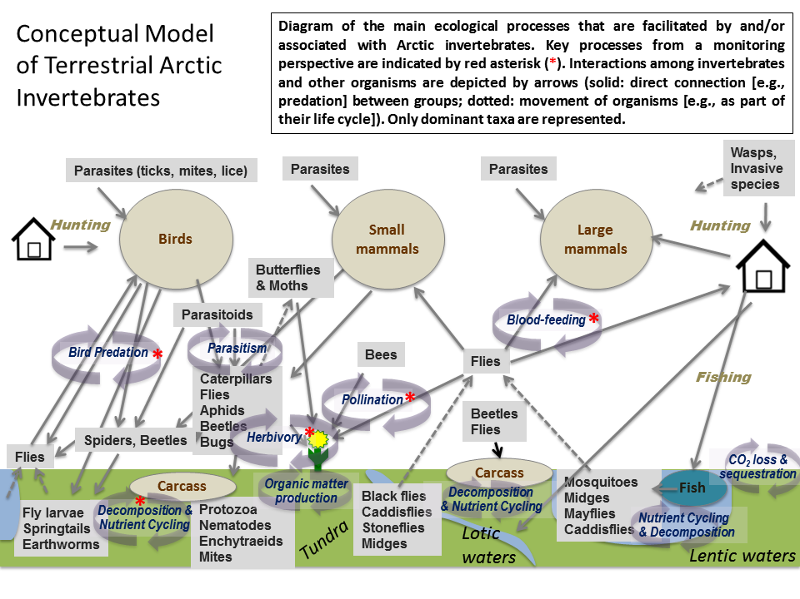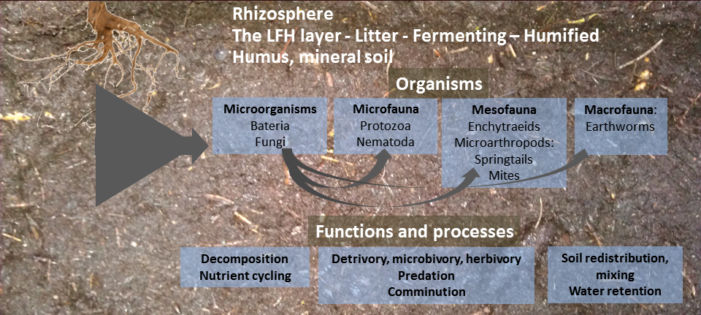
Figure. 4.4. The Arctic terrestrial invertebrates monitoring conceptual model; the bottom panel shows a model of the soil ecosystem.
Table 4.4. List of focal ecosystem components for terrestrial arthropods (FECs: major biodiversity elements), their attributes (compositional, structural, and functional aspects), monitoring priority of attributes, parameters of attributes (individual measures/methods to quantify attributes), geographic scale, method (monitoring technical approach or reference to methods), protocol complexity (basic or advanced) and temporal recurrence (how frequently monitoring should be conducted).
FOCAL ECOSYSTEM COMPONENT | ATTRIBUTE | PRIORITY | PARAMETER | SCALE | METHOD | PROTOCOL COMPLEXITY | TEMPORAL RECURRENCE | COMMENTS
BLOOD-FEEDING: Diptera (e.g., Culicidae, Simuliidae, Ceratopogonidae, Tabanidae) | Community structure (diversity; species richness) | Essential | Species richness (estimates) - local | Local | Larvae collections in aquatic habitats, sweep net samples for adults; sweep net samples around ungulates | Basic / Advanced (for taxonomy) | 3-5 yrs | Knowledge of the entire community is important; invertebrates such as biting flies are important for wildlife and humans, as disease vectors, etc. Community monitoring could be used to collect data on species richness.
 | Abundance | Recommended | Relative abundance, terrestrial and aquatic, via sweep sample / in ponds / densities | Local | Examples: # per unit effort (time, or number of sweeps), density per unit area/volume; baited traps; for aquatic, may need special nets | Basic / Advanced (for taxonomy) | 3-5 yrs | Difficult to get accurate estimates of density, although a relative activity index may be possible. Abundance of these species could act as a driver for large mammals.
 | Distribution | Recommended | Species presence/ absence | Regional/ pan-Arctic? | Same as above & historical collections (i.e., previously collected material) | Basic / Advanced (for taxonomy) | 3-5 yrs | Understanding range expansions of these species could be important in some locations.
 | Phenology | Recommended | Date of first emergence, seasonal activity | Local | Same as above, plus traditional knowledge (local, community) | Basic | 3-5 yrs | Important but requires full season monitoring which may not be possible
 | Demographics | Recommended | Body condition, life stage; sexes | Local | Analyses of sample sets; identification of sexes and stages | Basic / Advanced (for taxonomy) | Varies by group: As req. (min 5 yrs) | Perhaps in the future blood samples could be analyzed (DNA barcodes)
POLLINATION: Hymenoptera (e.g. Colletidae, Andrenidae, Halictidae, Megachilidae, Apidae), Diptera (many families) | Community Structure (Diversity) | Essential | Species richness (estimates) | Local | Flower visitation observations, sweep nets, passive sampling, i.e., collections in standardized yellow / white / blue pan traps (grids of traps), vane traps | Basic / Advanced (for taxonomy) | 3-5 yrs as a minimum; annually if possible | Bees are important in arctic systems, and taxonomically well-known but standardized techniques that are quick/efficient are lacking.
 | Abundance | Recommended | Relative number per sweep transect, or flower surveys | Local | # visitations per unit time; number of specimens per sweep, net transect, or timed sweep-net surveys | Basic / Advanced (for taxonomy) | Ideally, Annually | Difficult to standardize 'relative abundance' in monitoring program
 | Distribution | Essential | Presence / Absence | Local to pan-Arctic | Same as above, plus other published literature, historical collections & consultation with experts | Basic / Advanced (for taxonomy) | Ideally, Annually | Some pollinator species (e.g. Apidae) could be monitored via community efforts.
 | Phenology | Recommended | Seasonal activity patterns | Local | Traditional/ community knowledge | Basic | Ideally, Annually | Potentially important but not feasible without specialist and intense monitoring all season
 | Pollination success, fruit-set, and yield | Essential | Fruit set and seeds | Local | Some focal surveys required; traditional/ community knowledge | Basic and Advanced | 3-5 yrs as a minimum; annually if possible | This process is facilitated by arthropods, but is not a direct measure of pollinator species; this attribute is a driver for plant fitness.
FOOD PREY FOR BIRDS: Araneae, Diptera (e.g., Tipulidae), Lepidoptera | Community Structure (Diversity) | Recommended | Species richness (estimates) - local level | Local | Standard grids of pan and/or pitfall traps | Basic (some taxonomy req.) | 3-5 yrs | Spiders as top predators and as easily sampled taxa should be a priority
 | Relative abundance & Biomass | Essential | Relative number per trap | Local | As above; can conduct standardized area sampling to achieve density estimates also (labour intensive) | Basic and Advanced | 3-5 yrs | Possible if standard protocols can be used. This is a key driver for insectivorous birds.
 | Distribution | Recommended | Presence / Absence | Regional, pan-Arctic | As above, but include consultation with experts, historical collections | Basic and Advanced | 3-5 yrs | See above
 | Phenology | Essential | Seasonal activity patterns | Local | Same passive sampling approach but done over entire active season, from snowmelt until snow arrival; possible community / local knowledge? | Basic (some taxonomy req.) | 3-5 yrs | Potentially important (e.g. for vertebrate feeding), but requires season-long monitoring plan
 | Body condition | Essential (wolf spiders) | Body condition index, body size index, clutch size (wolf spiders) | Local | Wolf spiders only: body size index; clutch size of females, parasitism rates | Basic and Advanced | 3-5 yrs | Simple to conduct for some taxa, e.g. wolf spiders
DECOMPOERS & NUTRIENT- CYCLING: Soil Mesofauna (Collembola, Acari Enchytraids), Detrivores s.l. (Fungivores, Bacterivores, Saprophages), macroinvertebrates (e.g., earthworms), microfauna, microorganisms | Community Structure (Diversity) | Essential | Species richness (estimates) - local | Local | Soil and turf cores, taken on site, returned to laboratory for extraction (i.e., Berlese funnels or MacFadyen high gradient extractors, O'Connor's funnel for wet extraction) | Basic and Advanced | Annual | Sampling can be conducted over a short time should that be all that logistics allow. Collembolans are feasible to include concerning taxonomy. A trait-based (light-weight pseudotaxonomy short-cut) approach may be proposed in the future. Enchytraids and mites are difficult to identify. DNA Barcoding will provide a solution to this obstacle and deliver presence/ absence data (CBOL programme). It is also possible to use higher level taxonomy instead of species to increase feasibility.
 | Abundance | Essential | Density estimates i.e., number per standard soil core | Local | Numbers calculated per sq. m at a specified depth | Basic and Advanced | Annual | Abundance data (i.e. density) are collected with the same protocols as used for determining species richness; straight-forward.
 | Distribution | Essential | Presence/ absence | Local/ regional/ pan-Arctic | All collembolan life-forms (~4 types, representing the vertical stratification from epi-phytic to true soil-dwelling). The horizontal distribution is not included in environmental surveys, except for variance estimates between samples collected in a random but stratified manner. [Same species and target species/groups. Consult historical collections / experts] | Basic and Advanced | 3-5 yrs | For some taxa, getting presence/ absence is possible and high priority, given high feasibility (i.e. taking soil cores); DNA barcoding will facilitate this in the future
 | Demographics | Recommended | Phenology, voltinism, pgr (population growth rate) | Local | Repeated sampling | Basic and Advanced | Monthly
 | Nutrient levels | Recommended | NPK | Local | Sampling nitrogen, phosphate, potassium: chemical analyses | Advanced | As req. | These nutrients are a result of invertebrate activity within the soil/ tundra.
 | Decomposition | Recommended | % mass loss | Local | Method to be updated | Basic and Advanced | As req. | These nutrients are a result of invertebrate activity within the soil/ tundra.
HERBIVORES (Lepidoptera, Symphyta, Aphidae, Hempitera, Coleoptera, Acari) | Community Structure (Diversity) | Essential | Species richness (estimates) - local | Local | Opportunistic collection of adults and/or standardized sweep samples) / systematic surveys of plants for larvae | Basic (some taxonomy req.) | 3-5 yrs | Given the popularity of butterflies, and ease of identification, local estimates of species could be worthwhile
 | Abundance | Recommended | Relative number per sweep transect; visual surveys, number per beat-sheets (density) | Local | Opportunistic collection of adults; standardized sweep samples; standardized beat-sheet sample / systematic surveys of plants for larvae | Basic (some taxonomy req.) | Annually | Difficult to achieve by non-specialist
 | Distribution | Essential | Presence / Absence | Local/ regional/ pan-Arctic | Same, but also using expert knowledge, e-databases (e.g., e-butterfly), community/ local knowledge | Basic and Advanced | 3-5 yrs | Feasible and important (e.g. range expansions)
 | Herbivory | Essential | Plant damage | Local | % leaf area lost, index of leaf damage, leaf miner damage | Basic | Annually | This is an indirect measure of insect feeding, Time consuming; may be difficult to achieve.
 | Body Condition (resource acquisition, stress levels) | Recommended | Body size, pupal mass | Local | Weight of caterpillars, pupal cases | Basic | 3-5 yrs
 | Phenology | Recommended | Seasonal activity patterns | Local | Timing of first appearance, local/ traditional knowledge, season-long sampling | Basic | Annually | Requires season-long monitoring, which is time consuming and difficult, but potentially of high priority to monitor outbreaks
 | Demographics | Recommended | Population estimates (cycles), larvae/adult dynamics | Local | See methods above for abundance | Basic | Annually | May be high priority if damage is significant

5 Data Management Framework for the Arctic Terrestrial Monitoring Plan

5.1 Data Management Objectives for the CBMP

CAFF’s CBMP data management objectives are focused on the “art of the possible”—developing data-management systems that facilitate improved access to existing and current biodiversity data and integration of these data among disciplines, while maintaining the data holders’ ownership and control of the data. The CBMP aims to create a publicly accessible, efficient, and transparent platform for collecting and disseminating information on the status and trends in Arctic biodiversity. In essence, the primary objective is to create linkages to data where it already resides. However, in instances where this is too onerous, CBMP aims to provide alternative data management structures to host the data for partners. This objective will be instrumental in achieving the Program’s mandate to report on trends in a timely and compelling manner so as to enable effective policy responses.
It is expected that each country would still be responsible for supporting data management (e.g., QA/QC of data and compilation of existing national datasets) and providing data from their individual monitoring networks (i.e., the data holders). In contrast, the CBMP will focus efforts on building the mechanisms to access and integrate these data across countries and networks, as well as promoting a common, standardized data-management approach among the countries. For this approach to be successful, it is imperative that appropriate national and sub-national datasets are identified (metadatabases) and made available (interoperable linkages) to the CBMP.
Biodiversity data sources and formats vary widely across the Arctic. Thus, it will be challenging to access, aggregate, and depict the immense, widely-distributed, and diverse amount of this terrestrial biodiversity data from the many contributors involved in this monitoring. A related challenge is to integrate and correlate this information with other relevant data (e.g., physical, chemical, etc.) to better understand the possible causes driving biodiversity trends at various scales (regional to global). Furthermore, it is critical to deliver this information in effective and flexible reporting formats to facilitate decision-making at a variety of scales from local to international. Meeting these challenges will significantly improve policy and management decisions through better and timelier access to current, accurate, and integrated information on biodiversity trends and their underlying causes at multiple scales.
In some cases, especially for the higher trophic levels, biodiversity data and relevant abiotic data layers are already available and can be integrated into the CBMP’s Data Portal system (www.abds.is). However, the task of aggregating, managing, and integrating data for the lower trophic levels is arduous, and it may be some time before such information can be accessed readily via the CBMP Data Portal. The establishment of national Terrestrial Expert Networks (TEN) as defined in Section 8.1, and support from each nation and the CAFF Data Manager will facilitate this process through the adoption of common data and metadata standards and the development of common database structures.
The following sections provide an overview of the data-management framework to be used for managing the outputs of the CBMP-Terrestrial Plan. Such a framework is essential to ensure effective, consistent, and long-term management of the data resulting from coordinated monitoring activities.

5.2 Purpose of Data Management

Effective and efficient data management is fundamental to the success of the CBMP and its monitoring plans. A measure of success will be the ability to effectively connect individual partners, networks, and indicator-development efforts into a coordinated data-management effort that facilitates data access and effectively communicates Arctic biodiversity status and trends to a wide range of audiences and stakeholders. Executed correctly, data management can fulfill the following functions:
Quality Assurance: ensures that the source data sets and indicator development methodologies are optimal and that data integrity is maintained throughout processing;
Consistency: encourages the use of common standards and consistent reference frames and base data sets across parameters and networks;
Efficiency: reduces duplicate efforts by sharing data, methodologies, analysis, and experience;
Sustainability: ensures archiving capability and ongoing indicator production;
Enhanced Communications: produces and distributes information through integrated web-based services, making indicator methodologies accessible and providing source metadata;
Improved Linkages: ensures complementarities between various networks and partnerships and with other related international initiatives, other indicator processes (national, regional, and global), and global assessment processes (e.g., the Global Biodiversity Outlook and Millennium Ecosystem Assessment); and
Enhanced Credibility: provides transparency with respect to methodologies, data sets, and processes.
Implementation of the CBMP-Terrestrial Plan will rely on participation from many partners. An efficient and user-friendly metadata and data management system will facilitate this collaboration, providing multiple benefits as outlined above. It will offer unique opportunities for monitoring networks to exchange data, draw comparisons between data sets, and correlate biodiversity data with data derived from other networks, using a common, web-based platform. A roadmap for data management, the CBMP Data Management Strategy (C. Zöckler, 2010; unpublished), has been developed to guide the management and access of metadata and data among the CBMP networks.

5.3 Coordinated Data Management and Access: the CBMP Web-based Data Portal

While a large amount of terrestrial biodiversity information is produced by various networks in diverse formats, much of it is inaccessible, not reported, or in user-unfriendly formats. New, web-based data management tools and new computational techniques have provided an opportunity for innovative approaches for the data management and integration that is critical for a complex, international initiative such as the CBMP.
CAFF’s CBMP has developed a state-of-the-art data portal (www.abds.is ), which is a simple, web-based and geo-referenced information network that accesses and displays information on a common platform to encourage data sharing over the Internet. The data portal represents a distributed data management structure where data holders and publishers retain ownership, control, and responsibility for their data. Such a system provides access to immediate and remotely distributed information on the location of Arctic biological resources, population sizes, trends, and other indicators, including relevant abiotic information. As well as providing a point for Arctic biodiversity information, the data portal provides a simple approach for experts to share information through the web and allows for the integration and analysis of multiple data sets.
The CBMP’s data portal requires the establishment of a series of data nodes, with each data node representing a data type or discipline (e.g., caribou, shorebirds). Each data node will be established and supported nationally, most likely through connections to the TEN that will be established in each country (see Chapter 8 for details). The CAFF Data Manager will interact with the national nodes to ensure inter-operability and data aggregation and will provide overall maintenance and management of the resulting pan-Arctic aggregated data in the most efficient way possible. In some cases, where appropriate, the CBMP will establish web-based data-entry interface systems (web services) tailored to each data node/discipline, allowing researchers in each country to enter their data on an annual or semi-annual basis (depending on the frequency of data collection) via the Internet. This information will be aggregated, automatically populating a database established at an organization of the national TEN’s choosing. The TEN leads will have overall administrative privileges (password-controlled) to view, maintain, and edit the database. Each expert within a discipline group will have access (via a password) to enter and maintain their own data. Each TEN will be responsible for defining and implementing the analytical approaches to generating the indicators. The CBMP will work with each TEN to establish analytical outputs, via the Data Portal, tailor-made for the data collected and housed at the data node. Priority indicator data will be managed via the web portal whereas other dataset compilations can be directly archived at the CAFF Secretariat or through an agreement with an existing data center.
Users (e.g., scientists, decision-makers, and the public) will have password-controlled access to the data outputs via the CBMP Data Portal. Users will be able to perform set analyses (defined by each TEN) on the Portal, which will immediately access the most current data at the data node and display the output of the queried analysis. Much of the initial work in the implementation phase of the CBMP-Terrestrial Plan will involve aggregating existing data sets to create pan-Arctic data layers. The life cycle of the data, from collection to presentation, is shown in Fig. 5.1.
The CBMP Data Portal will be flexible, freely accessible or password driven as appropriate, and customizable to serve a diversity of clients (Fig.5.2). The general public will have access to broad indicators and general information on Arctic biodiversity data trends. National and sub-national governments as well as the national TENs will have the opportunity to customize the Portal for their own purposes (e.g., display only the geographic scope of relevance to them). Both governments and TENs will have the authority to choose which data layers are publicly available. In addition, they will have a password-controlled domain to allow the inclusion of other data layers that are not publically accessible (e.g., unpublished data or draft reports).
This model of operation allows for user involvement at a variety of stages and can accommodate a large number of participants. The aim is to facilitate complete access to the collective knowledge, analysis, and presentation tools available from the many participants and stakeholders both within and outside the Arctic community.
The web-based portal will serve two purposes for the CBMP. First, it will provide access to geo-referenced information from within partner networks, as well as providing a common platform with multiple entry points for controlled data access, integration, harmonization, and delivery. Secondly, it will enable a wide range of user groups to explore trends, synthesize data, and produce reports with relative ease. The web-based data portal will generate indicators representing status and trend analyses, which in turn will be reported by the CBMP through a variety of means. These could include turnkey web-based reports and status and trends reports at multi-year intervals.
Development of this distributed system will necessitate the adoption and use of existing and widely accepted standards for data storage and query protocols, along with high-quality and standardized metadata and web servers (spatial and tabular). The metadata will be housed on an existing meta-database system (Polar Data Catalogue http://www.polardata.ca/whitesnow/ ) allowing for simple and efficient access to a large and constantly updated, web-based, searchable, geo-referenced metadata system. The Arctic terrestrial monitoring identified as core to the implementation of the Terrestrial Plan will be input into this meta-database.
Geo-referencing will be critical to the successful integration of disparate data sets. Resolving the different spatial recording schemes used between the various data nodes and data holders—as well as the ranges of data volumes and bandwidth—will be challenges to overcome. Techniques will be devised to convert data into a standard format for integration. These technical issues will be addressed during the implementation phase.

5.4 Data Storage, Policy and Standards

A decentralized data storage system is proposed for the CBMP web portal because it offers a solution to concerns over data ownership and copyright. Through this system, the storage, responsibility for and ownership of the data will always remain with the data collector, publisher and/or holder. Although the data are decentralized, access to and depiction of the data is unified, allowing for multiple integrations for the user.
CAFF’s CBMP encourages data providers to comply with the Conservation Commons (http://conserveonline.org/workspaces/commons/ ) and IPY Data Policy (http://ipy.org ) on the delivery of free biodiversity data to the public, and equivalent legislation in the European Union for spatial information, such as the INSPIRE Directive (http://inspire.jrc.ec.europa.eu/ ). The web portal will allow for organized and restricted access to data where necessary. Compliance with accepted data policies and provision of data to the CBMP Data Portal system will result in password access being provided to the data layers found on the Data Portal. This incentive-driven approach should encourage scientists and others to contribute their data to the Portal as it will result in their access to other data layers relevant to them. Depending on the project and publication circumstances, the CBMP suggests a delay of no more than two years before information is released to the public, according to data type and project history.
In order for the various networks involved in implementing the CBMP-Terrestrial Plan to collaborate, input, and share data and metadata, common data and metadata standards should be followed. Freely available software allows users to apply these metadata conveniently and post them online with the clearinghouses (e.g., Polar Data Catalogue: http://www.polardata.ca/). Because data that lack details about their origin, methods, dates, collector names, and so on (metadata) can be virtually unusable, both data and their metadata are crucial requirements and thus requested by funding agencies and the data initiatives cited here. CBMP will encourage access to interoperable metadata nodes or storage at CBMP’s main metadata node (at the Polar Data Catalogue) as the first step in enhancing access and coordination of Arctic data.

Collection
Aggregation
Analysis & Synthesis
Presentation
Monitoring
Networks &
Nations
Terrestrial Expert
Networks
Terrestrial Expert
Networks & Portal
Data Portal

Figure 5.1. A simplified overview of the steps involved in accessing, integrating, analyzing, and presenting biodiversity information via an interoperable web-based data portal and an indication of the responsibilities at each step.

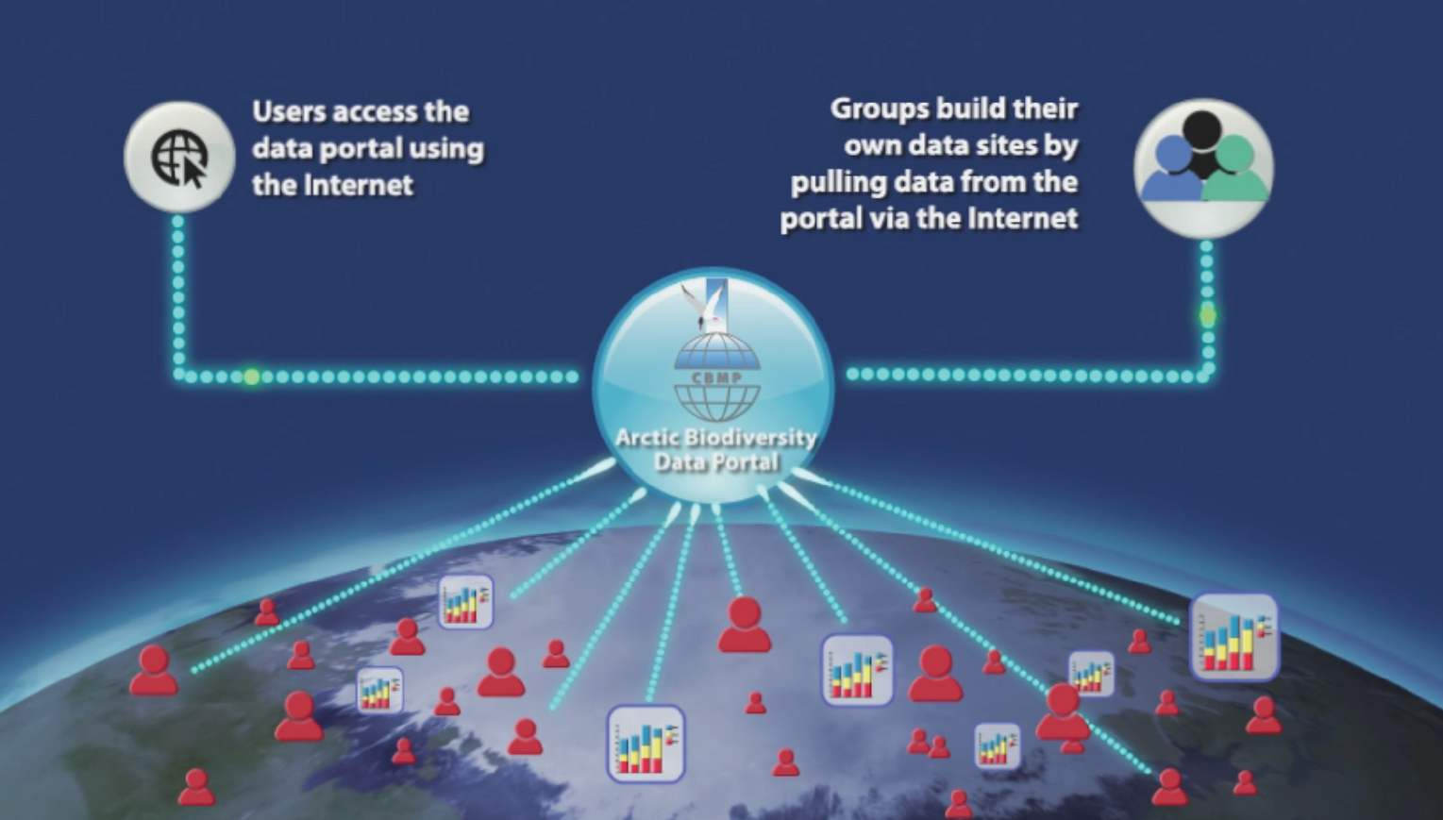

Figure 5.2. Illustration depicting the Data Portal concept and how clients can utilize the system to meet their specific needs.

6 Data, Samples and Information Analysis

6.1 Basis for Analysis

6.1.1 Start-up phase

6.1.1.1 Stakeholder and partner engagement
The successful implementation of the CBMP-Terrestrial Plan will depend entirely upon the engagement and participation of Arctic terrestrial biodiversity monitoring practitioners, stakeholders and users. The start-up phase will continue to recruit partners and engage them in the monitoring strategy. This outreach was initiated at the planning phase and must continue through the implementation phase. Active dialogue and communication with existing and new partners will be essential throughout the process.

6.1.1.2 Understanding baselines and natural variation
As described in section 3.7 and 3.8, the CBMP TEMG aims to characterize the range of natural variation for each identified parameter, at the appropriate scale. This context will help to interpret the significance of an observed biological condition and trend. Moreover, assessing the range of variation needs to be at the appropriate ecological scale. For example, for cyclical populations, the CBMP-Terrestrial Plan may assess both the population amplitudes and the range of changes in the cycle of populations.
During the start-up phase, temporal and spatial information of selected parameters will identify baseline conditions ascribed to a particular point in time or space and describe a parameter’s range of natural variation. Sources for this historical information will include traditional ecological knowledge and existing long-term monitoring data. Initiatives such as the International Polar Year “Back to the Future” research project (http://www.btf.utep.edu/) are particularly helpful for establishing long-term trends and natural variation. Historical satellite imagery can be compiled to establish baselines dating back to the 1970’s or 1980’s. Museum records, inventory data and published literature will also assist in building the historical ecological conditions or baselines. An International Arctic Vegetation Database will be a helpful tool for assessing the baseline of Arctic vegetation communities. To this end, additional Identification and digitization of historic datasets may be required. Where this has been done, access and coordination of historical datasets would follow. Natural archives in sediment can also be investigated using pollen and microfossil identification and new advances in DNA barcoding to complement modern data on historical trends (see below), within the capacity and requirements of the program. Establishing baselines from existing data may not be possible for all taxa, notably those which are data-deficient (e.g., terrestrial invertebrates). Several years of data collection following implementation of the CBMP-Terrestrial Plan may be required to identify spatial and temporal baselines.
During the start-up phase of implementation, methods to harmonize and integrate data from differing monitoring protocols, including traditional knowledge, for the key parameters in the CBMP-Terrestrial Plan will be identified, and need to be developed as required. This may involve creating strategies to calibrate data from one protocol to another and to calibrate between differing levels of study precision or resolution. Maintaining documentation for the transformation or calibration process will be essential. Where these integration methods already exist , and have proven to be robust and rigorous, these will be reviewed by the CBMP-Terrestrial Plan and considered for adoption.
Once these harmonization methods are in place, the integration and meta-analysis of existing data is recommended to inform an assessment of baseline conditions and trends to date. The data assessment tools or method will depend on the focal ecosystem component, attribute and parameter of interest and the spatial scale over which the analysis is required.

6.1.1.3 Statistical analysis of existing data and requirements for future data
Power analysis quantifies the relationship between the elements of a statistical inference including effect size, variation, confidence, power and sample size. It is a tool to assess the costs and benefits of alternative sampling designs and to estimate the quality of information that will result. A power analysis of existing integrated datasets related to the CBMP-Terrestrial Plan parameters is recommended to identify, where possible, the confidence in observed changes based on existing data relative to the monitoring question. Power analysis on data deficient taxa may not be possible, however, as a result of, for example, a lack of a priori information on variance estimates. An assessment existing and anticipated monitoring capacity to assess change across the spatial scales of interest for each CBMP-Terrestrial Plan parameter, using the spatial strata identified in Chapter 4 will be undertaken.
Power analysis should also be used to resolve the appropriate sample size required to detect change with the confidence desired at the scale desired. This will necessarily require further discussion of desired precision and confidence of the monitoring scheme with Arctic stakeholders. Power analysis has been conducted for some CBMP-Terrestrial Plan parameters at specific spatial scales. For example, a power analysis of four Arctic plant communities in Canada at two sites recommended monitoring between 10 and 20 plots within each plant community and grouping abundances by functional group, rather than by species . In the start-up phase, oversampling is recommended where capacity exists in order to support analysis of required sample size to obtain sufficient confidence and power. These analyses can be used to identify priority areas to identify partnerships for future data collection in support of the CBMP-Terrestrial Plan.

6.1.2 Implementation phase

Chapter 4 describes the recommended monitoring methods and temporal sampling frequency for each priority parameter. CBMP-Terrestrial Plan implementation partners and stakeholders will be encouraged and supported, as possible, to gather and process data following the recommended sampling design and to share and integrate the data as described in Chapter 5. Digitization and sharing, using common accepted standards, and creating comprehensive metadata will be paramount to the long-term use and accurate interpretation of data. As data is gathered, adaptation and tailoring of the CBMP-Terrestrial Plan to suit the needs of users and enhance data quality and monitoring effectiveness may be required.

6.2 Data Samples

6.2.1 Sample processing

Some CBMP-Terrestrial Plan recommended parameters will require sample processing and further analysis, including specimen sorting, taxonomic work, genomic testing or contaminant testing. Methods for sample processing should follow recommended protocols. Where required, coordinated, clear procedures for sample processing should be developed. The procedures must describe the chain of responsibility for sample processing and maintain high standards. Where such procedures exist, they should be harmonized. Some methods for sample processing are described in Chapter 4.

6.2.2 Sample archiving

The CBMP-Terrestrial Plan recommends that participating monitoring agencies follow standardized protocols for appropriately storing and archiving biological data collections. This will be true for all data sources including remotely sensed products, genomic data, and biological samples. For example, vegetation samples may be stored in herbaria, including digital herbaria, and invertebrate samples should be sorted, preserved in ethanol, and stored in long-term cold storage, as described in Chapter 4. Appropriate DNA preservation of samples will enable future barcoding analyses. Long-term, environmental barcoding methods have potential for use in Arctic monitoring plans (e.g., next generation sequencing ), but in the shorter-term (10-15 years), specimens (sorted, identified) are required to fill in the immense gaps in knowledge about Arctic invertebrates.

6.2.3 Tools, samples, and baselines to complement monitoring and future surveillance efforts

The potential of powerful new approaches for inclusion in current and future monitoring activities was mentioned briefly in Chapter 1. Such approaches include technology-based tools such as analyses of genetic data and stable isotope signatures, and satellite-based tracking. Novel tools are improving our knowledge on the ecology of species, enable monitoring changes in population connectivity and health, and provide a method to detect the effects of shifting drivers from human activities and climate change (e.g. the immigration of non-native lineages, transport of contaminants, and adaptive potential of populations). To illustrate the value of such tools, some applications are discussed below.
Ancient DNA methodology and advances in wildlife forensics have been invaluable in studies of populations even when species have migrated out of an area, are rare or difficult to study, or are sensitive to direct disturbance. Through improvements in technology in laboratory equipment (e.g. Next-generation sequencing technologies) and computing (e.g. computation-intensive analyses and data storage), and through the continued optimization of sample-collection, preservation, extraction, and screening methods, hair, feathers, egg fragments, degraded carcasses, museum skins, and even fecal samples can be used for studies of species. For example, even short fragments may be useful for species identification and clarifying systematics (e.g. DNA Barcoding and environmental sequencing), and for inferring the presence or origin of taxa in historic samples . Novel cryptic species and their status as endemics or representatives of cosmopolitan taxa have been uncovered by complementing other morphology –based taxonomic or lab culturing approaches . Genetic studies can complement behavioural studies of reproduction , and even of the future reproductive potential of species through dormant egg or seed banks . Combining phylogeographic (distribution of lineages) and phylogenetic (relationships among lineages) analyses can facilitate the distinction between expanding immigrant lineages from endemic taxa, tracing the origin of individuals, following colonization routes, and tracing species invasions and epidemics . Fecal samples, even from small avian taxa, are yielding DNA for population studies, and even providing insight into the prey species and diet of these taxa . Population genetics (sampling individuals within or/and among populations) enables investigating diversity (heterozygosity, the number of alleles and their frequency), genetic structure and meta-population dynamics (sources and sinks; population age), inbreeding and/or outbreeding depression (in small populations, the negative effects of breeding with close kin, or of locally-adapted populations becoming ‘swamped’ by immigrating individuals with unsuitable alleles from elsewhere). Comparative genomics and functional genomics approaches continue to be costly, but the availability of freely-accessible bioinformatics databases such as the Barcode of Life Database (http://www.barcodinglife.com/), GenBank (http://www.ncbi.nlm.nih.gov/genbank/), and the European Bioinformatics Institute (http://www.ebi.ac.uk/Databases/), provide outstanding resources to facilitate low-cost but high-quality and high-impact research. Furthermore, comparative studies of functional genes can provide insight into the ability of species and populations to adapt to future change .
Biogeochemical analyses of stable isotope signatures and trace elements provide broad to fine-scale geographic and temporal reference points for samples. Such analyses in conjunction or in addition to the use of genetics, satellite-based tracking technologies, and other tools, can provide crucial information on species movements, population declines, diet, and environmental conditions including the presence of contaminants. For example, temporal diet shifts and population bottlenecks have been inferred for some avian species following DDT exposure . For migratory species, stable isotope signatures have been invaluable to study movements and diet (particularly δ ¹³C and δ ¹⁵N to infer trophic level, and δ ²H to infer latitudinal and altitudinal gradients in a general sense), and in combination with genetics and satellite-based tracking tools (e.g. data loggers and accelerometers), these approaches are revolutionizing our studies of migratory species which are difficult to observe outside of the reproductive period . Furthermore, behavioral focal studies of species or even individuals in conjunction with these approaches can provide much insight into the movement, habitat use, threats to populations and their location, and the adaptive potential of populations as prey distributions shift or as food webs change . Similarly, through these approaches, it is now possible to trace the origins of contaminants within and outside the Arctic. For example, biogeochemical analyses have been used to trace the input of contaminants through migratory species functioning as vectors, including birds and migratory fish . Birds, and colonial species in particular, create nutrient-rich ornithogenic soils near colonies that support a diversity of and abundance of species , and thus have the potential of introducing contaminants into foodwebs via soil and water transport. Using advanced tools in combination, however, may enable the tracking of migrants and their origins, the early detection of contaminants, and thus the identification of pollution sources.
Archived samples and artifacts (from collections to crafts), as well as specimens from archaeological sites, or preserved in-situ at locations throughout the Arctic, provide a wide range of temporal and spatial scales to serve as baselines and for monitoring. As opportunities arise, incorporating advanced approaches into current monitoring or occasional collaborative studies is encouraged. As a first step, participation in the archival process of valuable baselines, the planning of future strategies and collaborative initiatives, and even in the sampling and storage of data and tissues for future study is recommended.
Because of current logistic challenges, costs, and constraints due to monitoring capacity, or even the perception of complexity, advanced tools are not being used to their full potential at present. While challenges exist particularly related to costs and the advanced applied knowledge required in some cases, the perception of complexity may be needlessly limiting our ability to visualize the enormous value of such baselines and snapshots of current states of change. Shifts in our perception are required to encourage the planning of sampling strategies that can be implemented in the short or long term, but that include the foresight of future needs. In fact, with some initial effort, overcoming some of our current limitations for the first steps may be feasible today through collaboration with academic, community, corporate or industrial partners. Accommodating existing infrastructure, matching needs with resources, and building on existing training opportunities and capacity-building, communication and networking resources, may be possible now. As an illustration, even the initial collection and storage of data or samples that could eventually serve as unrecoverable baselines can be critical for future monitoring needs, but may be accommodated with some modifications now through existing models as a first step. Subsequent steps in the implementation of new tools (including sample screening or advanced data analyses) can be followed as time and resources permit. The underscored value of ‘baselines’ in archives, libraries, sources of grey literature and maps, electronic records, museum collections, and herbaria, and even living biological collections (zoological parks and aquaria, conservatories and botanical gardens) continues to grow rapidly . Currently, existing infrastructure may be available, and samples and data sources may already exist from the local level within communities to international networks in educational institutions and schools, private collections, government records and laboratories, cultural and heritage collections, and everyday local objects, from photographs to clothing.

6.3 Data analysis strategy

Once integrated data from CBMP-Terrestrial Plan partners is generated following the recommended sample design from Chapter 4, improved assessment of baseline conditions and natural variation in the CBMP-Terrestrial Plan parameters will be conducted. This will be followed by power analysis for those parameters for which data were insufficient in the start-up phase where possible. This power analysis will enable a refinement of the monitoring design to maximize the generation of useful data with a minimum of resource requirements. The power analysis will inform the number of replicate samples within each ecological strata of interest required.
Regular analysis and reporting on observed trends related to the key monitoring questions will be conducted. The analysis used will be tailored to the parameter under study and could include for example:
- Multi-variate analysis, ordination methods, or Permutational Multivariate Analysis of Variance (PERMANOVA) to look at changes in community structure over time or against a spatial reference
- Analyses of Taxon sampling curves for high diversity taxa to assess completeness of sampling efforts and for estimations of species richness at various spatial or temporal scales
- Time series analysis of trends and parametric statistical analyses, such as ANOVAs, where possible and relevant
- Indicator species analysis to assess patterns of specific species across spatial or temporal scales
- Analyses of population genetic structure and phylogeography, when relevant and when capacity exists, to asses dispersal patterns or changes in these patterns, over longer time series

The analyses will be conducted at the appropriate spatial scale as identified in the CBMP-Terrestrial Plan, and as relevant to the taxa of interest. Field and remotely sensed data will be integrated and fed, as appropriate, into spatial models to extrapolate locally observed data to broader spatial scales, as described in Chapter 4. The analysis will also include reporting against indicators, as described in Chapter 8 and integration into policy and management tools and needs. Effective and on-going dialogue between biodiversity monitoring data providers, integrators and analyzers and data users will be required to maximize the utility of the monitoring strategy. It will be important to demonstrate early successes of the monitoring plan through the generation of useful products related to particular management and or community needs.

7 Reporting
This chapter outlines the methods by which activities related to the CBMP-Terrestrial Plan will be reported. These reports will include results of the data collection (both existing and new data), as well as information on the creation, development, and assessment of aspects of a coordinated monitoring plan. The audiences for this information range from international, national and regional policy and decision makers to local community residents, and as such, several types of reporting and timelines will be necessary. An initial State of Arctic Terrestrial Biodiversity Report (to be completed in 2016) will provide a follow-up and expanded assessment of the state of terrestrial ecosystems in the Arctic using the Arctic Biodiversity Assessment’s Terrestrial Ecosystems and related chapters as a baseline. These assessments will be conducted every five years to allow for an ongoing review of expected changes in Arctic terrestrial ecosystems with a specific focus on facilitating appropriate policy responses that can reverse, mitigate and/or adapt to these changes. Regular assessment reports will evaluate changes beyond the baseline conditions established in the Arctic Biodiversity Assessment.

7.1 Audiences

Table 7.1 lists the target audiences to be addressed by each type of reporting (for more details on target audiences, see the CAFF Communications Plan at http://caff.is/images/Meeting_Docs/Board_meetings/CommsPlan_CAFF_Sept2011.pdf). Regular reports on scientific results and program performance will be made to the Arctic Council and national and regional authorities that deal with biodiversity and/or land management issues to support programs, policies and decision-making. Program results are also relevant to local community residents across the Arctic, the scientific community (e.g., through peer-reviewed scientific publications), non-government and other international organizations, other partners and collaborators. Furthermore, information on the status and trends in biodiversity of Arctic terrestrial ecosystems is anticipated to be contributed to international forums and processes (e.g. National reporting for the Convention of Biological Diversity, Convention on Migratory Species, etc.).

7.2 Types and Timing of Reporting

Tables 7.1 and 7.2 list the types of reports and reporting formats that will be used to summarize activities related to the CBMP-Terrestrial Plan for each audience. Reporting types include general communications, performance reports for the plan and chosen indicators, status reports, and scientific publications. The frequency with which these reports will be produced is presented in Table 7.2. In part, the frequency and direction of these reports depends upon the success of the initial assessment of Arctic terrestrial biodiversity and the results that come from that assessment.
An initial State of Arctic Terrestrial Biodiversity Report will be completed in 2016, allowing approximately three years to prepare this report after the publication of the CBMP-Terrestrial Plan. This report will provide an initial assessment of the current state of Arctic terrestrial ecosystems and the biodiversity they support with some assessment of historical trends where possible. A subsequent status report will be completed in 2020 to synchronize report timing with the schedule for the Marine and Freshwater Steering Groups, followed by regular reports every 5 years. These status reports will use monitoring data obtained from the national Terrestrial Expert Networks (Chapter 8) to provide information on changes that have occurred since the initial assessment and previous report.

7.3 Reporting Results

7.3.1 State of Arctic Terrestrial Biodiversity Report

The first State of Arctic Terrestrial Biodiversity Report is targeted for production in 2016, three years after the release of the Arctic Biodiversity Assessment full scientific report . It will describe:
- the baseline conditions for FECs and spatial comparisons, where possible, within and among the different Arctic terrestrial subzones;
- temporal changes that have occurred since the baseline periods, in addition to historical trends, where data permits; and,
- differences that have occurred spatially within and between terrestrial subzones.
The results (e.g., trends, spatial differences, and changes in variability) will be described and interpreted, to the extent possible, both statistically and from a biophysical perspective. Emphasis will be placed on the implications of these changes for the Arctic terrestrial ecosystem, as well as within Subarctic regions and zones. The results will be presented as distribution maps, and graphs showing spatial and temporal trends for FECs and monitoring areas. It will be important to discuss the statistical significance, spatial representativeness, and confidence levels of the results.
Subsequent reports are planned in 2020 and then every five years, and will include an analysis of how changes in biodiversity may be linked to human stressor activities (drivers).

7.3.2 Status of indicators

The status of selected indicators for biotic FECs (see Chapter 4) will be updated bi-annually and published on the CBMP’s Arctic Biodiversity Data Service (see Chapter 5).

7.3.3 Program review

Internal review and independent external review will be used to evaluate and adjust the monitoring program periodically. Internal review will occur in 2016, 2020 and subsequently every 5 years, and will involve the evaluation of chosen parameters and indicators, sampling methods, data management, and analysis and reporting. The results of this review will be used to update the CBMP-Terrestrial Plan and make any necessary adjustments to the outlined methodology. Every 10 years beginning in 2020, there will be an additional independent external review of the program. The review process, although intended to assess the performance of the program and identify any shortcomings, should be conservative to provide statistically sound long-term measurements, and would, ideally, add to rather than remove aspects of the program.

7.3.4 Scientific publications

Scientific publications will be used to share the results of the status reports with the scientific community. Additional scientific publications are also expected to follow from the status assessments, and may be specific to a particular FEC or sampling region, or may be multidisciplinary and/or multiregional in scope. These articles are intended to address the links between changes to the biotic and abiotic FECs and possible driving mechanisms at a broader or more detailed scale than may be possible with the status reports.

7.3.5 Performance reports and work plans

Performance reports and work plans will be submitted to the Arctic Council through CAFF-CBMP on an annual basis. The performance reports will detail the steps that have been made to implement the plan in the previous year, and will outline the progress in managing the program. The work plans will outline the work that is anticipated to be completed during the following year, the budget for that work, and the deliverables. This process will begin with the submission of a work plan in 2013 following the publication of the CBMP-Terrestrial Plan.

7.3.6 Summaries and other communications material

Summaries and non-technical communication material will be prepared for local community residents, partners and collaborators, and non-scientific audiences to make the results of the status assessments and updates accessible to the general public. The CBMP will also use its existing communications network and media (e.g., newsletter, media releases, websites, etc.) to provide regular information on progress and results to these audiences.

Table 7.1. Overview of the type of reports that will be associated with the CBMP-Terrestrial Plan and the target audience for each report type.
Primary Target Audience | Type of Report
Primary Target Audience | State of Arctic Terrestrial Biodiversity Report, including status reports | Status of selected indicators | Review of indicator performance, selection of additional parameters, new techniques, sampling approaches, data management approach, analysis and reporting | Scientific output as scientific publications, either by discipline or multidisciplinary, by Arctic Terrestrial subzone and across the Arctic | Performance reports and work plans | Various summaries and other communications material
Arctic Council | X | X | X |  | X
National and Regional Authorities | X | X |  |  | X | X
Local Communities | X | X |  |  |  | X
Scientific Community | X |  | X | X
Other International Organizations | X | X |  |  |  | X
Partners and Collaborators | X | X | X | X |  | X
NGOs and the public | X | X |  |  |  | X

Table 7.2. The timing and frequency with which each type of report will be produced.

Type of Reporting | Timing/Frequency
Performance reports and work plans | Annually, starting with a work plan in 2013
Scientific output as scientific publications, either by discipline or multidisciplinary, by Arctic Terrestrial subzone and across the Arctic | Ongoing, beginning in 2014
Various summaries and other communications material | Ongoing, starting in 2014
Status of selected indicators | Bi-annually, starting in 2016
State of Arctic Terrestrial Biodiversity Report, including status reports | 2016, 2020, and subsequently every 5 years
Review of indicator performance, selection of additional parameters, new techniques, sampling approaches, data management approach, analysis and reporting | 2016, 2020, and subsequently every 5 years

8 Administration and Implementation of the Monitoring Program
Implementation of the CBMP-Terrestrial Plan requires a governing structure and process for program review that will ensure this monitoring effort is relatively simple, cost-effective and addresses the monitoring objectives and questions posed in Chapters 1, 3 and 4. In addition to international bodies of the Arctic Council, other groups involved in the implementation of the CBMP-Terrestrial Plan will include national, sub-national and local jurisdictions across the Arctic that already undertake terrestrial biodiversity monitoring. The implementation and review structure described below incorporates the CBMP’s network-of-networks approach and aims to provide value-added information on the state of Arctic terrestrial ecosystems and the biodiversity they support that is useful for global (e.g. CBD), national, sub-national and other reporting needs (Fig. 8.1). Ultimately, it will be the responsibility of each Arctic country to implement the CBMP-Terrestrial Plan in order for the program to succeed.

8.1 Governing Structure

CAFF will establish a CBMP Terrestrial Steering Group (CBMP-TSG) to implement, coordinate and track progress of work undertaken in response to the CBMP-Terrestrial Plan, and to oversee the activity of the eight national Terrestrial Expert Networks (TENs) (Fig. 8.1). Composition of the CBMP-TSG will include one representative and an alternate from each Arctic nation (i.e., Canada, Denmark-Greenland-Faroes, Finland, Iceland, Norway, Russia, Sweden, and the United States of America). The CBMP-TSG will be directed by co-leads drawn from these Arctic nation representatives. Permanent Participants will collaborate depending on their capacity and interest, and are invited to appoint at least two members to the CBMP-TSG. Other relevant Arctic Council working groups (e.g., AMAP) may appoint one member each to the CBMP-TSG.
Each national CBMP-TSG representative will be responsible for (1) facilitating implementation of the monitoring plan within their own nation; (2) building strong and ongoing connections with the relevant agencies, institutes and experts within their countries by coordinating and providing direction to their national TEN members; (3) gathering information and reporting on the implementation status of the plan within their respective nation to the CBMP-TSG; and (4) contributing to reporting to the CBMP and CAFF. As a group, the CBMP-TSG will be responsible for setting the overall course of the evolving monitoring program, providing ongoing program oversight and adjusting the implementation approach as necessary. The CBMP-TSG will be responsible for reporting on the status of the monitoring plan to CAFF and the CBMP Office. A number of value-added services will be provided to the CBMP-TSG by the CBMP Office. These services include the establishment of a common web portal and web-based data nodes, communication products and other reporting tools (Chapters 5 and 7).
It is the responsibility of each country representative to the CBMP-TSG to identify national experts (both scientific and traditional knowledge) to be included in their TEN. Each national TEN will include the expertise required to assess the status and trends of the Focal Ecosystem Components and Attributes identified in Chapter 3. In addition, they will be responsible for (1) identifying, aggregating, analyzing, and reporting on existing datasets to contribute to indicators and assessments; and (2) suggesting adjustments to the parameters, attributes and sampling schemes if needed. Each member country will benefit from the formation of its TEN as network activities will contribute to domestic reporting mandates and needs and improved coordination of domestic monitoring leading to cost-efficiencies and more powerful monitoring. The CBMP-TSG may facilitate coordination and cooperation among the various TENs as needed.
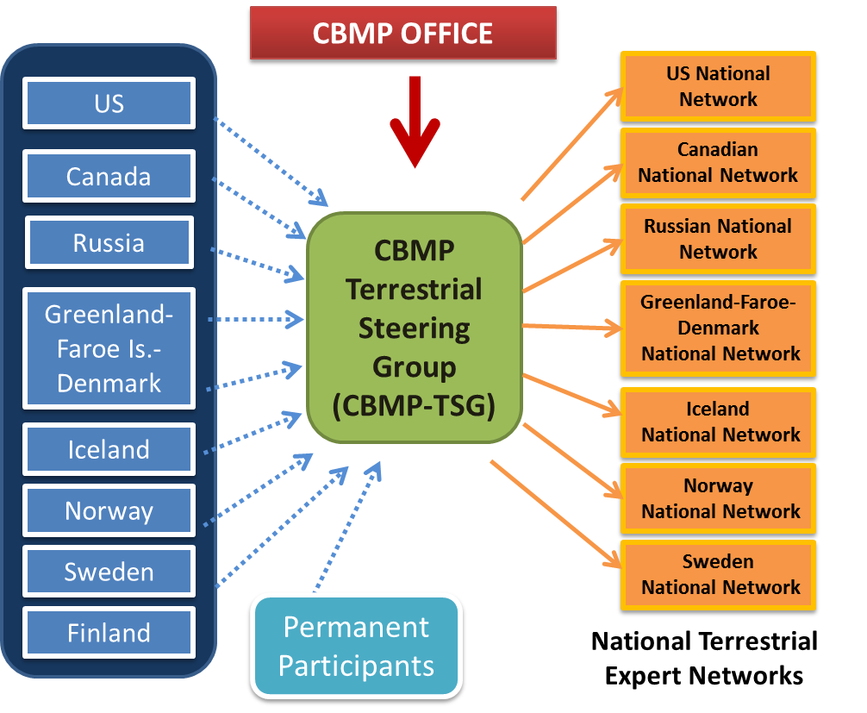

Figure 8.1. Governing structure for the implementation and ongoing operation of the CBMP Arctic Terrestrial Biodiversity Monitoring Plan. National Terrestrial Expert Networks report their output to the CBMP Terrestrial Steering Group, which in turn organizes and coordinates reporting to the CBMP Office and CAFF Board.

8.2 Program Review

The CBMP-TSG will initiate an internal review of the program beginning in 2016. A second review will take place in 2020 and will be followed by regular internal reviews every 5 years to align with the production of State of the Arctic Terrestrial Biodiversity reports. The internal review will assess progress towards the completion of program objectives (Table 8.1), with the goal of assessing indicator (attribute) performance, determining if additional parameters, techniques or sampling approaches are needed to improve the program or if some parameters or attributes should be dropped due to lack of sampling power, and evaluating the approach to data management. The review will determine if progress has been made in terms of answering questions related to the status and trends of Arctic terrestrial ecosystems and the biodiversity they support. In addition, an external review of these aspects of the program is recommended every 10 years with the first external assessment anticipated for 2020. Changes recommended by either internal or external reviews should be implemented with caution to ensure that recommended changes to the monitoring plan do not compromise data integrity. Besides the formal reviews scheduled every 5 years, the CBMP-TSG should ensure that yearly milestones are met and that concerns identified during the year are addressed in a timely fashion.

Table 8.1. Program objectives and performance measures of the CBMP-Terrestrial Plan to be assessed every 6 years beginning in 2016.
Objective | Performance Measure(s)
Identify an essential set of indicators (attributes) for terrestrial ecosystems that are suited for measurement and implementation on a circumpolar level. | Common indicators in use in three or more countries by 2016.
Identify abiotic parameters that are relevant to terrestrial biodiversity and require ongoing monitoring. | Relevant abiotic networks identified, and linkages made between common biotic indicators and abiotic data (2013-2016).
Identify harmonized or standardized protocols and optimal sampling strategies for Terrestrial Plan monitoring. | Arctic-based monitoring networks adopt sampling approaches (2013-2016).
Identify and organization of existing research and operational monitoring capacity and information (scientific, community-based, and TK). | Identify monitoring groups and accumulate available data for use in reports on the state of Arctic terrestrial biodiversity (2013-2016).
Establish and promote effective communication and linkages among Arctic terrestrial researchers and monitoring groups. | Utilization of CBMP web portal and web-based data nodes (Arctic Biodiversity Data Service) for CBMP-TSG reporting and communication outputs (2013-2016).
Address priority gaps in monitoring coverage (elemental, spatial and temporal). | Identification of priority data and sampling gaps and solutions to broaden monitoring coverage (2016).
Respond to identified scientific and TK science questions and user needs. | Indicators developed and reported in state of Arctic Terrestrial Biodiversity report (2016).

8.3 Implementation Schedule and Budget

Table 8.2 lists the major milestones involved with the implementation of the CBMP-Terrestrial Plan. The CBMP-TSG should use these as guidelines for outlining their annual work plans. These milestones include the initial publishing of the plan, the activation of the governing structure and establishment of the data nodes, the collection and analysis of existing monitoring data and establishment of coordinated monitoring, production of reports, and program review. A number of activities and deliverables are associated with each milestone, and the start year for each activity or first year in which the deliverable will be produced is indicated to provide a timeline for this implementation plan.
The budget for the implementation of the CBMP-Terrestrial Plan reflects the estimated costs for pan-Arctic coordination of the monitoring and assessment of the status and trends in Arctic terrestrial biodiversity (Table 8.3). These estimates do not include current and planned expenditures by each country to conduct their own Arctic terrestrial biodiversity monitoring. Similarly, costs for coordinating and holding in-country meetings with TEN members have not been included because of the large differences in cost anticipated among the countries. For an annual average investment of $35-65K USD per country in 2013 and $65-125K USD per country per year in 2014-2016, the value of current national monitoring efforts can be increased through a more coordinated, pan-Arctic approach. The budget for 2017 and beyond will be developed at a later date when activities and deliverables for ongoing assessment have been established. Even with an improved, harmonized approach, critical gaps in our monitoring coverage will still remain and new resources will be needed to address these gaps. Also, it is critical to acknowledge the ongoing need to sustain the monitoring activities that the CBMP-Terrestrial Plan aims to harmonize.
Table 8.2. Implementation schedule for the CBMP-Terrestrial Plan, including activities, deliverables, and start year for each milestone associated with the implementation of the plan. These activities will form the foundation of the annual work plans of the CBMP-TSG.
Milestone | Activities & Deliverables | Start Year
1. Plan published | a. Final plan endorsed by CAFF Board and published | 2013
 | b. Executive Summary report published (if needed) | 2013
2. Governing structure activated | a. CBMP-TSG established | 2013
 | b. National TENs established | 2013
3. Data management | a. Data nodes and hosts, web-entry and data standards established for each national TEN | 2014
 | b. Nodes linked to portal and web portal analysis tools developed | 2014
 | c. Metadata added to Polar Data Catalogue | 2013
4. Indicator development | a. Existing data sets identified and aggregated | 2014
 | b. Existing data sets analyzed to establish indicator baselines | 2014
 | c. Indicators updated based on performance assessments (annually) | 2016
5. Establish coordinated monitoring in each country | a. Recommended monitoring protocol manuals developed Arctic terrestrial biodiversity monitoring networks | 2014
 | b. Monitoring stations selected within each country | 2015
 | c. Arctic-based monitoring networks adopt parameters and sampling approaches | 2016
6. Reporting | a. Annual performance reports and work plans | 2013
 | b. State of the Arctic Terrestrial Biodiversity report (initial assessment of contemporary and historical data) | 2016
 | c. Arctic Terrestrial Biodiversity Status reports (incorporating new monitoring data) – 4 years after initial report (to align with Marine and Freshwater Steering Groups) and subsequently every 5 years | 2020
 | d. Indicator Status reports – every 2 years | 2016
 | e. Scientific publications (ongoing) | 2013
 | f. General communications | 2013
7. Program review | a. Review of parameters, sampling approaches, data mgmt. approach, analysis, and reporting (second review 4 years after initial review and subsequently every 5 years) | 2016
 | b. External independent review of parameters, sampling approaches, data management approach, analysis, and reporting (9 years after initial report and subsequently every 10 years) | 2020

Table 8.3. The operating budget for the implementation of the CBMP-Terrestrial Plan, outlining estimated costs for the activities and deliverables, and the responsibility for each cost. Note: the costs outlined in the table are focused on new efforts to harmonize terrestrial biodiversity monitoring, data management and reporting. They do not reflect the actual ongoing monitoring costs.
Milestone | Activities & Deliverables | Total Cost (USD) | Cost Details | Responsibility
1. Governing and operational structure activated | a. 2013 Inaugural meeting of CBMP-TSG  b. Annual meeting of CBMP-TSG | 50K (10 people at 5K each) plus 5K venue costs per year | Meeting costs (travel support for CBMP-TSG members and venue costs) and conference call costs | Arctic nations for travel support for their members. Lead TSG country for venue costs.
2. Data management structures established | a. Data nodes and hosts, web-entry interfaces, and data standards established | 2014: 30K (data node establishment)  2014 onwards: 10K per year (data node management) | Web-entry interface and web-based databases and nodes and data entry manuals established | CAFF CBMP Office
 | b. Data nodes linked to web portal and analytical tools developed | 2014 onwards: 20K (web portal maintenance) | Data Portal linked to data nodes via XML, and canned analysis tools developed | CAFF CBMP Office
 | c. Metadata added to Polar Data Catalogue | 2013 onwards: 0K (in-kind support from PDC and CAFF Data Manager) | Metadata entry by University of Laval and CAFF Data Manager free of charge | CAFF CBMP Office
3. Indicator development | a. Identification of existing data sets and historical data, collection of metadata, and spatial assessment of data coverage for national report (Project 1) | 2014: 30-60K per country | Costs for 1 person for 3-6 months per country (depending on country). | Arctic nations
 | b. Aggregation of existing data, national and regional dataset compilations, QA/QC, data agreements, and formatting (Project 2) | 2014-2015: 30-60K per year per country | Costs will vary depending on state of national datasets. Costs for 1 person for 3-6 months per year per country (depending on country). | Arctic nations
 | c. Analysis of indicator baseline status for each nation, summarized in national report (Project 3) | 2015-2016: 30-60K per year per country | Costs for 1 person for 3-6 months per year per country (depending on country). | Arctic nations
 | d. Dataset compilations archived | Minimal cost (10K). CAFF Data manager staff time. | All datasets compiled and used to be archived at CAFF Secretariat. | CAFF Secretariat
 | e. Accumulation of links to national/ regional protocols, identification of intercalibration needs, and definition of indicator comparison limits (Project 4) | 2014-2015: 30K | Costs for 1 person for 3 months. | CBMP-TSG
4. Reporting | a. Annual performance reports and work plans | Cost to be determined:  per year starting in 2014 | Performance report/work-plan layout and digital publication | CBMP-TSG
 | b. Compilation of national reports to create State of Arctic Terrestrial Biodiversity Report | 50K (10 people at 5K each) plus 5K venue costs per year | Meeting costs (travel support for CBMP-TSG members and venue costs) and conference call costs | Arctic nations for travel support. Lead TSG country for venue costs.
5. Program Review and adjustments | a. Review of parameters and sampling approaches.  b. Independent review of data management approach, analysis, and reporting using performance measures | 0K – costs reflected above.  30K every ten years starting in 2016 | Contract independent review of Monitoring Program | CBMP-TSG  CBMP Office
TOTALS |  | 2013: 5-10K per country  2014-2016: 65-125K per year per country

9 Literature Cited

10 GLOSSARY
Term | Description | Reference or resource
Advanced protocols | Monitoring protocols that consist of methodology requiring comprehensive scientific expertise and oversight for proper application
Aichi Biodiversity Targets | Strategic plan goals to promote, protect, and enhance biodiversity by 2020; CBD | http://www.cbd.int/sp/targets/
albedo | surface reflectivity; fraction of solar radiation that is reflected back into space
ABA | Arctic Biodiversity Assessment | http://caff.is/aba
AMAP | Arctic Monitoring and Assessment Program, Arctic Council | http://www.amap.no/
AOU | American Ornithologists' Union | http://www.aou.org/
APECS | Association of Polar Early Career Scientists | http://www.apecs.is/
APEX | Arctic Palaeoclimate and its Extremes | http://www.apex.geo.su.se/
Arctic | Land north of the Arctic Circle (approx. 66° 33' N); ecologically, the land north of treeline at present corresponding to the 10°C (50°F) July isotherm
Arctic Breeding Bird Conditions Survey (ABBC) | Project to collate data on environmental conditions on breeding grounds particularly of waders and waterfowl in the Arctic in a regularly updated database (Wetlands International and Wader Study Group) | http://www.arcticbirds.net/
Arctic Council | an intergovernmental forum formalised in 1996 to facilitate collaboration among the Arctic States (Canada, Denmark including Greenland and the Faroe Islands, Finland, Iceland, Norway, the Russian Federation, Sweden, and USA), Arctic Aboriginal Peoples and other Arctic inhabitants on sustainable development and environmental protection in the Arctic. | http://www.arctic-council.org
Arctic PRISM | see PRISM | http://www.ec.gc.ca/reom-mbs/default.asp?lang=En&n=FC881C1B-1
Arctic WOLVES | Arctic Wildlife Observatories Linking Vulnerable EcoSystems | http://www.cen.ulaval.ca/arcticwolves/en_intro.htm
Attributes | characteristics and descriptors of focal ecosystem components
Basic protocols | Monitoring protocols that consist of simplified methodology that can be used at sites with minimum monitoring capacity
BBS | Breeding Bird Survey | https://www.pwrc.usgs.gov/bbs/about/
Biodiversity | the variability among living organisms from all sources including, inter alia, terrestrial, marine and other aquatic ecosystems and the ecological complexes of which they are part; this includes diversity within species, between species and of ecosystems (CBD) | CBD (http://www.cbd.int/)
BIP | Biodiversity Indicators Partnership | http://www.bipindicators.net/
Biotic group | Set of organisms that share some characteristics (e.g. taxonomy, habitat, functional groups, communities, etc.). In the CBMP-Terrestrial Plan, these are the major groups consisting of Vegetation, Birds, Mammals, and Invertebrates.
Black-listed species | Non-native species that are invasive or harmful in the introduced region (e.g. term used in Norway and other countries, but other terms have not been standardised in other countries); compare with Red List species (IUCN)
CAFF | Conservation of Arctic Flora and Fauna Working Group of the Arctic Council | http://www.caff.is/
CALM | Circumarctic Active Layer Monitoring Network | http://www.udel.edu/Geography/calm/about/program.html
CANNTEX | Canadian Tundra and Taiga Experiment; a network of scientists and sites across the Canadian North (and see ITEX) | http://www.taiga.net/canttex/index.html
Capture-Mark-Recapture | A general group of ecological methods based on the initial capture of individuals which are tagged and the subsequent re-trapping of the same or a portion of the original captured individuals; CMR data can be used to study population dynamics, movement of individuals, territoriality, population size, survival and demographics, etc.
CARMA | Circumarctic Rangifer Monitoring and Assessment Network | http://caff.is/carma
CAVM | Circumpolar Arctic Vegetation Map | http://www.geobotany.uaf.edu/cavm/
CBC | Christmas Bird Count, Audubon Society | http://birds.audubon.org/christmas-bird-count
CBD | Convention on Biological Diversity | http://www.cbd.int/
CBM | See Community-based monitoring
CBMP | Circumpolar Biodiversity Monitoring Program; created by the CAFF Working group of the Arctic Council | http://www.caff.is/monitoring
CBMP Data Portal | CBMP’s Data Portal system (www.abds.is) | http://www.abds.is
CBMP-Terrestrial Plan | Arctic Terrestrial Monitoring Plan; created by the TEMG
CBMP-TSG | Circumpolar Biodiversity Monitoring Program - Terrestrial Steering Group
CEMG | Coastal Expert Monitoring Group (see EMG)
CIMP | Cumulative Impacts Monitoring Program | http://www.aadnc-aandc.gc.ca/eng/1100100027498/1100100027499
CMR | see Capture-Mark-Recapture
COI Barcode | DNA Barcoding: fragment of the cytochrome oxidase c I gene that is sequenced systematically and is useful for species identification in many taxonomic groups (additional markers may be needed in groups such as plants) | http://www.barcodeoflife.org/content/about/what-dna-barcoding
Conceptual model | A working hypotheses about ecosystem organization, function, and key system inter-relationships
Community-based monitoring | Observation and measurement activities involving participation by community members; activities are designed to learn about ecological and social factors affecting a community
Cumulative Impacts Monitoring Program | A community-based program in the Northwest Territories, Canada, that coordinates, supports, disseminates, and conducts monitoring-related initiatives incorporating both scientific and traditional knowledge, and builds capacity | http://www.aadnc-aandc.gc.ca/eng/1100100027498/1100100027499
Critical component | Elements considered to play a crucial role in a system and that would lead to detrimental changes if these ceased to exist; elements which may be considered as priorities for long term monitoring.
DEM | Digital Elevation Model
DNA Barcoding | System of protocols and databases of biodiversity taxonomy and identification based on standardised sequences of DNA | http://www.barcodeoflife.org/
DPSIR framework | model to assess and manage environmental problems (Driving forces; Pressures; State of the environment; Impacts; Responses) | http://www.grida.no/graphicslib/detail/dpsir-framework-for-state-of-environment-reporting_379f
Driver | An ecological biotic or abiotic component that causes a change in an organism, population, habitat, ecosystem, or other element of the landscape
Driving forces | Socio-economic and socio-cultural forces driving human activity that may increase or decrease pressures on the environment (DPSIR framework) | http://www.grida.no/graphicslib/detail/dpsir-framework-for-state-of-environment-reporting_379f
eBird | Online avian abundance and distribution checklist based on reporting by volunteers and professionals (citizen science). | http://ebird.org/content/ebird/
Ecosystemic | Related to the environment
Ecological tipping points | Points along a gradient of change where a small change in external conditions can result in a drastic change in the structure and composition of a system
EMG | Expert Monitoring Group (see CBMP); one of four groups of collaborating scientists, managers, and community members with expertise in Terrestrial (TEMG), Marine (MEMG), Coastal (CEMG) and Freshwater (FEMG) environments.
Essential Attribute | Attributes of focal ecosystem components that must be measured at any given monitoring site to capture a minimum set of biodiversity information for the FEC under study; considered critical
Focal Ecosystem Components | Ecosystem components (indicators) that are considered critical to the functioning and resiliency of Arctic ecosystems and are of fundamental importance to the subsistence and economies of Northern communities
FEMG | Freshwater Expert Monitoring Group (see EMG)
Function | Ecosystem function; the ecological role performed by a species or functional group (e.g. nutrient cycling, herbivory, etc.)
GBIF | Global Biodiversity Information Facility (and Data Portal) | http://www.gbif.org/
GEO BON | Group on Earth Observations Biodiversity Observation Network | http://www.earthobservations.org/geobon.shtml
GLORIA | Global Observation Research Initiative in Alpine Environments | http://www.gloria.ac.at/
Gray literature (or grey literature) | Manuscripts and articles that may be unpublished and typically do not undergo the same peer-review process as journal articles; material may consist of reports, technical papers, white papers, etc.
High Arctic | Northern region of the Arctic particularly including the island in the north; ecologically, the area consisting of polar semidesert to desert where mean July temperatures range from 6° to 2° C
Historic monitoring | Relevant monitoring previously conducted which could be incorporated into the monitoring scheme
Impacts | Effects of environmental degradation (DPSIR framework) | http://www.grida.no/graphicslib/detail/dpsir-framework-for-state-of-environment-reporting_379f
Indicator | see Focal Ecosystem Components
INTERACT | International Network for Terrestrial Research and Monitoring in the Arctic | http://www.eu-interact.org/
IPBES | Intergovernmental Platform on Biodiversity and Ecosystem Services | http://www.ipbes.net/
IPCC | Intergovernmental Panel on Climate Change | http://www.ipcc.ch/
IPY | International Polar Year Programme | http://www.ipy.org/ (NOTE: domain name and site may be down temporarily)
ITEX | International Tundra and Taiga Experiment | http://www.geog.ubc.ca/itex/
IUCN | International Union for Conservation of Nature and Natural Resources | http://www.iucnredlist.org/
Key elements | see Focal Ecosystem Components
Landscape | A geographic area including its properties of physical terrain, land cover, water bodies, climate, land use patterns, and other characteristics
Life forms, Vegetation | Functional type of vegetation related to ecosystem function (e.g. trees, shrubs, forbs, graminoids, bryophytes, fungi, lichens, bare ground, etc.)
Low Arctic | Southern region of the Arctic; ecologically, area with higher diversity in vegetation where mean July temperatures range from 6° to 12° C
Management, Wildlife or Ecosystem | Decision-making and applied ecology to preserve and enable sustainable use of wildlife populations in a manner that strikes a balance between the needs of those populations and the needs of people
MEA | Multilateral Environmental Agreements
MEMG | Marine Expert Monitoring Group (see EMG)
Mire | Boggy habitat
MODIS | Moderate Resolution Imaging Spectroradiometer; satellite-borne imaging instrument that gathers data on the Earth's surface | http://modis.gsfc.nasa.gov/
NDVI | MODIS Normalized Difference Vegetation Index; satellite-based data collected on land cover changes that can be used to monitor vegetation growth conditions, climate, and land use. | http://glcf.umd.edu/data/ndvi/
PAME | Protection of the Arctic Marine Environment | http://www.pame.is/
Parameter | Traits or items that are measured in the field and that are elements and integral parts of attributes
PPS Arctic | Norwegian IPY program: Present day processes, Past changes, and Spatiotemporal variability of biotic, abiotic and socio-environmental conditions and resource components along and across the Arctic delimitation zone | http://ppsarctic.nina.no/
Pressures | Stresses that human activities place on the environment (DPSIR framework) | http://www.grida.no/graphicslib/detail/dpsir-framework-for-state-of-environment-reporting_379f
PRISM | Program for Regional and International Shorebird Monitoring
Range of temporal variation | Temporal and spatial distribution of ecological processes and structures prior to European settlement of North America
Recommended attribute | Attributes that can be measured at some sites when additional capacity and/or expertise is available to capture information on the processes driving biological change
Red List of species (IUCN) | Framework for the classification of taxa according to their extinction risk and including species with near threatened to extinct status | http://www.iucnredlist.org/
Redundancy | Ecologically, when a species or group of species can perform the equivalent ecosystem function of another species or group of species
Region | Spatial area demarcated by political borders (territorial or settlements), socioeconomic categories, geology, watersheds, or biogeography
Resilience | Amount of disturbance that ecosystem can withstand without changing key processes and structures (alternative stable states); time needed to return to a stable state
Responses | Responses by society to the environmental situation (DPSIR framework) | http://www.grida.no/graphicslib/detail/dpsir-framework-for-state-of-environment-reporting_379f
SAON | Sustaining Arctic Observing Network | http://www.arcticobserving.org/
SCANNET | Circumarctic network of terrestrial field bases; see INTERACT | http://www.scannet.nu/ (NOTE: main site may be experiencing problems); http://faro-arctic.org/fileadmin/Resources/DMU/GEM/faro/2010_SCANNET_Rasch.pdf
SDWG | Sustainable Development Working Group, Arctic Council | http://portal.sdwg.org/
SMART | Specific, Measurable, Achievable, Results-oriented, and Temporarily-defined
State of the environment | Condition of the environment (DPSIR framework) | http://www.grida.no/graphicslib/detail/dpsir-framework-for-state-of-environment-reporting_379f
Stressor | Driver (e.g. an agent, force or external factor) that exerts detrimental pressure on an ecosystem, community, biotic group, organism, or on natural ecological processes or ecosystem functions.
Subarctic | Ecotone between timberline (taiga) and treeline (tundra) with connections to the Arctic via alpine zones, coastal tundra, and forest tundra
SWIPA | Snow, Water, Ice, Permafrost in the Arctic assessment (produced by AMAP) | http://amap.no/swipa/
TEK | Traditional ecological knowledge (and see Traditional Knowledge)
TEMG | Terrestrial Expert Monitoring Group (see EMG)
TEN | Terrestrial Expert Networks (established by country for coordinating metadata accessibility; CAFF)
Terrestrial Plan | Circumpolar Biodiversity Monitoring Plan for terrestrial biodiversity
Threshold | The ecological tipping point of an ecosystem; point where abrupt change in a quality, property or phenomenon, or where small changes in a driver, produce large responses
Timberline | The altitudinal or latitudinal boundary or transition zone that delineates the ecological conditions of climate (especially temperature, precipitation, and wind) beyond which forests no longer form a closed canopy ecosystem (and see treeline)
Tipping point | See Threshold
Traditional Knowledge (TK) | Knowledge and values which have been acquired through experience, observation, from the land or from spiritual teachings, and taught through generations.
Traditional Ecological Knowledge (TEK) | Cumulative body of knowledge about people and organisms in relation to their environment, and that has been acquired through experience and taught through generations (and see Traditional Knowledge as broader term)
Treeline (or tree line) | The altitudinal or latitudinal boundary or transition zone that delineates the ecological limit beyond which trees can no longer grow due to harsh climatic conditions, especially temperature, precipitation, and wind (and see timberline)
TSG | Terrestrial Steering Group
Vegetation | Comprehensive term referring to land cover components including all plants and their growth forms, and fungi.
Wing Surveys (or Tail Surveys) | Harvested bird species provide opportunities to estimate the numbers and species, age and sex composition of the harvest. Hunters participating in surveys submit one wing and/or the tail of bird that they shoot during the hunting season; programs run by governments in collaboration with experts identify the tissues to gather demographic and abundance data. | Examples: http://www.flyways.us/surveys-and-monitoring/hunter-surveys/parts-collection-surveys https://www.ec.gc.ca/reom-mbs/default.asp?lang=En&n=CFB6F561-1

11 Appendices

A Appendix: Metadata and Sampling Coverage Maps by Focal Ecosystem Elements - ONGOING
Section to be completed – Work is still ongoing to compile master file of METADATA.
METADATA will be uploaded to the Polar Data Catalogue (http://www.polardata.ca/whitesnow/ ). Data files are undergoing final updates and will include all circumpolar countries part of the CBMP-Terrestrial Plan.

i. Introduction and Description
Brief description will be included here.

ii. MAPS
Maps will be included here (GIS) based on geographic coordinates of long-term monitoring programs and infrastructure (e.g. research stations). Maps will show monitoring capacity for various biotic groups (e.g. vegetation, birds, mammals, arthropods, and others).

PLACE-HOLDER FOR METADATA MAPS (INVENTORY SITES)
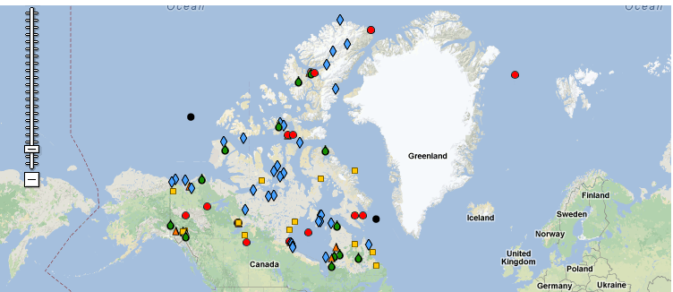
(For illustration purposes only: example of Canadian research facilities in the North from http://www.polarcom.gc.ca )
Figure A1: Location of long-term monitoring sites, programs and infrastructure that can contribute to monitoring capacity as part of the CBMP-Terrestrial Plan. (When completed, maps may be separate for different types of programs or for different biotic groups; some types will be pooled and distinguished by different marker types on GIS maps).

B Appendix: What Can We Monitor with Satellite Data in the Arctic?

i. Remote Sensing
Remote sensing is a tool that can support an integrated Arctic terrestrial biodiversity monitoring program. Remote sensing observations can provide information at a variety of scales (cm-km). Synoptic satellite spatial and temporal information as presented in Table B1 can be generated. Presented on the table are both biotic and abiotic parameters, hence remote sensing provides useful information on both indicators and drivers. Remote sensing observations can also support modeling efforts, particularly those that are geospatially based. Ground based observation can be used to truth remote sensing data which can then be used to classify areas of the Arctic which are inaccessible. Fine spatial resolution remote sensing data combined with on-the-ground-sampling can also be combined to better interpret coarse resolution (1km) satellite data so that Arctic-wide classifications are possible. Combining the ground sampling with remote sensing observations provide insight into how to put detailed ground measurements into a regional context. Remote sensing technologies are also rapidly evolving; Lidar-generated topography and vegetation-height data are one example. The monitoring activities should take advantages of these emerging technologies when budgets can support such new technology based projects.
Remote sensing supports the measurement of biodiversity parameters such as vegetation type, indices (NDVI, EVI, and others), phenology (start, end, duration of growing season-SOS, EOS, and DOS), and leaf area index (LAI), as well as providing important information on abiotic drivers such as temperature, cloud cover, snow cover, soil moisture, active layer, land cover, anthropogenic change, hydrology, fire burn areas, and freeze /thaw cycles (see Table B1). Remote-sensing-derived information on weather, climate, sea ice and the coastal marine environment are also useful driver information to support the terrestrial biodiversity monitoring activities that include models.
Table B2 presents a recommended series of satellite systems that can support long term monitoring in the Arctic. Presented on the table by satellite system is the organization, sensor type, resolution on the ground, spatial and temporal coverage, data type, and derived products per system. These satellite systems were selected based on the following criteria: (1) polar orbit, (2) ten year duration or longer, (3) electro-optical, and active/ passive microwave, and (4) data available at little or no cost. Generation of the time series products identified in Tables B1 and B2 would be an invaluable set of observations to support the overall monitoring effort. Some of the derived satellite products identified in the table are partially completed; however, a comprehensive complete time series of the entire pan- Arctic in a user friendly Arctic map projection does not exist. A number of time –series investigations using these satellite systems have been performed, but are incomplete from a time and space perspective. However, if available in a common database (portal), these would be very valuable to the terrestrial monitor efforts.
A series of gaps in the satellite derived products (Table B2) have been identified. These include: 1) 1980 –present seasonally integrated NDVI using POES data, 2) Landsat derived pan- Arctic land cover for 1980, 1990, 2000, and 2010, with separate hydrology layers, 3) The suite of MODIS- derived product in polar user-friendly projection formats, 4) MODIS and AVHRR derived fire occurrence maps 2002-present, 5) Annual and inter-annual surface temperature maps 1980- present for the pan-Arctic, and 6) Annual maximum snow cover map for the Arctic 2003-present (from MODIS). The gaps identified above should be rectified as an early step in the implementation of the terrestrial monitoring activity. In addition to the six recommended time series generations based on the gap analysis, the synthetic aperture radar (SAR) ERS-1/2 should be utilized to classify shallow/deep (frozen/some liquid water at maximum freeze) for 1992, 2000, and 2010 to provide information on lake depth change and freeze/thaw history.
Before and after photography whether collect on the ground, air or in space can also be a very important tool to quantify change. The back to the future concept has documented significant changes in vegetative state over a few decades.
In addition to the satellite based synoptic pan-Arctic time series derived products identified above, remote sensing data of varying platforms (ground, air, and space) spatial resolution (cm to km) and sensor types (electro-optic, infrared, and microwave) will be used to support the recommended on the ground observations summarized in the vegetation sampling strategy tables presented in Chapter 4 (Table 4.1). The multiple roles of remote sensing in supporting the CBMP-Terrestrial Plan by providing information at different scales and time periods on biotic and abiotic indicators and drivers should be noted.
Table B1. Ecosystem changes, components, and drivers that can be monitored at various spatial and temporal scales.
Climate | Ground and sea temperature  Snow cover  Sea ice extent  Aerosols/emissions
Land | Digital Elevation Maps (DEM)  Soil moisture  Active layer/permafrost  Vegetation type (land cover)  Vegetation indices (NDVI, EVI, and many others)  Vegetation phenology (start/end/duration of growing season [SOS, EOS, DOS])  Snow cover  Albedo  Fire/Burned Area  Leaf Area Index (LAI)
Hydrology | Lake extent and relative depth  Fluvial (gravel bars, channel locations)
Coastal erosion  - (time series) | Requires fine resolution data (1-2 m)
Freeze/thaw cycle | Lakes  Active layer  Ice break-up  Snow cover
Anthropogenic | Oil and gas development (ice roads, pipelines, drill pads, etc.)  Infrastructure/development
Ocean | Surface wind speeds  Wave height  Ocean current dynamic height method  Wavelength and direction  Ocean frontal boundaries  Ocean temperature  Color (chl, doc, sm)  Oil spills and surfactants
Sea Ice | Sea ice concentration  Sea ice dynamics  Ice type (age)  Detailed ice movement and rheology  Leads  Marginal ice zone (MIZ)  Land fast ice  Ice edge  Ice free-board

Table B2: Recommended satellite systems that have potential for supporting long-term monitoring over ranges of temporal and spatial scales. Some of the derived products here are partially completed, and efforts will be made to address gaps as described in the CBMP-Terrestrial Plan.
Satellite System | Organization | Sensor Type | Spatial Resolution | Spatial Coverage | Temporal Coverage | Data Type | Derived Products | Remarks
Polar Orbiting Platform (POES) | USA-NOAA | Visible and infrared (AVHRR) | 1 km | All pan-Arctic daily | 1978-present | Visible and infrared images | Surface Temp  NDVI  Clouds | 1978-TIROS-N under re-calibration
ERS-1/2 Envisat  Radarsat-1 | ESA  Canada | SAR | 25 m | 100 km swaths all pan-Arctic over time | 1991-present | Radar backscatter images | Frozen/non-frozen lakes  Active layer Ice cover | Radarsat-2 can provide continuity but costly
DMSP | USA-DOD | AVHRR and passive microwave | 1 km  25 km | All pan-Arctic daily | 1960s-present | Visible and thermal imagery and microwave brightness temp | Sea ice type  Sea ice cover  Surface time  Clouds  Snow cover | Best source of long-term ice coverage  1979-present SMMR-SMMI
Landsat | USA-USGS | Visible and infrared | 30-100 m | 165 km frames all pan-Arctic over time | 1973-present | Visible and infrared images | Land cover  Hydrology  Snow cover  Ice cover | Landsat 7 has data gaps at scene edges, Landsat 5 current limited data collects over U. S. only
MODIS (Aqua and Terra) | USA-NASA | Visible and infrared | 250 m-  1 km | Entire earth every 1-2 days | 2002-present | Visible and infrared images | Ocean ice, time, and productivity  Enhanced Vegetation Index (EVI)  Fire events  Snow cover  Surface temp.  Cloud cover | Potential for generating a comprehensive suite of pan-Arctic observations

ii. Satellite Imaging of Pan-Arctic Research Stations
Table B3 and Figure A1 address the imaging requirements of satellites to map the suite of Pan-Arctic Research Stations. Represented on the figure are the locations of the Pan-Arctic Research Stations, the Arctic Circle, the CAFF Pan-Arctic Boundary, and the different footprints (coverage) of Landsat, MODIS, and AVHRR for the region. The map of long-term Pan-Arctic Research Stations and satellite swath widths (footprints) provides the information needed to determine approximately how many satellite scenes of a given sensor are needed to cover all of the stations. For example, Landsat provides data at a fine spatial resolution (~30 m) but at the cost of a small satellite footprint (185 km). Each AVHRR scene covers a large geographic area but the spatial resolution is coarse (~1 km). MODIS has irregular shaped satellite footprints at the poles due to the use of a sinusoidal projection, but several research stations are covered in one image scene in many areas. In terms of spatial resolution, MODIS data is provided at 250 m – 1 km depending on the portion of the electromagnetic spectrum (i.e. satellite band) utilized.
Table B3 summarizes the satellite sensor, spatial resolution, footprint or swath width, temporal revisit time, and number of scenes necessary to image each station one time. For example to image each station once a year for ten years with Landsat would require 330 images.

Table B3. Number of satellite scenes required to image the suite of Pan-Arctic research stations
Satellite Sensor | Spatial Resolution | Footprint Size | Temporal Revisit | # of Satellite Scenes Needed to Cover All Pan-Arctic Research Stations
Landsat | 30 m | 185 km | 16 Days | ~33
MODIS -  Aqua and Terra | 250 m – 1 km | 1,000 – 1,500 km | Daily | ~16
AVHRR | 1 km | 2,500 km | Daily | ~8

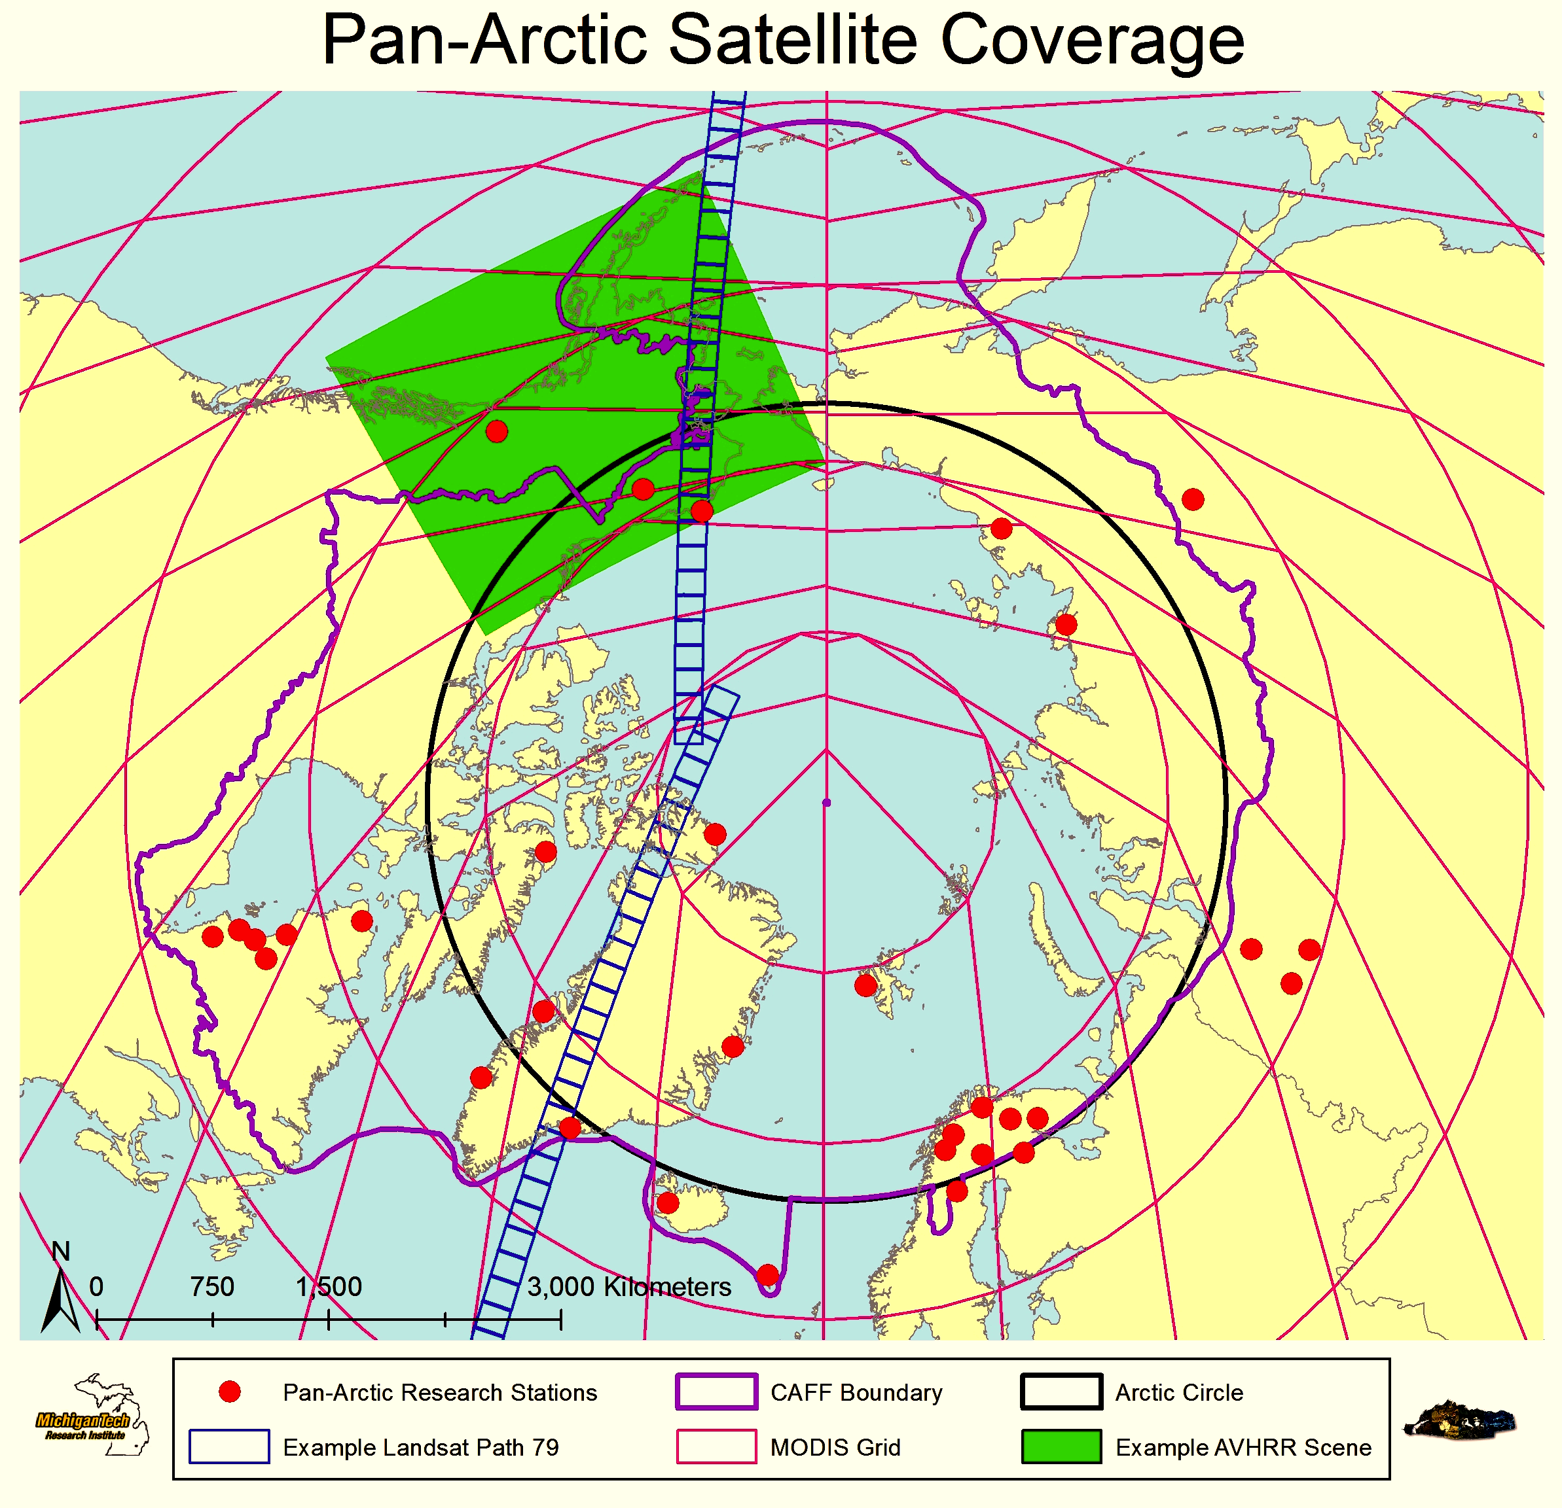
Figure B1: Locations of the Pan-Arctic Research Stations (red dots), the Arctic Circle (black line), the CAFF Pan-Arctic Boundary (purple line) along with the different footprints of Landsat (blue boxes), MODIS (red lines), and AVHRR (green box) for the region.

C Appendix: Workshop Participants

i. Workshop 1 (October 11-13, 2011, Hvalsø, Denmark) - Designing an Arctic Terrestrial Biodiversity Monitoring Plan
Niels Martin Schmidt | Aarhus University – Institute of Bioscience, Demark
Peter Aastrup | Aarhus University – Institute of Bioscience, Demark
Christian Bay | Aarhus University – Institute of Bioscience, Demark
Jesper Madsen | Aarhus University – Institute of Bioscience, Demark
Mads Forchammer | Aarhus University - Institute of Bioscience, Denmark
Tony Fox | Aarhus University – Institute of Bioscience, Denmark
Tom Christensen | Aarhus University – Institute of Bioscience, Denmark
Hans Meltofte | Aarhus University, Denmark
Tom Barry | CAFF, Iceland
Michael Svoboda | CBMP Office, Environment Canada
Mike Gill | CBMP Office, Environment Canada
Mikala Klint | Danish Environmental Protection Agency, Denmark
Marlene Doyle | Science & Technology, Environment Canada
Katarzyna Biala | European Environment Agency
Anna Maria Fosaa | Faroese Museum of Natural History, Faroes
Ulla-Maija Liukko | Finnish Environment Institute, Finland
Inge Thaulow | Greenland Homerule Government
Christine Cuyler | Greenland Institute of Natural Resources
Josephine Nymand | Greenland Institute of Natural Resources
Starri Heidmarsson | Icelandic Institute of Natural History, Iceland
Anne Brunk | Indigenous Peoples Secretariat, Denmark
Elisa Pääkkö | Metshallitus Natural Heritage Services, Finland
Bob Shuchman | Michigan Tech Research Institute, USA
Morten Skovgaard | Ministry of Energy and Climate, Denmark
Mikhail Soloviev | Moscow State University, Dept. of Vertebrate Zoology, Russia
John Payne | North Slope Science Initiative, USA
Dagmar Hagen | Norwegian Institute for Nature Research (NINA), Norway
Bård Øyvind Solberg | Norwegian Institute for Nature Research (NINA), Norway
Donald McLennan | Parks Canada, Canada
Mora Aronsson | Swedish Species Information Centre (SLU), Sweden
Hans Gardfjell | Swedish University of Agricultural Sciences (SLU), Sweden
Wenche Eide | Swedish Species Information Centre (SLU), Sweden
Cheryl Rosa | U.S. Arctic Research Commission, USA
Lawrence Hislop | UNEP GRID Arendal
Donald Walker | University of Alaska, Fairbanks, USA
Rolf Anker Ims | University of Tromsø, Norway
Bud Cribley | U. S. Bureau of Land Management, USA
Jason J. Taylor | U. S. Bureau of Land management, USA
Carl Markon | U. S. Geological Survey, USA
Kristine Bakke | Westergaard Norwegian Institute for Nature Research (NINA), Norway
Tatiana Minaeva | Wetlands International, Russia

ii. Workshop 2 (May 15-17, 2012, Anchorage, Alaska, USA) - Designing an Integrated Arctic Terrestrial Biodiversity Monitoring Plan
Elmer Topp-Jorgensen | Aarhus University
Niels Martin Schmidt | Aarhus University
Tom Christensen | Aarhus University
Maryann Smith | Aleut International Association
Don Russell | CircumArctic Rangifer Monitoring Network
Marlene Doyle | Science & Technology, Environment Canada
Michael Svoboda | CBMP Office, Environment Canada
Mike Gill | CBMP Office, Environment Canada
Katarzyna Biala | European Environment Agency
Christine Cuyler | Greenland Institute of Natural Resources
Josephine Nymand | Greenland Institute of Natural Resources
Starri Heidmarsson | Icelandic Institute of Natural History
Carolina Behe | Inuit Circumpolar Council Alaska
Christopher Buddle | McGill University
Robert Shuchman | Michigan Tech Research Institute
Mikhail Solovyev | Moscow State University
Robert Winfree | National Park Service
Denny Lassuy | North Slope Science Initiative
John Payne | North Slope Science Initiative
Morten Wedege | Norwegian Directorate for Nature Management
Dagmar Hagen | Norwegian Institute for Nature Research
Kristine Bakke Westergaard | Norwegian Institute for Nature Research
Donald McLennan | Parks Canada Agency
Mora Aronsson | Swedish Species Information Centre
Jason J. Taylor | U.S. Department of the Interior - Bureau of Land Management
Cheryl Rosa | United States Arctic Research Commission (USARC)
Catherine Moncrieff | Yukon River Drainage Fisheries Association
Representatives | APECS (Association of Polar Early Career Scientists)

Acronyms and key terms used throughout the Terrestrial Plan are defined in Chapter 10 (Glossary).
Visit http://www.caff.is/about-the-cbmp for more information on the Circumpolar Biodiversity Monitoring Plan, the Monitoring Expert Groups and the completed CBMP Monitoring Plans for each biome.
See Chapter 10 (Glossary) for more information and links to these programs
Wing surveys or tail surveys: Harvested bird species provide opportunities to estimate the numbers and species, age and sex composition of the harvest. Hunters participating in surveys submit one wing and/or the tail of bird that they shoot during the hunting season; programs run by governments in collaboration with experts identify the tissues to gather demographic and abundance data.
Piscivores are included here as omnivores because this group represents relatively few species which overlap to some extent with CBMP-Freshwater Plan, but which do not constitute a major group of their own in the terrestrial environment.

